Evolutionary Trade-Offs

Structures built by organisms have an energetic cost. So building a molecule, such as a large protein, means allocating ATP for making these molecules rather than using the energy for other physiological functions. The experiments of Dahlhoff and Rank shows that the beetles with the PGI 1-1 genotype start producing Heat Shock Proteins (HSPs) under less stress than beetles with the 1-4 or 4-4 genotypes. This suggests that the 1-4 and 4-4 beetles are more stress tolerant and are less likely to allocate their ATP to make HSPs and therefore they have more ATP available for other tasks.
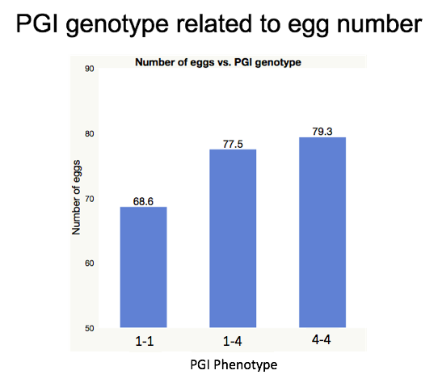
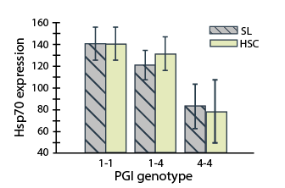

Examine the graphs above to answer the following questions:

- What genotype(s) are associated with producing larger number of eggs? Explain the relationship between egg production and the concept of natural selection.

- Describe the energetic trade-offs shown by the 1-1 and 4-4 genotypes.

- Using the data, make a prediction about which genotypes would survive best in an environment with long, cold winters with deep snowpack. Justify your prediction.

Image at right adapted from Rank, N.E. & Dahlhoff, E.P. (2002) Allele frequency shifts in response to climate change and physiological consequences of allozyme variation in a montane insect. Evolution 56, 2278–2289.

