Lady Beetle Lab:
PROCEDURE FOR SETTING UP BEETLE HABITATS AND PLACING BEETLES INTO CHILL COMA

Setting up habitats:

- Beetle populations can be stored at room temperature in their original packaging, if it is fairly stable, or in a refrigerator at 4℃ for several months, but viability declines over time. Viability is improved if some of their straw packing material or crumpled, clean paper towel is kept with them (they will cluster together in the crevices). A vial with water plugged with cotton is also needed. The container must have some form of ventilation (add a few holes that are smaller than the beetles). Periodic light misting is helpful in maintaining a humidity level that the beetles prefer, but too much moisture will encourage mold growth. The pictures below show one possible example of beetle habitats.

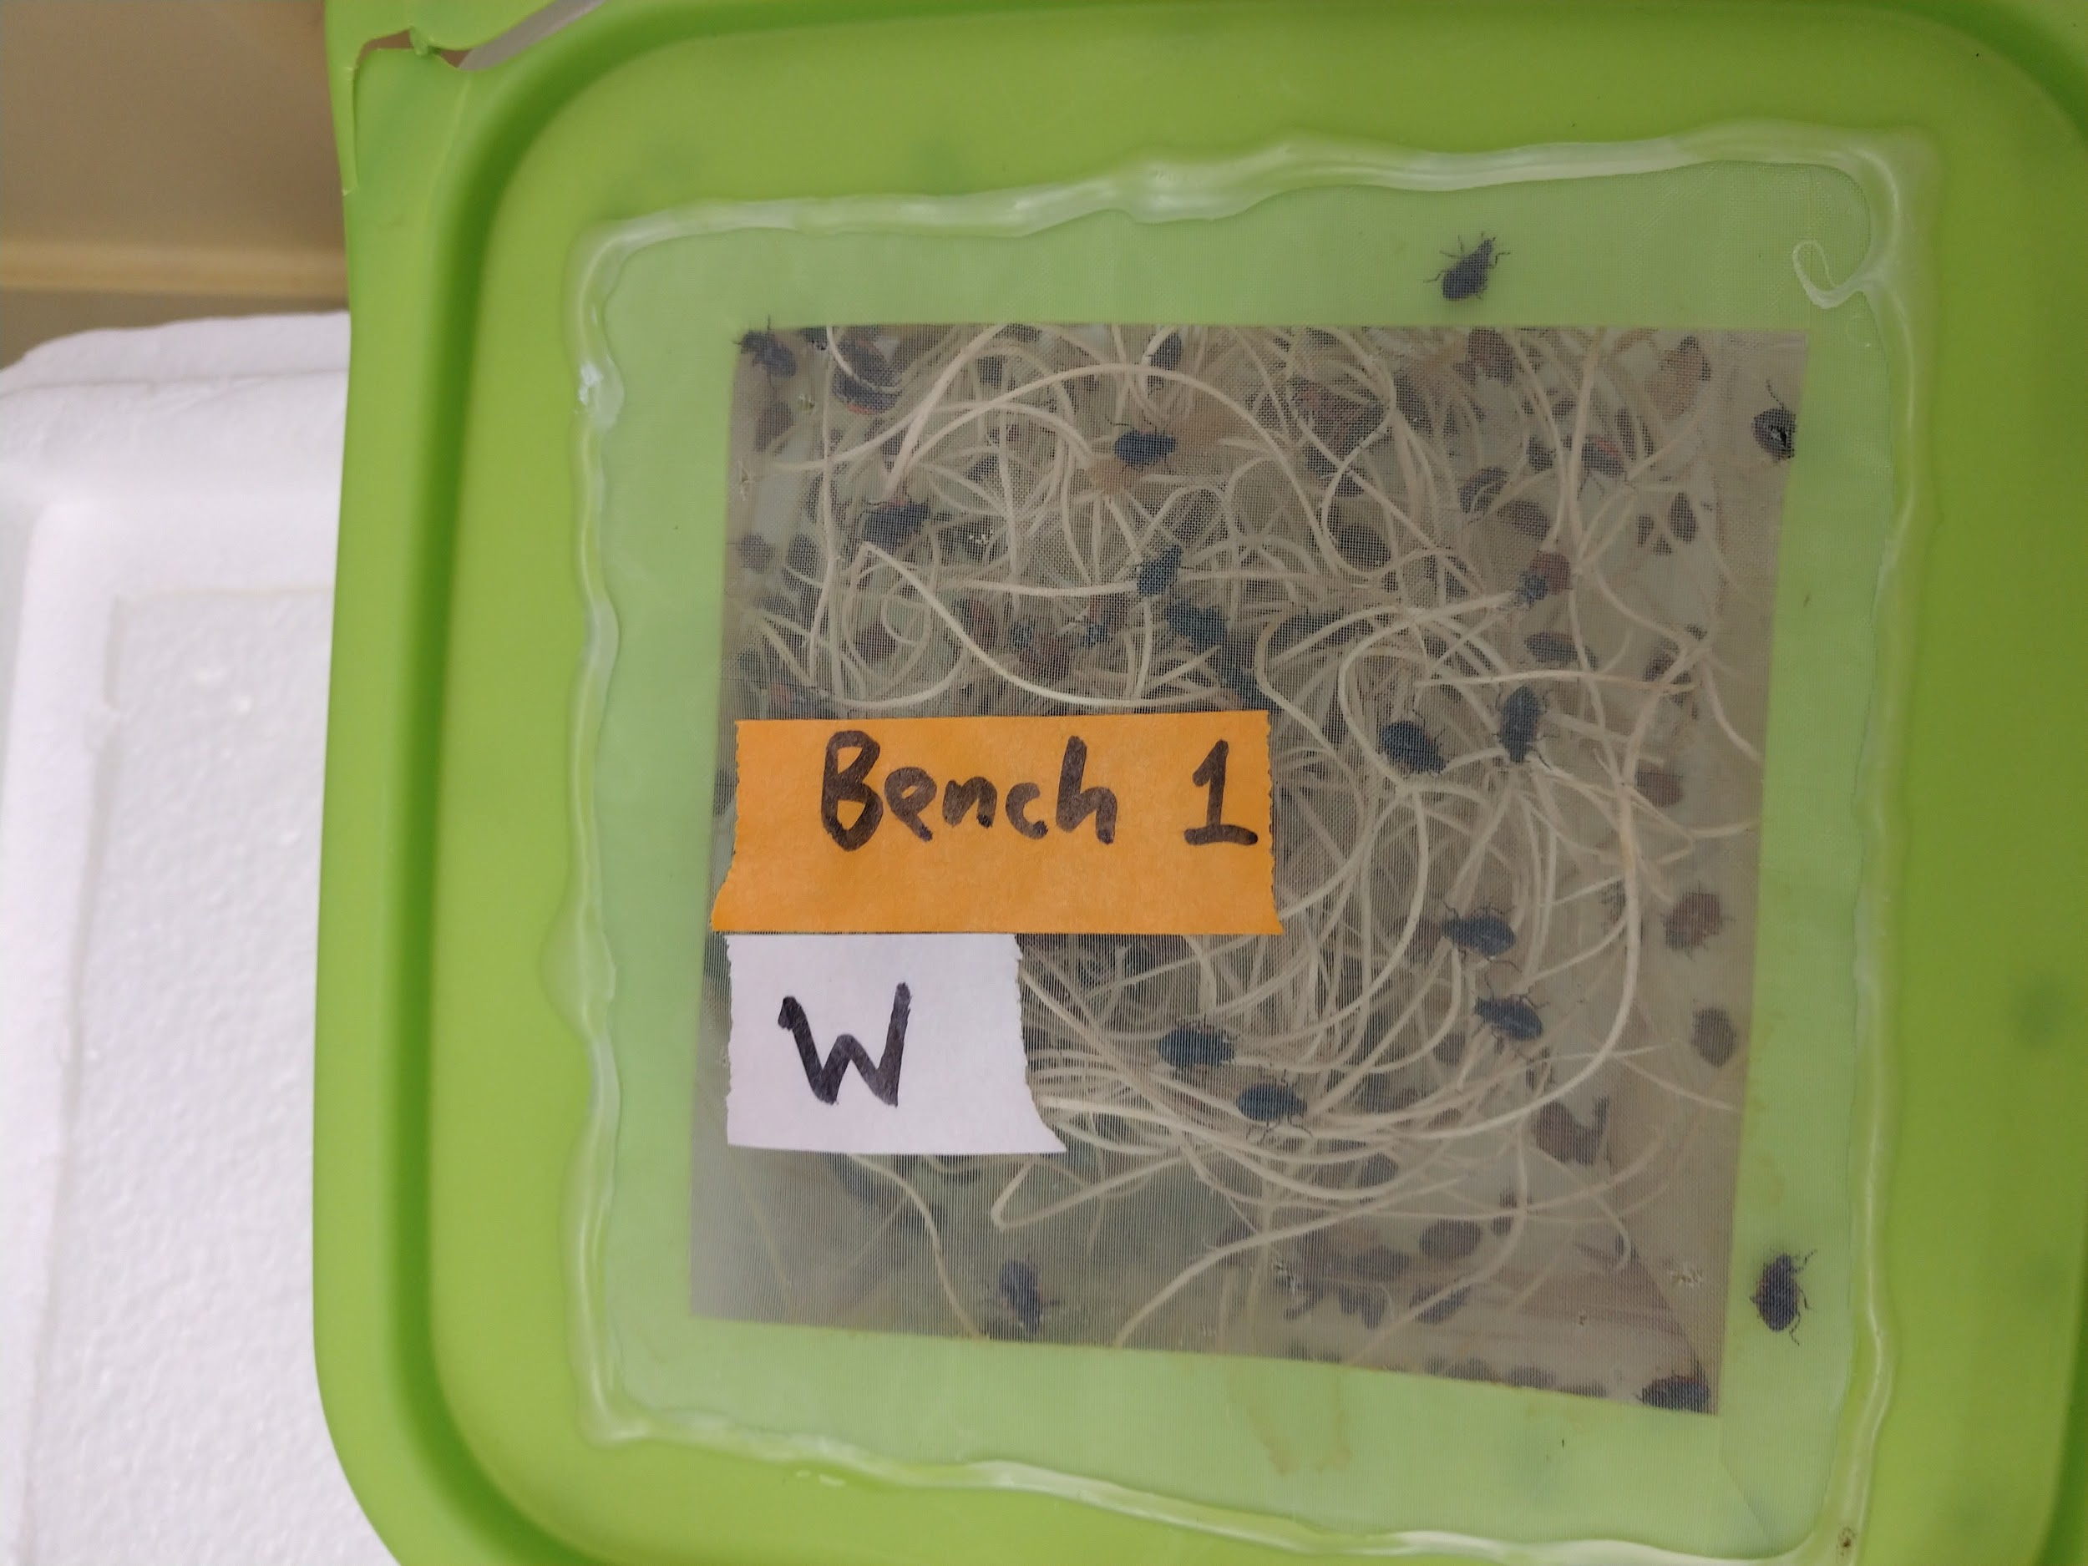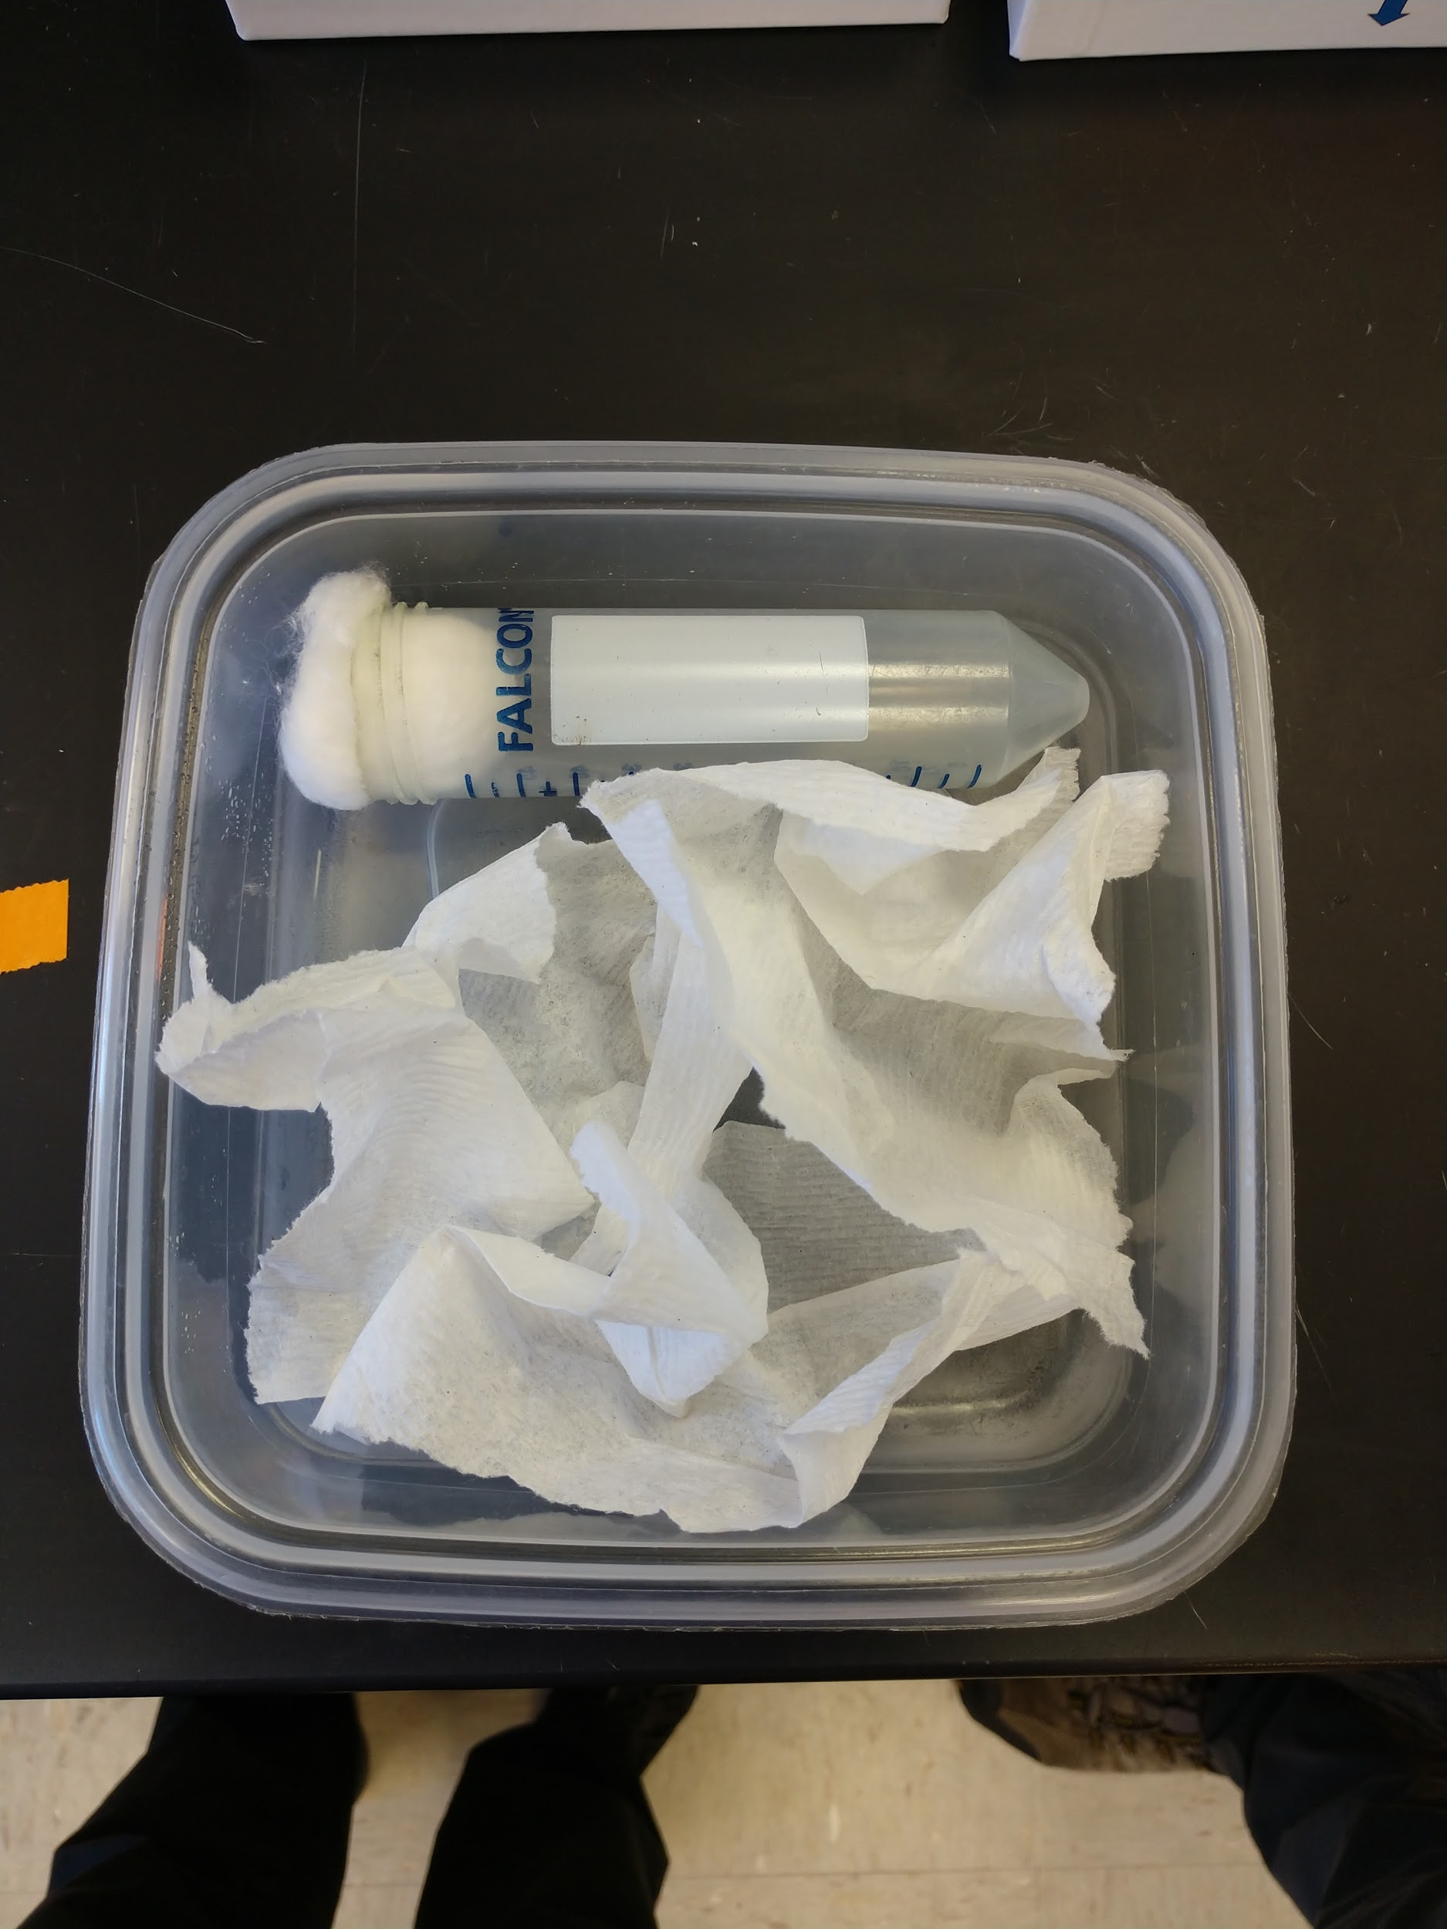

Placing beetles into chill coma - Protocol tips:

- To chill beetles, a styrofoam box filled with crushed ice may created, although other methods may be used. 15mL conical tubes were used, 8 beetles/tube. Cotton should be loosely packed into the tube to keep beetles in bottom portion of tube and thus immersed in ice. It is critical that the tubes be secured so that beetles be submerged in ice for the entire time period; if the tubes float or bob in such a way that the beetles can access a portion of the tube that is above the ice, they will not enter chill coma.

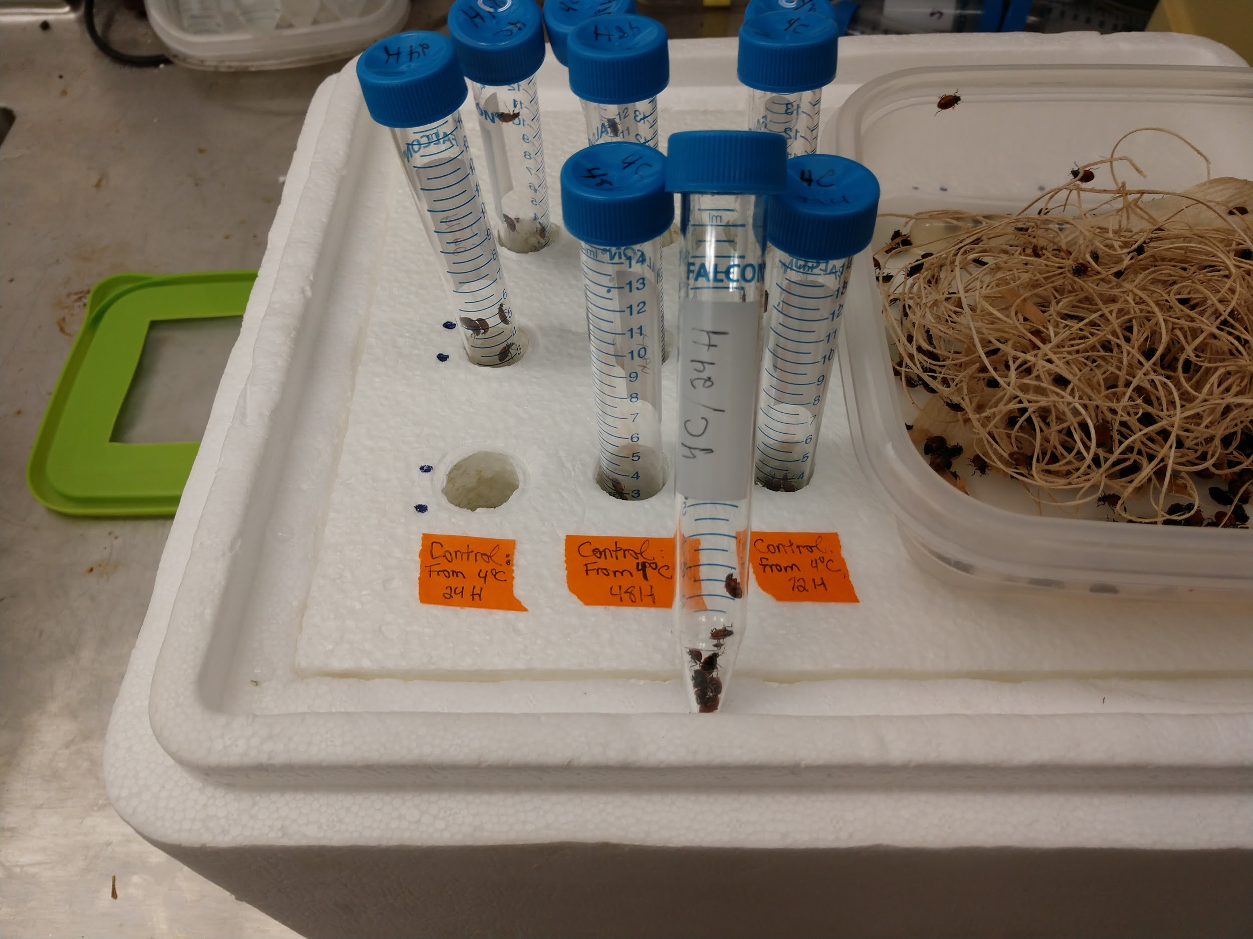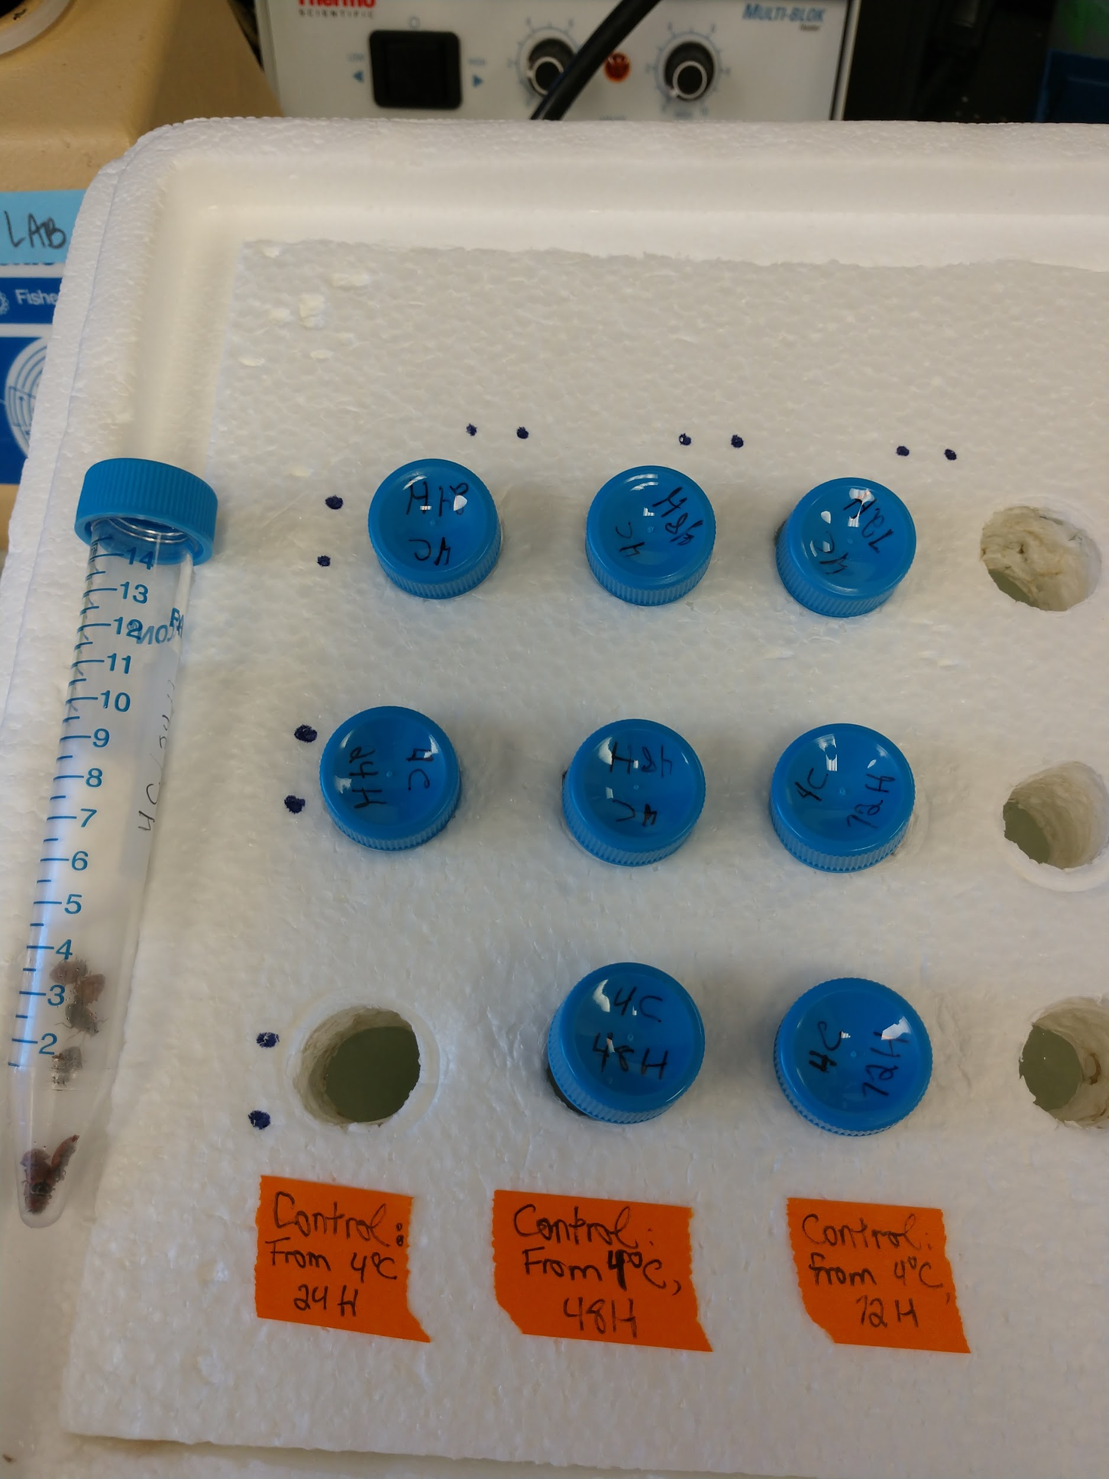

- Lady beetles may be transferred with fingers or by using featherweight soft forceps (Bioquip item #4748 or 4750). Grab beetles by the leg!

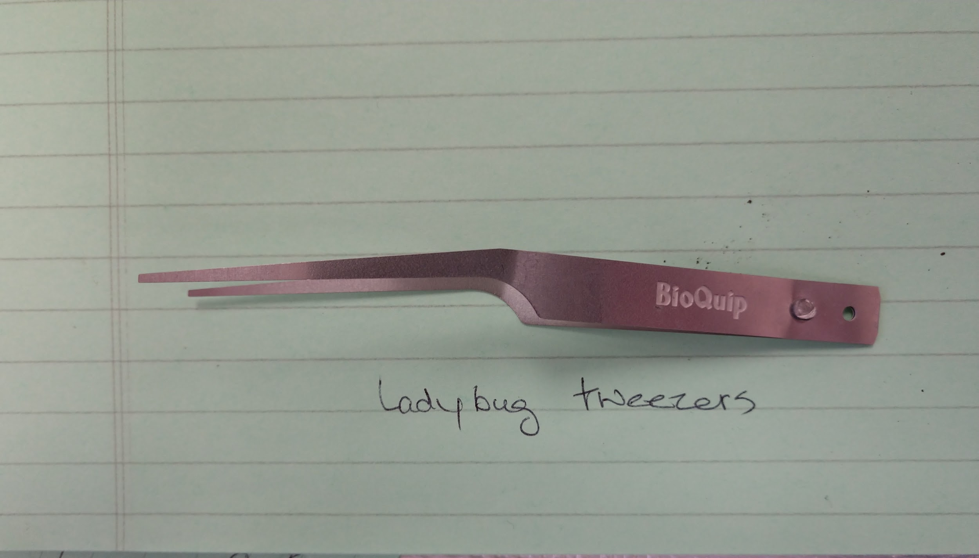

Lesson choreography:
- Ideally students should transfer beetles into vials, although the teacher could prep them as well (this would be time-consuming on the teacher’s part). Beetles become active very quickly when removed from the refrigerator. Work quickly but calmly. Beetles may be re-refrigerated to slow them down if necessary.
- 8-10 beetles is a reasonable number for a pair of students when evaluating Chill Coma Recovery Time (CCRT).

Lady Beetle Lab:
Measuring Chill Coma Recovery Time (CCRT)

Protocol: Recording Chill Coma Recovery Time (CCRT)

- Set up an “arena” to assess CCRT. The arena can be a round piece of filter paper or any other clean, dry, flat and smooth (i.e. non-folded or wrinkled) piece of paper. Secure the edges to the lab bench with tape to prevent movement or vibration.

- Have the following ready for each student pair:
- Arena (see above)
- Timing device (ideally a smartphone with “lap” capability in stopwatch)
- Blank data table
- Pen or pencil
- Paper towel (to dry the tube)
- Forceps (hard style to remove cotton; soft to capture bugs)
- 1 individually labeled microfuge tube for the fastest-recovering beetles
- 2 individually labeled microfuge tubes for the two slowest-recovering beetles

3. Beetle manipulation/data collection tips and suggested practice:
- When emptying tube, do it close to the arena, but don’t touch arena.
- Beetle Catcher: As soon as beetles have been emptied onto arena, use closed forceps tip to flip beetles onto their backs and space them at least 2 cm apart. Only manipulate beetles if necessary; those that are already on their backs and reasonably spaced should not be handled. (The goal is to stimulate the beetles as little as possible, as stimulation can alter their CCRT).
- Other tips to avoid excess stimulation of beetles: don’t lean closely to beetles and breathe on them; avoid tapping the vial or the arena; avoid vibrating the lab bench.
- When picking up beetles, pick them up from the top, not the side, to avoid pushing them into other beetles or vibrating the arena. Place removed beetles into original vial unless directed otherwise.
- Watcher/Timer: As soon as all beetles are on their backs and spaced, start the timer. If using the “lap” feature on your smartphone stopwatch, hit “lap” every time a beetle completely rights itself.

4. CCRT PROCEDURE: After 24 hours:
- One student is the watcher/timer; the other student is the Beetle catcher.
- Have stopwatch ready to start.
- Beetle catcher pulls one 24-hour tube, QUICK wipe with paper towel to dry the exterior; unscrew the cap; remove cotton plug; tip beetles out onto arena.
- Beetle catcher makes sure all beetles are flipped on back and spaced (see above). AS SOON AS all beetles are on back and spaced, Watcher/Timer starts timing.
- Record the time at which each beetle completely rights itself. If using the “lap” feature on a smartphone stopwatch, just tap “lap” without stopping the stopwatch.
- Beetle catcher needs to remove each recovered beetle from the arena without disturbing other beetles.
→ The first recovered beetle goes into individual microfuge vial labeled “F1”.
→ The next 7 beetles go back in the conical tube in which they were frozen.
→ The last TWO beetles go into individual microfuge vials labeled “S1” and “S2.”
- Watcher/Timer stops time after all beetles are righted, or after 15 minutes have gone by.
- Students transfer time data to blank data tables. Clearly indicate any beetles that were unable to right themselves after 15 minutes.

Data can now be graphed and analyzed as directed by the teacher.

