SIMULATING NATURAL SELECTION

Robert P. Gendron
Biology Department
Indiana University of Pennsylvania
Indiana, PA 15705
rgendron@auxmail.iup.edu
rpgend01@gmail.com

This is a board game that simulates natural selection. It is an alternative to more expensive software-based labs and is suitable for an introductory biology class. It would also be suitable for more advanced classes where you could go into more detail on important principles such as the role of variation and mutation. There are some Instructor’s Notes at the end of this document.

You are free to use and modify this lab in your own courses with the following provisions:
1. I would appreciate it if you let me know if you use the lab and how it worked. (Any comments and suggestions would be appreciated as well.).
2. Some mention is made of where the lab came from, even if it is modified.
3. If the lab is sold to students (e.g. as part of a lab manual) this be done at cost and not for profit.

SIMULATING NATURAL SELECTION

Robert P. Gendron
- Indiana University of Pennsylvania

We know from the fossil record that species change (evolve) over time. Darwin argued, and this has subsequently been confirmed, that the primary mechanism of evolutionary change is the process of natural selection. Given that evolutionary theory is the most important unifying principle in biology, the importance of understanding natural selection is obvious. The problem is that under most conditions this process is relatively slow, occurring over many generations. Fortunately, with the help of a simulation we can study how natural selection works in a relatively short time.

For many years biologists have used simulations as a tool for understanding ecological and evolutionary processes. These simulations can be extremely complex and require the use of a computer, or they may take the form of relatively simple "games." In this lab you will play a game that simulates the interaction between a population of predators and its prey over several generations. By the end of the exercise you should have a better understanding of how natural selection changes the genetic make-up of a population.

You will recall that several conditions are necessary for natural selection to occur:

1. VARIABILITY. Individuals within a population must be different from each other. These differences may involve characteristics such as resistance to cold, susceptibility to disease, photosynthetic efficiency or the ability to attract a mate, to name just a few.

2. HERITABILITY. Some of the variability between individuals must have a genetic basis. Thus offspring will tend to resemble their parents and have the same traits.

3. DIFFERENTIAL REPRODUCTION. Individuals with some traits will leave more descendants than others. This could be either because they survive longer (e.g. faster animals are better at escaping from predators) or because they have a higher reproductive rate (e.g. a bird with more colorful plumage may attract more mates.)

It should be obvious that, given these conditions, the traits of successful individuals will gradually become more common in the population. In effect, the environment "selects" some traits over others.

In this simulation you will look at the evolution of two traits, camouflage in a prey population and visual acuity in predators. Each individual within a population has a number that indicates the effectiveness of its camouflage (if it is a prey) or vision (if it is a predator). During the simulation surviving individuals will periodically reproduce. As in nature, offspring are similar, but not identical, to their parents. In this simulation selection results from differential mortality; prey with poor camouflage are more likely to be killed by predators and predators with low visual acuity are more likely to die of starvation.
Playing the Game

The game is played on a board divided into 5 rows and 5 columns. Each animal is represented by a piece of paper with a number written on it to indicate the animal's camouflage or visual acuity. Different color paper will be used for predators and prey. Each round begins by randomly placing the predators and prey on the board. Predators then search for prey within their square and, if successful, reproduce. Predators that do not catch any prey within two rounds starve. At the end of each round those prey that have managed to survive can reproduce, but only if they are not too crowded.

Each student at a table has a different task. If there are fewer than four students some of these tasks can be combined.

a. The GAME MASTER has the primary responsibility for carefully reading the instructions and ensuring that each step is performed properly, and in the correct sequence. In case of questions ask your instructor before continuing. If the instructions are not followed to the letter the simulation will fail and you will have to start over.

b. The RANDOMIZER reads numbers off a random numbers table. These numbers are used when placing animals on the board randomly at the beginning of each round. The use of a random numbers table is analogous to rolling dice. It adds an element of chance to the simulation.

c. The DISTRIBUTOR is in charge of placing and removing pieces from the board. The random numbers read by the second person determine where a particular piece is placed.

d. The RECORDER cuts up and labels additional pieces as they are needed. This person should also record and graph the results as they come in.

SETUP:

Before you can begin the simulation you need to prepare the game pieces. Cut out 1" squares of paper. Use a different color for predators and prey. If you put a bend in them as shown in Figure 1 they will be easier to pick up. You need 16 prey and 16 predators to start, but you will need more as the game progresses. At the beginning of the game the prey vary from easy to detect (a score of 2) to well camouflaged (8). Similarly, the predators vary from 2 to 8 in visual acuity. Label the prey and predator pieces as described in Table 1. The initial frequency distribution of each population is shown in Figure 3 at the end of this chapter. In addition, predator pieces must have a number to indicate when they were born. Put a small 0 on each predator's piece to indicate that it was born in the Setup Round. If these predators have not eaten by the end of Round 2 they will starve.

Figure 1. Two game pieces, a prey with a camouflage score of 5 and a predator with a visual acuity score of 8. The predator was born in round 0. If it does not feed in round 1 or 2 it will starve.

Table 1. Initial Frequency Distribution of Traits in Predator and Prey Populations. This shows the number of prey and predators with a particular camouflage score or visual acuity, respectively. See Figure 3.

Camouflage / Vision Score |  | # Prey Pieces | # Predator Pieces
Worst 2 |  | 1 | 1
3 |  | 2 | 2
4 |  | 3 | 3
5 |  | 4 | 4
6 |  | 3 | 3
7 |  | 2 | 2
Best 8 |  | 1 | 1
 | Total # Pieces: | 16 | 16

What is the average camouflage score of the prey population ? ________

What is the average visual acuity of the predator population? ________

Keep in mind that these numbers are starting values. After a couple of rounds the scores may be much higher. Scores can go above 8 but they cannot go below 0.

ROUND 1:

Here is where the animals are actually placed on the board and begin to interact with each other. Take your time with this round as you learn the rules of play. Subsequent rounds will go faster. Be sure to ask your instructor if any of the instructions are not clear.

a. DISPERSAL. Use the table of random numbers to put each animal in turn on the board. You can begin anywhere on the table and read numbers from top-to-bottom or left-to-right. Each pair of numbers represents the coordinates of one of the squares on the board. For example, if the number is 25 place the animal in column 2 - row 5.

b. PREDATION. After all animals are placed on the board each predator now has a chance to eat and reproduce, but only if there is a prey in the same square with a camouflage score less than the predator's visual acuity. For example, a predator with a visual acuity of 6 will detect and eat a prey with a camouflage score of 5, but not one with a score of 7. If the predator and prey have the same number flip a coin to see who wins. Remove dead prey immediately. After a predator eats it then reproduces as described in (c) below.

If there are more than one predator and/or prey on a square these rules apply:

- If there are two predators the one with the greatest visual acuity will see the prey first and eat it.

- If there are two prey, the one with the poorest camouflage will be seen and eaten first.

- A predator can eat only one prey. It then reproduces and dies (see below).

c. PREDATOR REPRODUCTION. When a predator eats it obtains enough energy to produce two offspring. Then it dies and is removed from the board. Remember that in nature parents and their offspring tend to resemble each other but are not identical. To simulate this let one of the two offspring have a visual acuity score greater than the parent by 1 (there in no upper limit to visual acuity). Give the second offspring a score that is one less than the parent, but no lower than 0. If there are any uneaten prey still in the square the offspring can immediately eat them (and reproduce themselves) if their visual acuity is high enough. Thus, you could have several generations of predators in one round.

Mark each new offspring with the round in which it was born (in this case round 1). Figure 2 illustrates an example of an interaction (steps b and c) within one square on the board.

Figure 2. A predator with a visual acuity of 8 eats a prey with a camouflage of 5 and then reproduces and dies.

d. STARVATION. Normally in step (d) predators that had not eaten in two rounds would starve. In Round 1, however, none of the predators have been around long enough so skip this step for now.

e. PREY REPRODUCTION. All surviving prey now have the opportunity to reproduce. However, a prey can reproduce only if no other prey occupy the same square. If two prey occupy the same square there is not enough food to supply the energy needed for reproduction. However, prey do not starve. They survive into the next round. (The presence of predators in the square does not prevent a prey animal from reproducing since predators do not compete for the same food eaten by the prey.)

Reproduction by prey is the same as in predators. Each prey is replaced by two offspring, one of which has better camouflage (by 1) and one of which has worse camouflage (by 1), except that camouflage can never drop below 0.

f. RECORD RESULTS. At the end of each round calculate the average scores for surviving predators and prey. Record these numbers in Table 2 NOW!

ROUND 2:

Round 2 is similar to Round 1 except now any predators that have not eaten in two rounds will starve.

a. Did you record the average scores of predators and prey after the previous Round? If so, then remove all the animals from the board and, using the random numbers table, redistribute them as you did before.
b. Predators eat and reproduce if their square is occupied by a prey with a lower score. Label new predators with the round in which they were born (2).

c. Predators that have not eaten in two rounds starve and are removed. Since this is Round 2 any predators labeled with a 0 starve. Remove them from the board.

d. Prey reproduce as before.

e. Record the number of predators and prey in Table 2.

ROUNDS 3, 4, 5, . . . .

Repeat the steps of the previous round for as long as time permits, or until one of the populations goes extinct. Remember to remove any predators that have not eaten in two rounds and to mark all new predators with the round in which they were born.

Data Analysis

1. Figure 3 shows the initial frequency distribution for each population. Draw your final frequency distribution on the same graph.

2. On Figure 4 plot the average score of each population over time and on Figure 5 plot the size of each population over time.

Questions (Write your answers on a separate sheet in complete sentences)

1. Did the average camouflage and visual acuity increase or decrease? By how much?

2. Compare the initial and final frequency distributions in Figure 3. Did the variability of the two populations change? By how much? (Hint: an approximate measure of variability is the range of scores for each population.)

3. You probably noticed that there is an element of chance in this simulation that can cause the average scores to fluctuate erratically. Explain. Give two examples of chance events that might affect the course of evolution in nature.

4. If the initial size of each population was much larger (e.g. 1000 instead of 16) would the effect of chance events on evolution be more or less important? Explain.

5. Sometimes in these simulations a population will go extinct. Is extinction more likely for a small or large population? Why?

6. Did the size of the prey and predator populations change during the simulation? How and why?
Table 2: Record the average score and number alive at the end of each round. You may complete more or less than 10 rounds depending on time.

 | PREY POPULATION |  | PREDATOR POPULATION
ROUND | Avg. Score | # Alive | Avg. Score | # Alive
0 | 5.0 | 16 | 5.0 | 16
1
2
3
4
5
6
7
8
9
10

Table 3: After the last round record the number of pieces with a particular score for both predators and prey. Plot these numbers on the frequency distribution in Figure 3.

SCORE | # Prey | # Predators
0
1
2
3
4
5
6
7
8
9
10
11
12
13
14
15
16
17
18
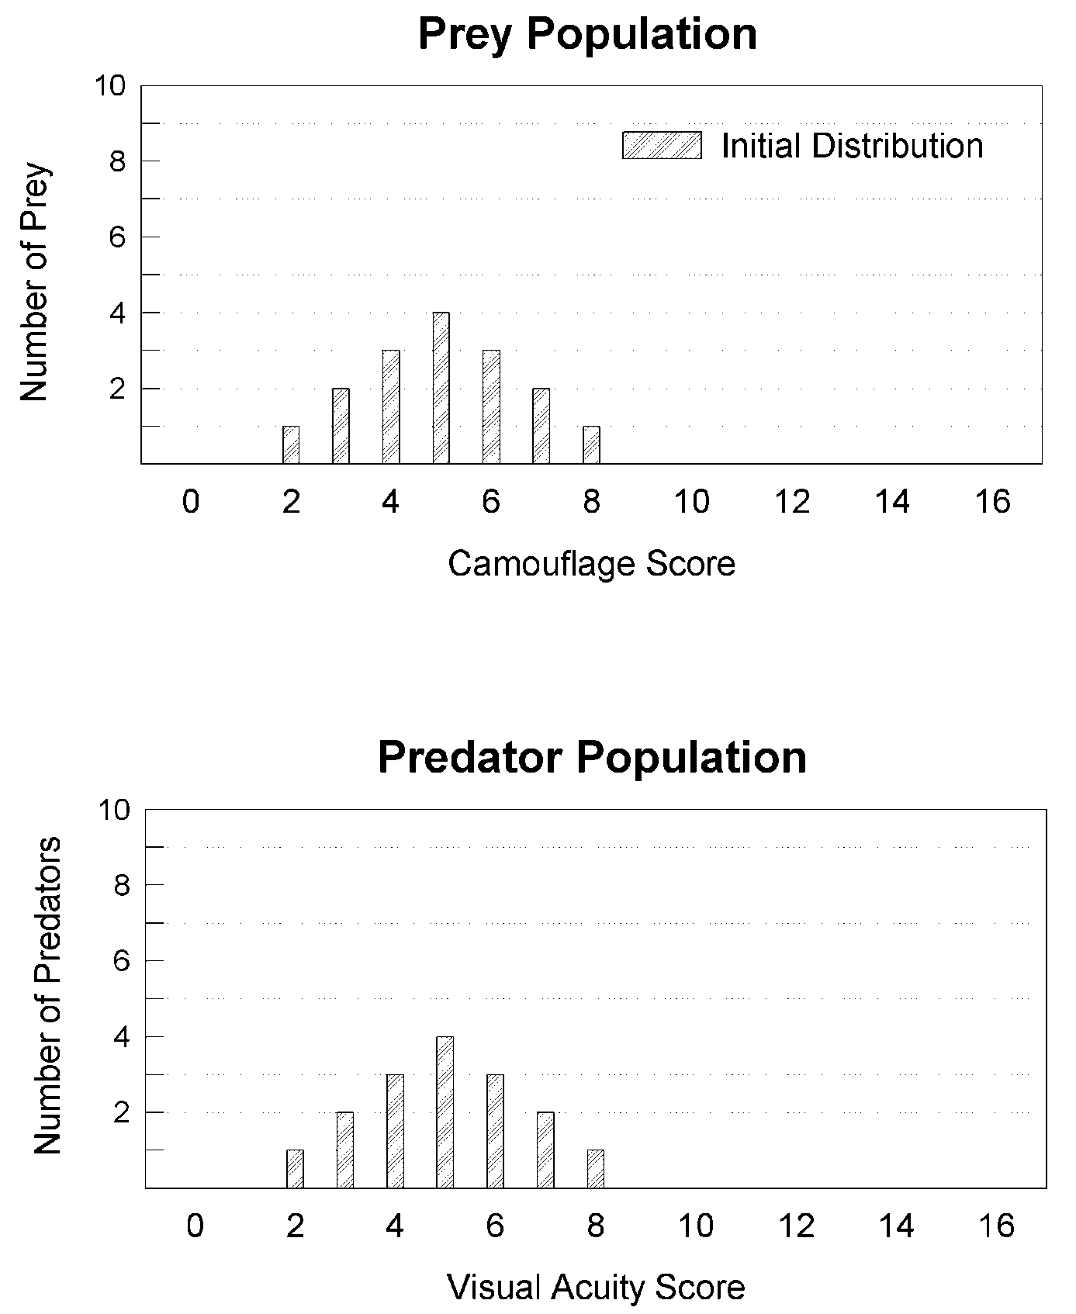

Figure 3. These bar graphs show how the scores for both species are distributed at the beginning of the game (the initial frequency distributions). The scores range from 2 to 8 with an average of 5. After the last round of the game draw the final frequency distributions on these graphs for comparison. You can place the bars of the final frequency distribution in the spaces between the hatched bars.

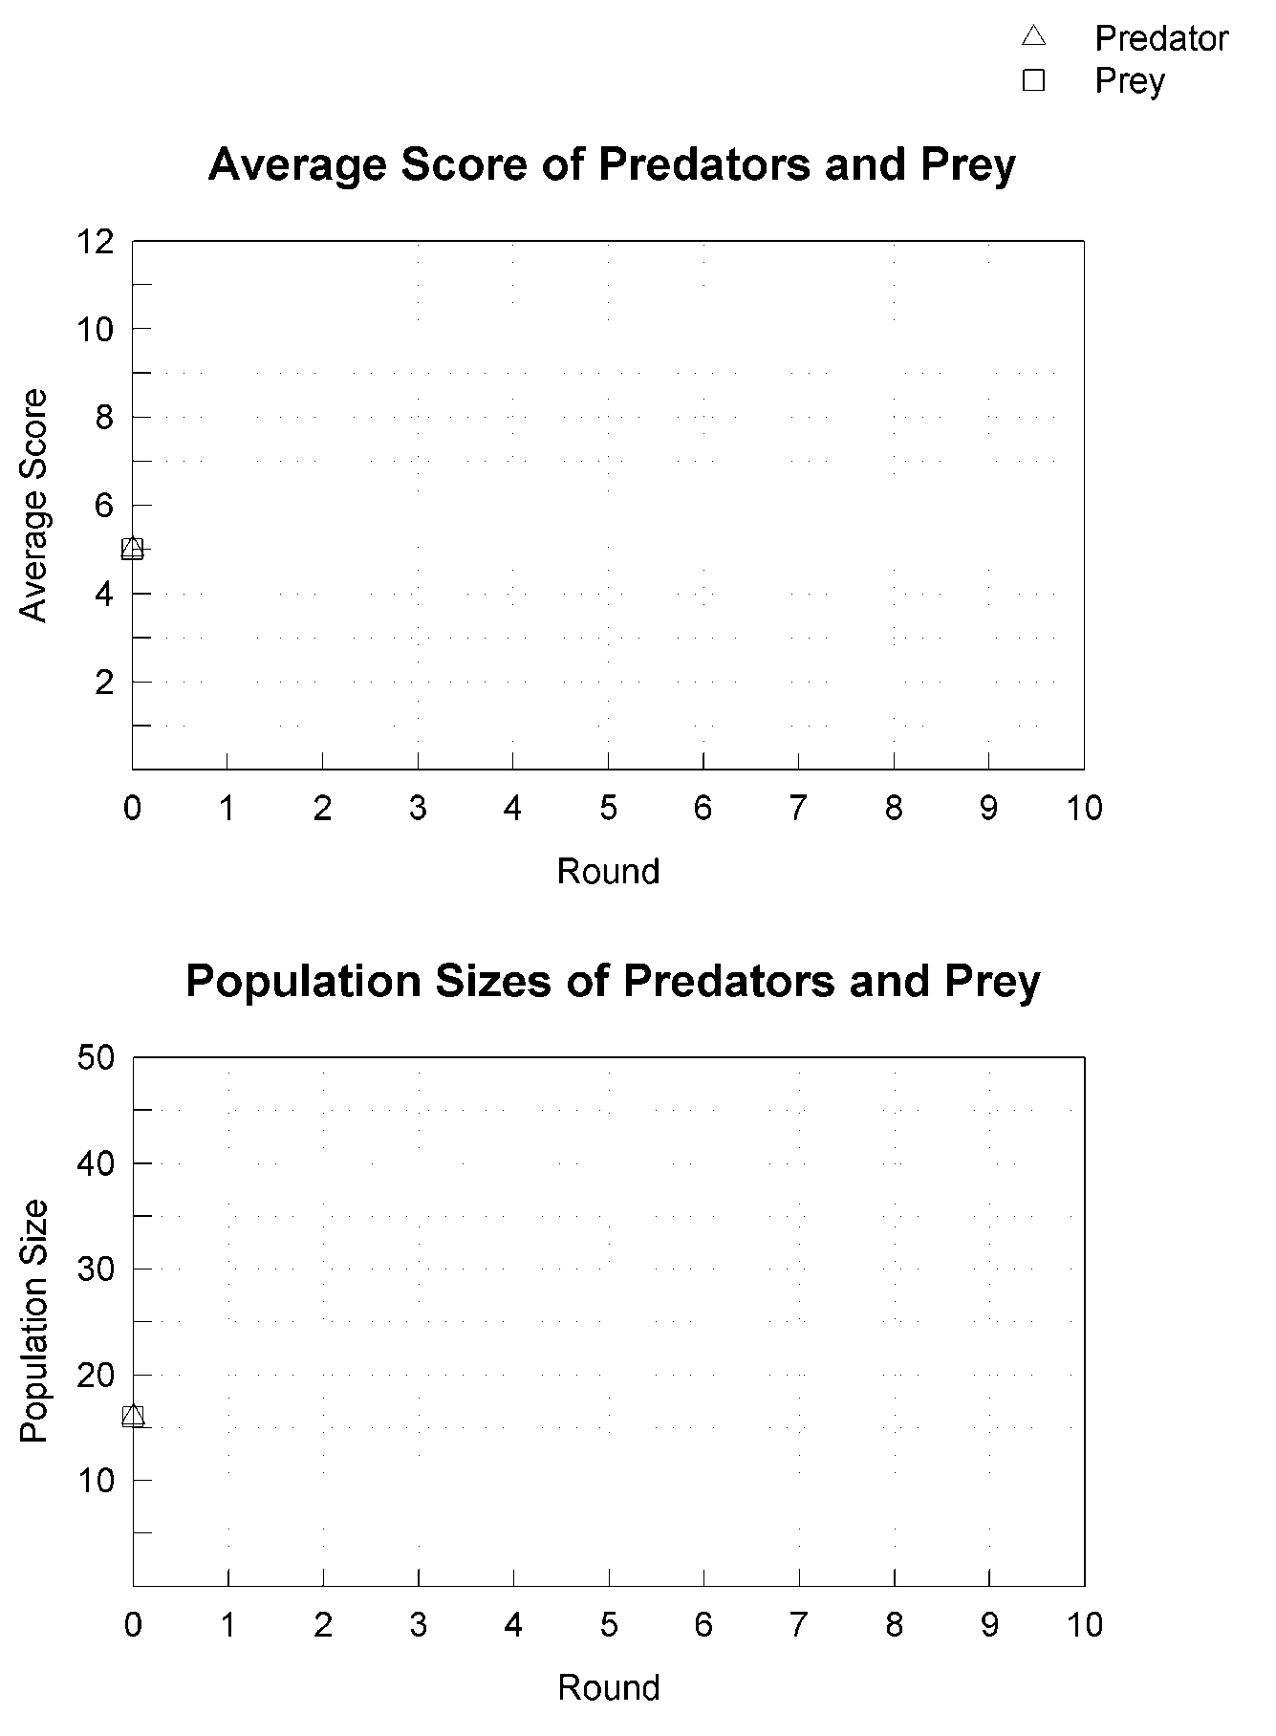
Figures 4 and 5. Plot the average score (top graph) and population size (bottom) over time. Use triangles for predators, squares for prey and then draw a line to connect them. The initial values for Round 0 are already plotted.
Random Numbers from 1-5

3 2 2 5 4 3 1 1 1 3 2 5 2 1 2 4 4 5 2 1 2 3 3 4
5 2 4 3 4 5 3 2 2 2 1 1 4 4 1 1 4 2 5 5 1 4 3 5
4 5 3 5 1 2 2 5 4 3 4 1 4 5 2 3 2 1 4 4 1 5 4 3
2 5 2 3 5 1 3 3 3 1 5 3 3 1 2 3 2 4 1 3 2 1 5 2

4 3 3 3 5 1 3 4 3 3 5 5 2 3 5 3 4 4 1 5 3 3 3 1
1 5 5 4 4 2 1 4 3 2 5 1 3 5 1 4 2 2 4 1 2 2 5 2
4 2 3 3 3 3 4 3 3 1 3 1 1 4 4 4 2 4 5 5 5 3 3 3
4 3 5 1 5 4 3 1 1 3 4 2 1 2 3 3 2 2 4 4 2 2 1 5

3 1 2 2 5 4 4 1 5 4 1 1 2 1 3 2 3 1 5 5 4 4 5 4
2 5 1 5 1 1 1 4 1 1 4 1 3 1 4 4 1 3 5 5 3 1 1 3
2 5 2 3 1 1 2 2 1 3 2 1 2 3 5 4 5 1 4 1 2 4 2 3
5 1 5 3 1 4 4 4 4 2 5 3 4 4 5 1 3 3 3 3 4 3 3 1

2 3 3 1 5 4 1 3 3 5 2 2 2 2 5 4 4 4 1 3 2 3 5 2
3 2 4 2 4 2 2 5 2 3 4 4 3 3 3 3 3 3 4 4 5 2 3 4
1 5 5 1 3 1 3 1 4 3 3 5 5 4 5 2 4 2 5 4 1 2 1 1
1 4 4 2 4 1 3 4 3 1 4 2 3 1 2 3 1 1 3 1 3 1 2 3

4 1 1 4 1 2 1 5 2 5 4 1 3 2 4 1 4 4 1 3 1 5 1 5
1 1 2 5 2 3 5 2 2 5 3 5 3 2 2 1 4 3 5 4 5 1 3 3
1 1 3 3 2 5 1 5 4 2 2 2 4 2 2 1 1 3 1 4 1 4 2 2
2 4 3 4 5 4 1 5 1 4 4 1 2 1 3 4 5 5 5 1 3 4 5 2

2 5 2 5 3 3 4 3 4 1 2 4 4 5 2 4 3 1 3 5 2 3 3 4
5 5 3 1 4 4 4 5 5 3 4 2 1 2 1 2 3 1 5 1 1 1 2 2
2 1 5 3 4 5 4 5 3 1 3 5 5 5 5 3 4 3 1 3 2 4 4 3
1 5 5 2 3 2 3 4 5 3 4 3 3 5 2 2 1 3 4 2 4 3 2 3

4 4 1 1 3 2 5 2 3 5 4 5 4 1 3 4 5 2 1 1 1 2 2 4
2 3 1 1 5 4 1 5 2 1 2 1 4 5 4 1 3 1 2 5 3 2 2 1
3 1 5 1 2 5 2 4 5 4 2 1 2 1 2 4 1 4 3 2 3 4 5 1
5 2 3 3 5 4 5 2 2 4 5 4 5 2 4 1 4 4 3 3 3 3 4 2

4 4 3 1 1 2 1 4 3 2 4 1 5 3 4 5 4 1 1 5 5 3 2 3
4 3 5 4 1 3 3 1 1 2 1 5 4 5 5 1 1 1 1 3 1 2 1 1
3 2 2 4 3 1 3 3 4 2 4 4 5 2 1 4 4 1 5 1 2 1 5 1
3 5 2 4 4 1 2 5 3 4 5 2 1 5 4 4 4 1 5 1 4 1 1 3

3 3 3 3 3 2 3 4 1 1 2 4 4 4 5 5 5 3 4 1 3 1 1 1
5 5 2 5 3 4 4 1 2 2 1 3 5 2 1 5 2 2 1 3 2 4 5 5
4 5 2 1 3 3 5 5 3 1 4 3 2 5 5 2 4 5 2 5 3 3 3 4
4 3 2 1 3 1 5 4 2 3 4 3 4 5 3 1 3 1 3 2 4 3 1 2

SIMULATING NATURAL SELECTION

SETUP AND INSTRUCTOR NOTES

Supplies

Game Boards 1 per table
Scissors 2 per table
Random Numbers Table 15-20 copies per lab
Paper 2 reams per lab (2 colors)

Instructions

Game boards can be made of poster board which is at least 16” x 16” is size. Using a meter stick draw 5 columns and 5 rows approximately 3” apart. Label the columns 1-5 across the top and bottom. Label the rows (1-5) down both the left and right sides.

Supply each lab with several reams of paper obtained from the office. Half the paper should be white and the remainder should be another color (e.g. blue or yellow).

This exercise simulates genetic drift (random fluctuations in gene frequencies) as well as natural selection (see discussion topic 2 below). This randomness is the natural result of using a random numbers table and the flip of a coin. For fun, and to add a little excitement to the exercise, the instructor can play the role of a natural disaster which, like a landslide or fire, destroys individuals without regard to their “fitness.” Simply reach out and sweep part of the board clean of pieces. For dramatic effect do this without warning. The startled students should be receptive to a discussion of the role of chance events in evolution.

Class Discussion

To facilitate class discussion I first have each group plot the average scores on the board. This results in two graphs, one for the predators and one for the prey, with one line for each group.
Average
Score
Possible discussion questions include:

1. What is the mode of selection?

Directional

2. Why aren't the curves smooth?

There are actually two processes going on simultaneously. Directional Natural Selection and Genetic Drift. The latter refers to chance events that result in random fluctuations in allele frequencies within a population.

Answers to Questions

1. Did the average camouflage and visual acuity increase or decrease? By how much?

In virtually every case that I have seen the average score for camouflage and visual acuity does increase after several rounds. There is a large element of chance in the game however, so the amount of increase varies each time you run the game. In this question I simply want the students to tell me how much the average score increased.

2. Compare the initial and final frequency distributions in Figure 3. Did the variability of the two populations change? By how much?

In many cases the variability of the scores within a population increases (sometimes it decreases). That is to say, the frequency distribution in Figure 3 becomes more spread out. I use this question because I want to familiarize the students with the concept of population variability as opposed to just averages. Many non-science majors are mathematically unsophisticated so I simply suggest they look at the width of the frequency distribution as a measure of population variability. More advanced students could calculate the change in variance of each population from the beginning to the end of the game. There is no single correct answer here; sometimes variability increases and sometimes it decreases. The point is simply to get the students to look at the data in a little more depth than they otherwise would.

3. You probably noticed that there is an element of chance in this simulation. Explain. Give two examples of chance events that might affect the course of evolution in nature.

Chance plays a big part in the outcome of the simulation. A prey individual with a low camouflage score may survive if it is lucky enough to occupy squares that do not have any predators. A predator with excellent visual acuity might starve if it always lands on empty squares. In nature, these sorts of chance effects in evolution are referred to as GENETIC DRIFT. Genetic drift refers to random fluctuations in allele frequencies in a population. For example a hurricane might kill genetically superior individuals who happen to be in the wrong place at the wrong time. Their genes are thus eliminated from the population for reasons other than natural selection. Natural disasters like fire can similarly change gene frequencies. Chance also plays a role in finding mates and successfully rearing offspring. In fact, even sexual reproduction plays a role in genetic drift since each allele has only a 50% chance of being passed on to any particular offspring.

4. If you increased the initial size of each population to 1000 (with a corresponding increase in the size of the board) would this increase or decrease the importance of chance events on the final outcome? Explain.

Increasing the size of a population, whether in nature or in the simulation, would decrease the importance of chance events (i.e. genetic drift). By analogy, if you flip a coin 10 times it is not very surprising if it comes up heads 7 times (70%). However if you flipped the coin 1000 times (i.e. increased the size of the population) you would very surprised if it came up heads 700 times. To put it another way, in a small population, one chance event can have a relatively large effect on the average score (i.e. allele frequency). In a large population, however, chance events that change the allele frequency in one direction tend to be balanced by chance events that change the allele frequency in the opposite direction.

5. Sometimes one of the populations in this simulation will go extinct. Explain how the probability of extinction in nature is related to population size.

Small populations are at greater risk of extinction. Small populations tend to be more localized so natural disasters (drought, fire, flood) or other environmental changes are more likely to wipe them out.

6. Was there any pattern to the changes in the size of the two populations? What would you expect to happen in natural populations?

This question refers to Figure 5. At this point in the course our students have already learned about population growth and predator-prey population cycles such as that exhibited by the lynx-hare system. Sometimes we see the beginning of a similar cycle in this simulation.

