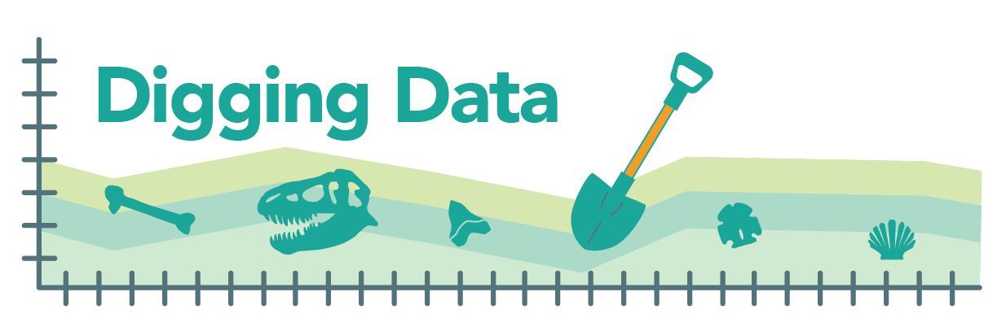
Digging Data: Sexual selection
The venomous female redback spider – also known as the Australian black widow – poses a danger to humans … and to male redback spiders, which are often eaten by their mates. Males seem go out of their way to make this happen, flipping themselves over and presenting their abdomens to the female while mating. This behavior might at first seem like one that selection would act against. After all, how could risking one’s life be adaptive?
Maydianne Andrade, evolutionary biologist and Professor and Vice Dean at University of Toronto Scarborough

Remember that evolutionary fitness is about getting genes into the next generation, not just survival. Sexual selection is a “special case” of natural selection, where selection acts on an organism's ability to obtain a mate or successfully mate. This process may produce traits that decrease an organism's chance of survival, while increasing its chances of mating and producing young. Perhaps the extreme mating behavior of male redback spiders is favored by sexual selection because it gives males a fitness boost. But what advantage could it offer? Biologist Maydianne Andrade made observations and designed a set of experiments to find out.

Background. Male redback spiders deliver their sperm to females using specialized mouthparts. If the female is hungry, she will eat the male during the mating process. In the wild, this happens about 65% of the time. Females often mate with more than one male and can store sperm (sometimes for years!) to use later. Females produce multiple egg sacs throughout their lives, each of which can contain hundreds of eggs. Different eggs in a single egg sac may be fertilized by sperm from different fathers.
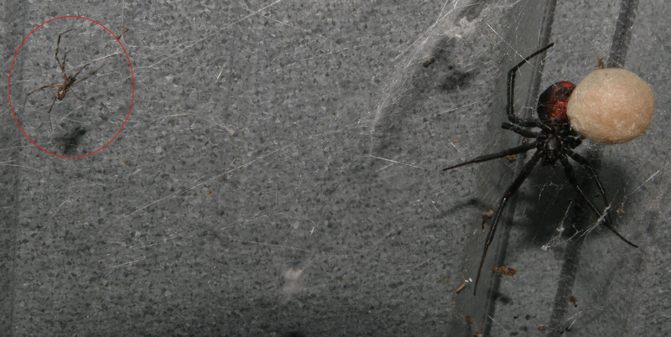
Female redback spider with egg sac at right. Much smaller male (circled) at left.

Hypotheses: There are several explanations that could lead to the evolution of males’ risky mating behavior:
- The nutrients provided by eating the male are passed on to the eggs/offspring. In this scenario, sexual selection would favor males that offer themselves up as a meal because those males would leave behind more or perhaps more robust eggs that are more likely to hatch into live spiderlings.
- Eating one’s mate decreases the likelihood that a female will mate again with another male. In this scenario, sexual selection would favor the risky behavior because males that allow themselves to be eaten would prevent later matings and, thus, would father more of a female’s brood.
- Males that are eaten mate for longer and so fertilize more of a female’s eggs. Perhaps eating a mate takes time, or perhaps females simply allow mates that offer up their abdomens to mate longer. In either case, evolution would favor the risky behavior if it allows a male to father more of the female’s offspring than do males that do not offer up a snack.
Maydianne made observations and carried out experiments to test each of these hypotheses.

Data:
Hypothesis 1 – Does a female’s “snack” give a boost to her eggs? In captive redbacks in the lab, Maydianne compared the number of eggs in and weight of egg sacs from matings where the male was eaten to those from matings in which he was not. Here are her data:

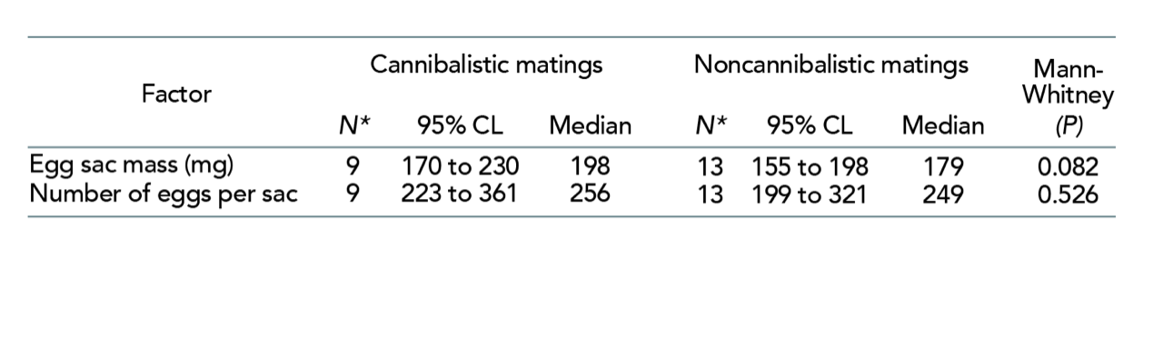
The 95% CL (confidence level) is the range within which the true value is likely to fall (i.e., in 100 cases with similar data, the true value is within this range in 95 of the cases). The Mann-Whitney test looks at whether two samples are likely to come from sources with the same median. The p value of this test indicates the probability that the two samples come from sources with the same median (i.e., are *not* different).

Hypothesis 2 - Did eating a mate decrease the odds that a female would mate again with a different male? In the lab, Maydianne observed females’ first and subsequent matings and collected the following data:
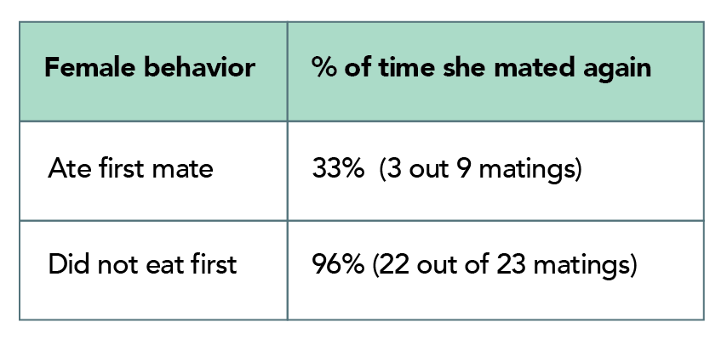

Hypothesis 3 – Does self-sacrifice pay off with paternity? Maydianne also observed and timed matings in the lab, and then determined the paternity of the eggs that the female ultimately produced. Maydianne focused on the second male to mate with a female. She thought that a male allowing himself to be eaten might pay off in terms of paternity, particularly if he were able to mate for longer if cannibalized. She observed that cannibalized second males mate for much longer (a median of 25 minutes) than second males that are not eaten (and mate for a median of just 11 minutes). Here are data from 10 matings:
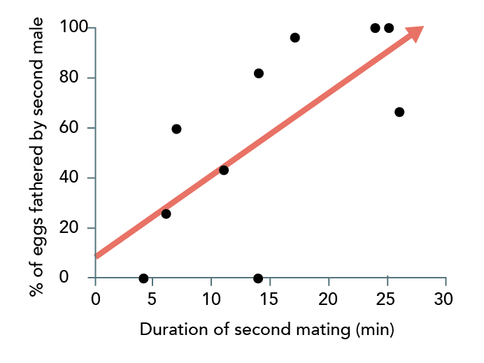
Each black dot represents one mating. The red arrow represents the regression line for these data.

Stepping into science: Maydianne started doing research as an undergraduate. She got interested in studying invertebrates, since she could mimic their natural environments in the lab. She was particularly curious to learn what males contribute to their mates and offspring – so when her Master’s advisor told her about the strange behavior of male redback spiders, she was intrigued. And when she realized she’d be able to escape the Canadian winter and visit sunny Australia, she was sold!

Reference: Andrade, M. C., B., (1996). Sexual selection for male sacrifice in the Australia redback spider. Science. 271: 70-72. (http://comportamento-animal.weebly.com/uploads/2/2/6/0/22602398/cannibalism_spiders.pdf)

Comprehension questions:
- What is the “surprising” behavior that male redback spiders perform? In terms of evolution by natural selection, why is it surprising?
- In your own words, explain what sexual selection is. Research and briefly explain a trait in a different organism (i.e., not the redback spider) that might reduce an individual’s chance of survival but be favored by sexual selection.
- Maydianne investigated three hypotheses that might explain the male redback spider’s surprising behavior. Each relies on sexual selection. Explain the similarities and differences among the three hypotheses in your own words.
- Are the three hypotheses mutually exclusive – that is, could only one be true, or could more than one be true? Explain your answer. If you said that more than one could be true at the same time, explain which of the hypotheses could co-occur and how they might operate at the same time.

Data interpretation questions:
- If hypothesis 1 were true, what would you expect to observe if you compared egg clutches laid by females who ate their only mate to egg clutches laid by females who did not eat their only mate.
- Examine the data relating to hypothesis 1. Do these data support the hypothesis, contradict the hypothesis, or do neither? What aspect(s) of the data lead you to that interpretation? Explain how the p value given in the last column of the table affects your interpretation.
- If hypothesis 2 were true, what subsequent behavior would you expect to observe if you compared females who ate their first mates to females who did not eat their first mates?
- Examine the data relating to hypothesis 2. Do these data support the hypothesis, contradict the hypothesis, or do neither? What aspect(s) of the data lead you to that interpretation?
- If hypothesis 3 were true, what would you expect to observe if you compared the lengths of time that cannibalized and non-cannibalized males mate? If hypothesis 3 were true, what would you expect to observe if you compared length of mating to the percent of eggs in a clutch fertilized by that male?
- Examine the data relating to hypothesis 3. Do these data support the hypothesis, contradict the hypothesis, or do neither? What aspect(s) of the data lead you to that interpretation? How confident are you in this interpretation? Explain how the number of observations made affect your confidence.
- In your own words, explain what explanations for the evolution of male redback spiders’ self-sacrificial mating behavior are supported by the evidence presented here.

