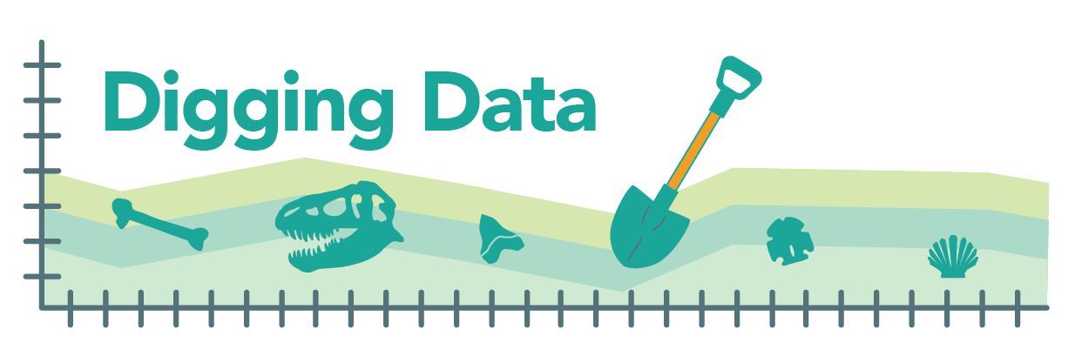
Digging Data: Extinction
Extinction is a fact of the history of life. Just as new lineages have evolved over Earth’s history, so, too, have lineages gone extinct. This balance of speciation and extinction has generated turnover in the set of species alive at each point in time. Biologists have long wondered if there are patterns in this churning of biodiversity. In particular, are there factors that predispose a species to extinction? Answering this question has taken on urgency as we face what is shaping up to be the Earth’s 6th mass extinction, caused not by meteorite impacts or volcanic activity, but by humans. If we could figure out which species are most vulnerable to extinction, perhaps we could work out better ways to protect them.

Biologists have already found that large body size is a risk factor for extinction. Several intuitive hypotheses could explain this. Larger organisms often reproduce more slowly, producing fewer offspring and taking longer to mature, so they can’t bounce back as quickly if their numbers are reduced. Larger organisms also often have smaller population sizes to begin with and require a larger home range to sustain those populations, putting them at risk of extinction if part of that range is made uninhabitable. This pattern (increased risk of extinction with larger body sizes) has been observed in several different animal groups. For example, among living bird species, birds with larger bodies are more likely to be at higher risk of extinction. Biologists Melissa Kemp and Elizabeth Hadly wondered if it might also hold true for lizards in the Caribbean, a biodiversity hotspot, over the last few million years. Are larger body sizes associated with greater risk of extinction in Caribbean lizards?
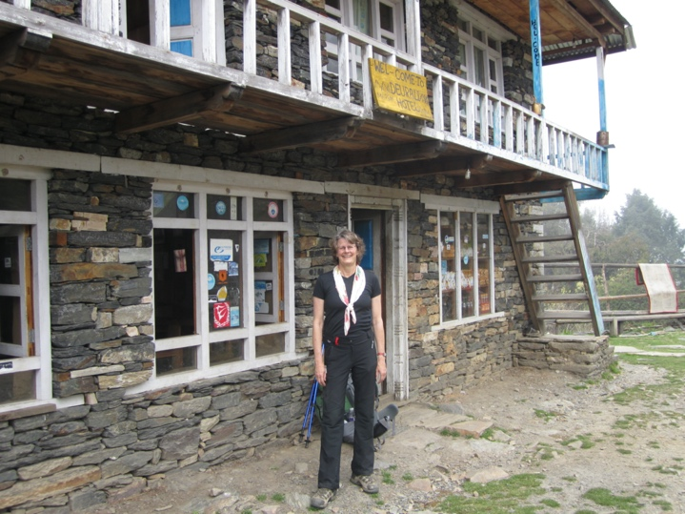
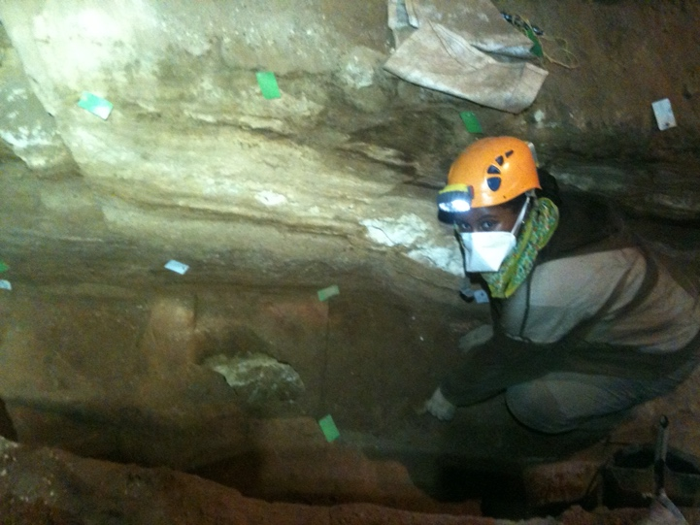
At left, Melissa Kemp, Assistant Professor at the University of Texas at Austin, excavating a cave site in the Caribbean. Photo provided by Melissa Kemp. At right, Liz Hadly, Professor at Stanford University, in Nepal while doing fieldwork on Pikas. Photo taken by Uma Ramakrishnan.

Hypotheses: Melissa and Liz investigated their question using statistical tests that rely on a null hypothesis. A null hypothesis proposes that there is no difference or no association between variables. If your statistical tests rejects the null hypothesis, then you know that the patterns in the data are not due to chance alone and are likely meaningful. Hence, the team’s null hypotheses were:
1) Extinct Caribbean lizard species have the same distribution of body sizes as living Caribbean lizard species. Larger species are not particularly likely to have gone extinct over the last 2.6 million years.
2) Among modern Caribbean lizards, threatened species have the same distribution of body sizes as those not at risk of extinction (i.e., species of “least concern”). Among modern species, larger species are not particularly likely to be at elevated risk of extinction.
Testing these null hypotheses required comparing data from modern lizard species to data from fossils. However, this introduced a potential bias to the study. What if larger or smaller species are more likely to show up in the fossil record? That could cause a pattern in the data – one that Melissa and Liz might mistake for extinction bias, when it was really preservation bias (which species are more likely to fossilize). To rule out this possibility, Melissa and Liz needed to check one more null hypothesis:
3) Caribbean lizard species known from fossils have the same distribution of body sizes that those known from modern-day field studies. Fossilization is not size-biased.
This table summarizes all three null hypotheses:
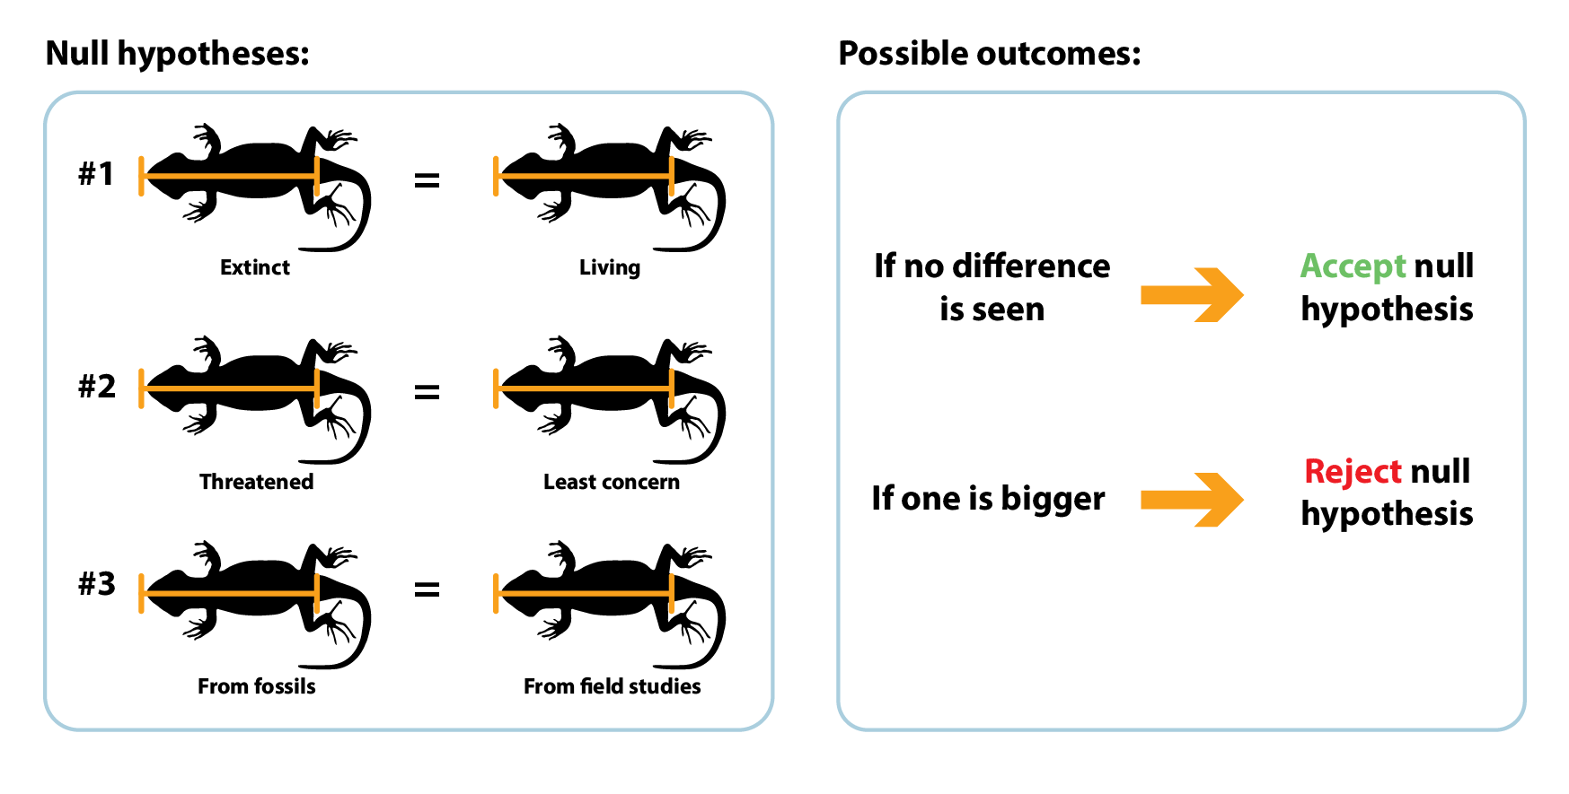

Data:
To test their hypotheses, Melissa and Liz needed a lot of data on body size in both modern and ancient Caribbean lizards, as well as information about which species went extinct and which are currently threatened with extinction. Luckily, a lot of these data had already been collected by other researchers. Melissa and Liz put together their data set from previously published studies, estimating the body size of extinct lizards from the sizes of fossilized bones and closely related modern species. Body size was indicated by the distance between the tip of a lizard’s snout and its cloacal slit – aka, the snout-vent length (SVL). They used math to convert the data into a form that makes patterns easier to see. They divided modern species into “threatened” or “non-threatened” based on their conservation status according to the IUCN (International Union for Conservation of Nature) Red List.
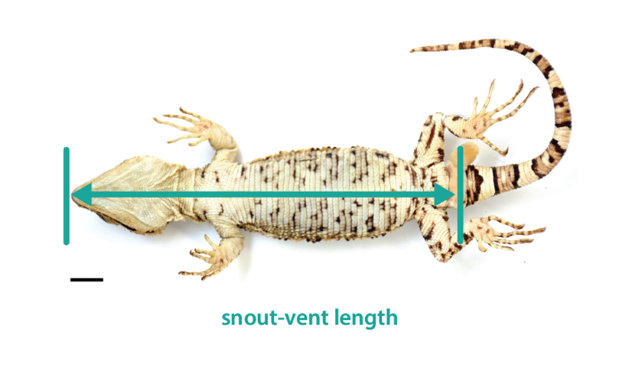

Testing null hypothesis 3 – Do species known from fossils have the same range of sizes as species known from modern field studies? Though this question was not the main point of the study, knowing its answer would be key in interpreting the data for null hypothesis 1.
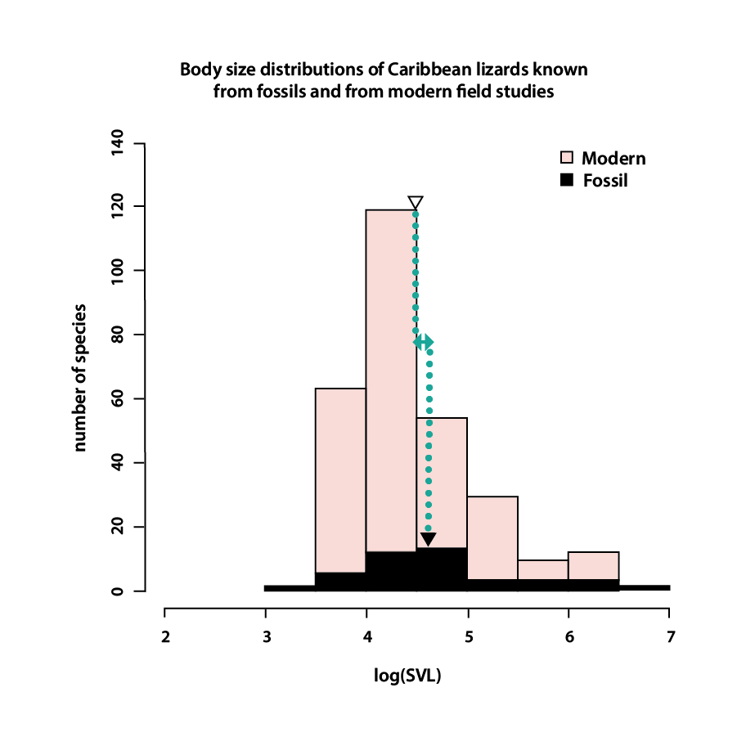
Graph 1

It’s clear from this graph (and its much taller pink bars) that there are lots more species known from modern field studies than from studies of fossils. But does one group tend to have larger species than the other? Body size is shown on the x-axis. The triangles in the graph above represent the mean body size for each group, and they appear to be similar (see blue annotation). Statistics can tell us if that small difference is likely a meaningful pattern or one that could easily be due to chance alone. Melissa and Liz calculated the likelihood that two samples come from the same underlying distribution (i.e., are statistically “the same”). The p-value was 0.11, indicating that 11% of samples drawn from the same distribution would differ by this much or more just by chance alone. The usual cut-off for a significant difference is less than or equal to 5%, so they did not reject this null hypothesis, meaning that the small differences between the size of modern and fossil species in this sample could easily be caused by chance alone and not by a true difference between the overall sizes of the groups. In other words, fossilization does not appear to be size-biased in this group. That meant that whatever patterns Melissa and Liz found while investigating their other hypotheses are likely to represent real differences in body size and extinction risk.

Testing null-hypotheses 1 and 2 – Do extinct and threatened species have the same distribution of body sizes as living and “least concern” species?
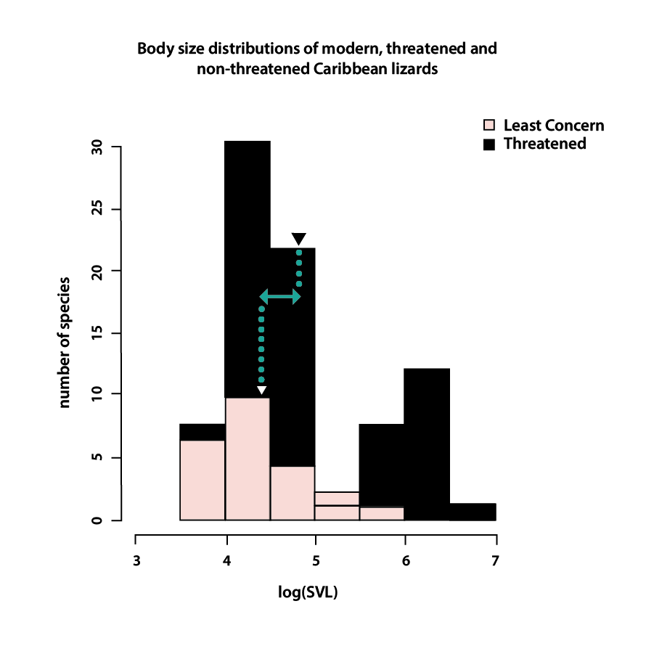
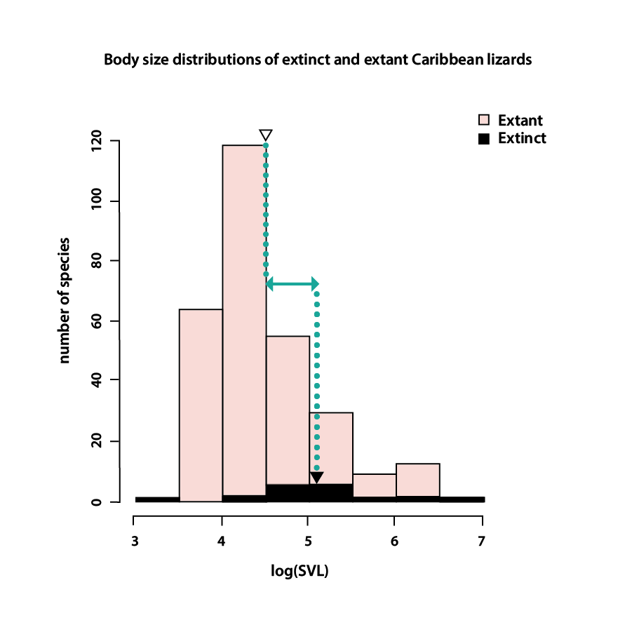

Graph 2 Graph 3

In these graphs, the triangles again represent the mean body size of each group. At left, in the blue annotation, we can see that extinct species tend to have larger body sizes than extant (living) species. At right, we can see that threatened species tend to have larger body sizes than species of least concern. Are these differences significant? Melissa and Liz’s statistical tests showed that they are. Fewer than one in a thousand samples drawn from the same distribution would have had the observed or greater size differences between extinct and extant species (p < 0.001) by chance alone. And fewer than three in a thousand samples would have had the observed or greater size differences between threatened and least concern species (p < 0.003) by chance alone. This means that it is extremely unlikely that the observed size differences occurred by chance alone, and much more likely that there were true differences between the two sample sets. The researchers’ data led them to reject both of their other null hypotheses: extinct Caribbean lizard species are larger than living Caribbean lizard species, and threatened Caribbean lizard species are larger than “least concern” Caribbean lizard species.

This is yet another line of evidence suggesting that body size matters when it comes to extinction – larger Caribbean lizard species are more likely to have gone extinct in the past and are more likely to be threatened or endangered today. What we still don’t fully understand, however, is why? Do large, slow-reproducing lizard species evolve slowly and so don’t adapt to environmental changes as efficiently as smaller species? Is it that they require larger home ranges and are more vulnerable to extinction via habitat loss? Answering these questions will shed even more light on what we can do to optimize our conservation efforts.

Stepping into science: Melissa loves to paint and draw. She thought she would grow up to be an artist. Today she finds that the approaches that informed her art – her appreciation for nature, perseverance, and eye for detail – make her a better scientist too! Liz didn’t set out to be a scientist either. She had never had a science or math teacher who was a woman, so couldn’t picture having that job. Now she’s the role model she didn’t have as a girl!

Reference: Kemp, M. E, and E. A. Hadly. (2015). Extinction biases in quaternary Caribbean lizards. Global Ecology and Biogeography. 24: 1281-1289.

Glossary:
Bias - In the context of data interpretation, a factor that unfairly causes data to support a particular interpretation or a tendency to interpret data in an unfair way that supports a particular hypothesis.

Extant - Not extinct, currently living.

Extinction - An event in which the last members of a lineage or species die. A single species goes extinct when all members of that species die. An entire lineage goes extinct when all the species that make it up go extinct.

Extinction bias - The tendency for certain lineages or lineages with certain characteristics to go extinct more or less often than others.

Mass extinction - Event in which many different lineages go extinct around the same time. Mass extinctions involve higher rates of extinction than the usual rate of background extinction that is going on all the time.

Null hypothesis - Hypothesis that proposes that there is no difference or no association between variables.

Preservation bias - An elevated or lowered tendency for certain organisms to be preserved in the fossil record.

Threatened - In the context of extinction, at high risk for extinction in the wild.

Comprehension questions:

- Based on the opening paragraph of this article, does extinction appear to be a typical phenomenon of life on Earth, or an unusual event? Explain your answer.
- The article states that “biologists have already found that large body size is a risk factor for extinction.”
- What intrinsic (related to the organisms themselves) reasons are suggested to explain this?
- What extrinsic (related to the organisms’ place in their environment) reason is suggested to explain this?

- What is the key question that Melissa Kemp and Elizabeth Hadly are seeking to answer?
- Explain what a “null hypothesis” is, in your own words.
- What is the difference between Melissa and Liz’s first two null hypotheses? Why are both relevant to answering their key question?
- Why is the third null hypothesis needed?
- Melissa and Liz gathered data sets about the snout-vent length (SVL) of both extant and extinct lizard species. What did they do to the data to help organize it and make it easier to compare?
- What does Graph 1 tell you about the size of fossil lizards, compared to the size of modern lizards? Is the difference statistically significant?
- What does Graph 2 tell you about the body size of extinct lizard species compared to the body size of extant species? Is this likely to be a true difference, or could it be due to chance alone?
- What does Graph 3 tell you about the body size of threatened lizard species, compared to the body size of lizards of “least concern”? Is this likely to be a true difference, or could it be due to chance alone?
- Does Liz and Melissa’s study support or refute the statement, “biologists have already found that large body size is a risk factor for extinction”? Explain your reasoning.
- What important question do biologists still have about extinction in Caribbean lizards?

Specifically, they took the logarithm of the SVL for all their lizard species. This changes the magnitude of each data point, but keeps the relationships among data points the same (e.g., the largest raw number is still the largest after converting the data using logarithms).
They used a Kolmogorov-Smirnov test to calculate this value.

