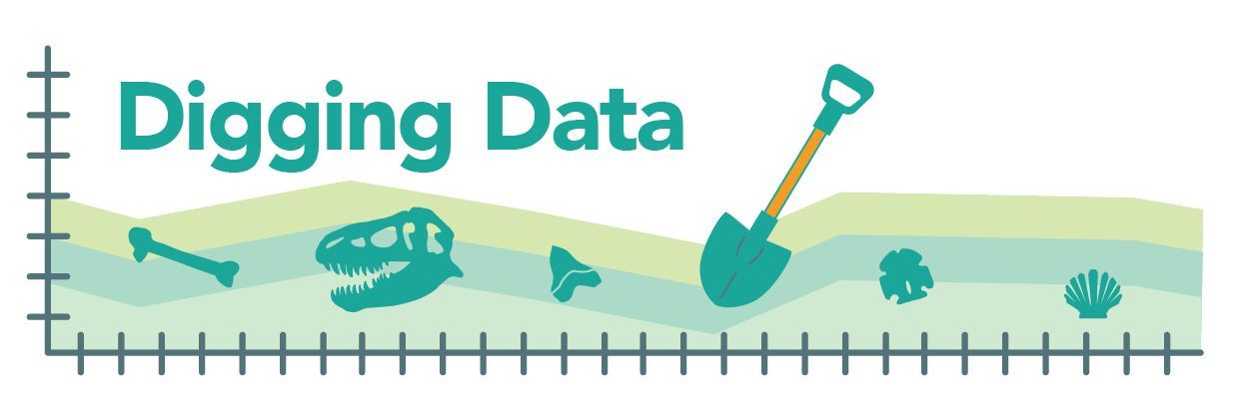
Digging Data: Extinction vulnerability

Most of the food we eat every day is grown or raised specifically for that purpose. Wheat is planted so we can have bread, orchards watered to provide fruit, chickens raised for meat and eggs. However, with seafood, it’s a different story. Much of what’s available at the seafood counter is pulled directly from the wild. You may already know that overfishing takes a huge toll on these populations, threatening many with extinction. For example, the Southern Bluefin Tuna, a sought-after delicacy in Japan, is classified as an endangered species. The problem is so big that initiatives such as Seafood Watch have been launched to educate people and encourage sustainable practices in the seafood industry.

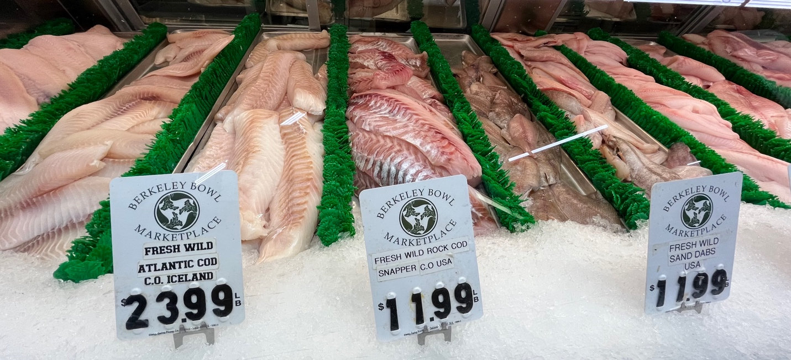
This seafood counter offers a mix of wild-caught and farmed animals. Photo credit: Anna Thanukos

But what about the less flashy (and fishy) staples of seafood counters? Bivalves – mollusks with two shells, like clams, scallops, oysters, and mussels – are not as charismatic as a tuna or swordfish but are vital to marine ecosystems. They filter and clean water; they serve as food for other animals; they store carbon; and their reefs help protect shorelines from erosion and flooding, and can provide “nurseries” for other marine life. Are conservationists so focused on restoring crashing fish populations that threatened bivalves are being overlooked?

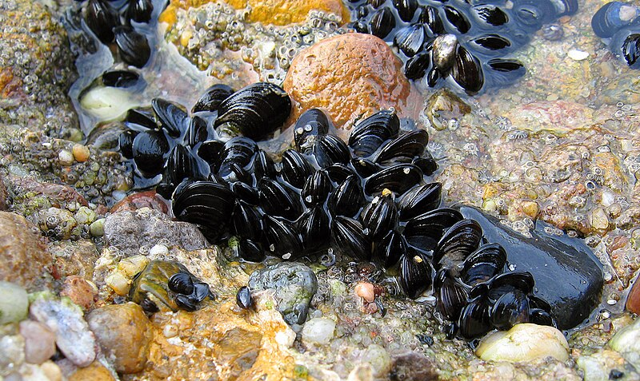
Blue mussels in the intertidal zone. Photo credit: https://commons.wikimedia.org/wiki/File:Blue_mussel_Mytilus_edulis.jpg

Scientists and policymakers don’t know much about bivalves as a food source. Until recently, we haven’t done a good job of keeping track of which species are being harvested and how much we are taking – let alone checking in on the health of wild populations. There are more than 6000 species of bivalve living in the shallow waters of the world’s oceans, and for less than 50 of those have we even considered whether they are nearing extinction.

Directly assessing the risks to the 800 species of mollusk that provide food for people all over the world would be an enormous undertaking. Paleontologists David Jablonski, Shan Huang, and Stewart Edie, along with a team that included Katie Collins, Nicholas Crouch, and Kaustuv Roy, set out to give conservation biologists an idea of where to start. The team evaluated the traits of mollusk lineages to see if those that we eat have traits that might make them particularly vulnerable or resistant to extinction.

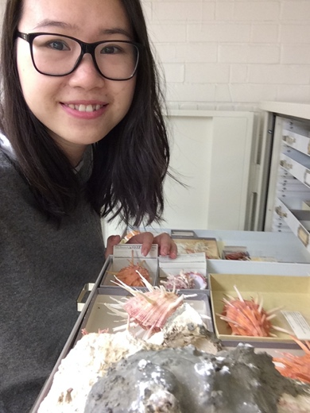
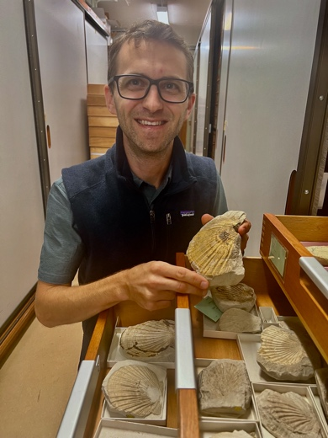
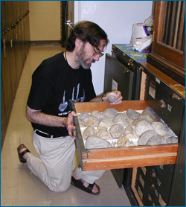

David Jablonski, Shan Huang, and Stewart Edie pose with some favorite mollusks. Photo credits (left to right): Sue Kidwell, Shan Huang, and Shan Huang

Hypotheses:
Biologists have hypothesized that the following traits might make a bivalve species more vulnerable to extinction:
- Small geographic range – If a species lives only in one restricted spot, it’s much more likely that a disaster will wind up killing every individual of the species. However, if a species has a broad geographic range, odds are that, when disaster strikes, somewhere, some individuals will survive and can replenish the population.
- Small temperature range – If a species can only tolerate a narrow temperature window, it is unlikely to survive as the Earth rapidly warms (as it is now) or cools (as it has many times in the past). Even short-term extremes, like a really bad summer month, can be lethal. Change is inevitable, so a species that can live in a wide range of temperatures has a big advantage for avoiding extinction.
- Lots of extinction among close relatives – Just as feeding habits and shell structure are passed down from ancestor to descendent, so too it seems is vulnerability to extinction. If a species belongs to an evolutionary group – a family – that has experienced a lot of extinction in the past, that species is more likely to go extinct in the future. The researchers called this overall estimate of how sensitive a species is likely to be when faced with environmental changes volatility. Mollusk families with high volatility contain many lineages that have gone extinct over Earth’s history and are known only from their fossils.

Many prior studies have shown that these hypotheses are good ones – that mollusks with small geographic and temperature ranges and high volatility are more vulnerable to extinction than others. But the team wasn’t sure how these three traits would sort out among mollusk species. They hypothesized that having larger geographic and temperature ranges would make a mollusk species more accessible to more people, and so make it more likely to be selected as a food source. However, there was no reason to suspect that harvested mollusks would come from families that were particularly extinction prone or extinction resistant.

Data:
By scouring the research literature, the scientists assembled a database of more than 6000 bivalve species, for each noting the size of its geographic range, its temperature range (i.e., the complete range of temperatures the species experiences in all the places it lives), and the extinction rate within its evolutionary family. These three factors can all affect a species’ vulnerability to extinction, but of course, they don’t always sync up. How would the team compare, for example, a species with a large geographic range from a family with lots of extinction to a species with a narrower range but from a family with little history of extinction?

To address this problem and provide an overall picture of extinction vulnerability, the researchers combined all three factors into a single score that they called PERIL (for Paleontological Extinction Risk In Lineages). PERIL scores take a little math to calculate, but all you need to know to understand them is that geographic range, temperature range, and extinction history are all weighed equally in the score and that higher PERIL scores mean higher vulnerability to extinction.

When the team mapped out the different variables and compared bivalve species we eat to those we do not, they saw some interesting patterns.

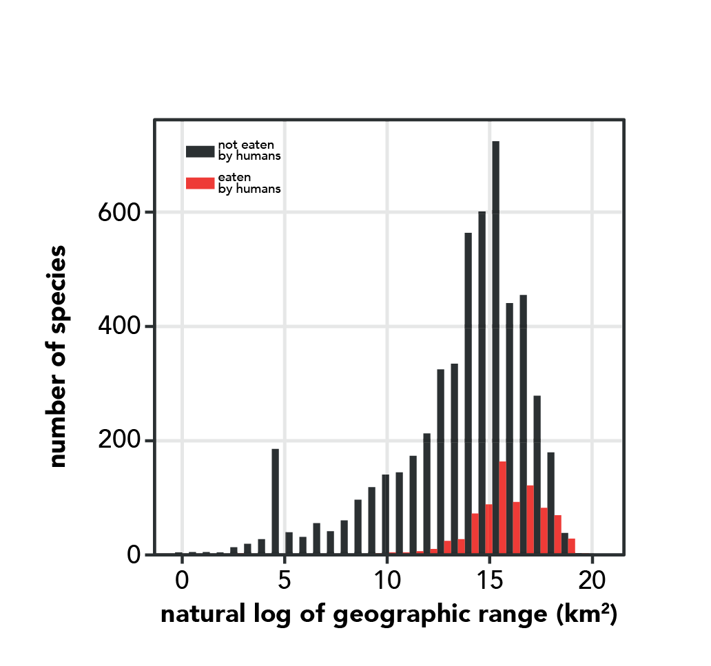
Graph 1. Adapted from Huang et al. (2023)

This graph shows the different geographic range sizes of bivalve species that we eat (red bars) versus those we do not (black bars). Geographic range is on the x-axis. Because a few species have very large ranges, the researchers used math to convert the geographic ranges to a form in which patterns are easier to see. The y-axis shows how many bivalve species there are with different geographic range sizes (i.e., how tall the bars are indicates the number of species with each geographic range size).

Statistics can tell us whether the ranges of the eaten species differ meaningfully from the ranges of the species we do not eat, or if this difference is one that could easily be due to chance alone. The team calculated the likelihood that the two samples (eaten species and species that we don’t eat) come from the same underlying distribution (i.e., are statistically “the same”). The p-value was less than 0.001, indicating that less than one tenth of one percent of samples drawn from the same distribution would differ by this much or more just by chance alone. The usual cut-off for a significant difference is 5% maximum.

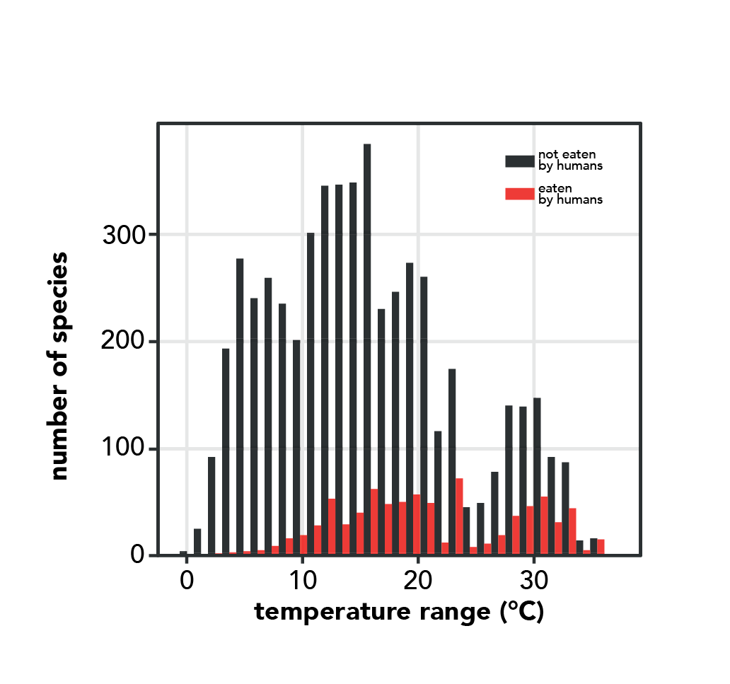
Graph 2. Adapted from Huang et al. (2023)

This graph shows the different temperature ranges of bivalves that we eat versus those we do not. The temperature range within which a species lives is shown on the x-axis. The y-axis shows how many bivalve species there are with different temperature ranges. The team performed the same statistical test that they did for the geographic range data, calculating the likelihood that the two samples (eaten species and species that we don’t eat) are statistically “the same”. The p-value for that test was less than 0.001.

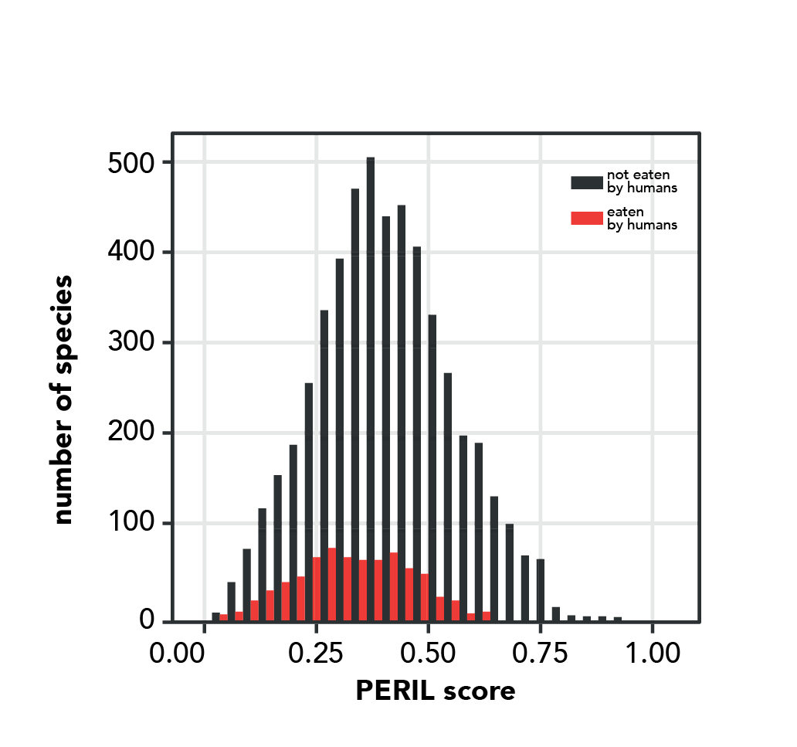
Graph 3. Adapted from Huang et al. (2023)

Finally, the graph above shows PERIL scores, which indicate how vulnerable a species is to extinction overall by incorporating its geographic and temperature ranges, as well the volatility of that species’ family (i.e., how much extinction has happened in the species’ closest relatives). PERIL score is on the x-axis, and the number of species with different PERIL scores is shown by how tall the bars are. The team performed the same statistical test that they did for the geographic range data, calculating the likelihood that the two samples (eaten species and species that we don’t eat) are statistically “the same”. The p-value for that test was less than 0.001.
Stepping into science: David, Shan, and Stewart came to science via different routes. David grew up in New York City where museums and dinosaur fossils inspired his first interest in science. As a child, Shan was drawn to her science classes and liked to spend her free time solving puzzles and devouring stories though books and movies. And Stewart started off mucking about in rivers and marshes – until a high school science teacher helped him see these wild playgrounds as a biologist would, as complex webs of interacting organisms and processes. Now, all three scientists are united by a shared curiosity about one of the biggest questions in biology: what controls the number and kinds of different species on the planet? Yet their different childhood passions are all present in their work today. David spends much of his time working with data from the museum collections that first inspired him. Shan feels like she’s following a story through her research: “I really like detective stories, and jigsaw puzzles, and I feel like a detective when I look at data and try to deduce some theories out of them.” And Stewart’s focus has shifted from frolicking in muddy marshes to understanding such ecosystems over deep time – but his feelings about scientific research still sound like those of a kid on a playground: “It’s a blast!”

Reference: Huang, S., Edie, S. M., Collins, K. S., Crouch, N. M. A., Roy, K., and Jablonski, D. (2023). Diversity, distribution, and intrinsic extinction vulnerability of exploited marine bivalves. Nature Communications. 14: 4639.
Glossary:
Population – a group of organisms living close to one another that interbreed with one another and do not breed with other similar groups; a gene pool. Depending on the organism, populations may occupy greater or smaller geographic regions.

Extinction – An event in which the last members of a lineage or species die. A single species goes extinct when all members of that species die. An entire lineage goes extinct when all the species that make it up go extinct.

Family – a group of closely related evolutionary lineages, often with similar form and mode of life. When biologists classify species, they group species with close evolutionary relationships to one another into the same genus, and they group genera with close evolutionary relationships to one another into the same family.

Lineage – A continuous line of descent; a series of species, populations, organisms, cells, or genes connecting ancestors and their descendents.

Hypothesis – A proposed explanation for a narrow set of phenomena. A hypothesis must be testable with evidence from the natural world. If an explanation can’t be tested with experimental results, observation, or some other means, then it is not a scientific hypothesis.

Fossil – Any trace of a living organism (body, part of body, burrow, footprint, etc.) preserved over geologic time.

Comprehension questions:

- According to the opening paragraph, what is an important difference between the animals sold as food at the meat counter (e.g., pork, beef, chicken) and the animals sold as food at the seafood counter (e.g., tuna, halibut, squid)?
- What easy-to-identify trait distinguishes bivalves from other types of mollusks?
- What key question were David, Shan, and Stewart trying to answer in the study described here?
- The team based their study on three hypotheses about what traits might affect a species’ vulnerability to extinction:
  - In your own words, explain how having a small geographic range is likely to affect a species’ vulnerability to extinction and why this might be.
  - In your own words, explain how having a small temperature range is likely to affect a species’ vulnerability to extinction and why this might be.
  - In your own words, state the third hypothesis.
- What types of data did the researchers use to investigate their key question?
- If a particular bivalve has an unusually high PERIL score, what does that indicate about the species?

Data interpretation questions:

- Examine Graph 1.
  - The black bars are longer than the red bars. What does this difference indicate?
  - Describe the overall pattern you see comparing the geographic range sizes of species we eat to those that we do not eat.
  - What does your answer to part b indicate about the extinction vulnerability of bivalves we eat vs. those that we do not?
- Examine Graph 2.
  - Describe the overall pattern you see comparing the temperature ranges of species we eat to those that we do not eat.
  - What does your answer to part b indicate about the extinction vulnerability of bivalves we eat vs. those that we do not?
- Examine Graph 3.
  - Describe the overall pattern you see comparing the PERIL scores of species we eat to those that we do not eat.
  - What does your answer to part b indicate about the extinction vulnerability of bivalves we eat vs. those that we do not?
- Taken together, what do these three sets of data indicate about the overall extinction vulnerability of bivalves we eat compared to those that we do not eat?
- Do the results of this study suggest that all bivalves are good choices for harvesting in terms of extinction risk? Explain your answer.
- If you were a conservation biologist focused on bivalves, how might the results of this study affect your work?
- Imagine that you are a conservation biologist focused on bivalves. You have a limited budget and must choose among a group of equally threatened bivalve species to determine which to prioritize for a conservation project. What factors would you consider in making this choice? List at least two.

Specifically, they took the natural logarithm of the range size. This transformation changes the magnitude of each data point but keeps the relationships among data points the same (e.g., the largest raw number is still the largest after taking the natural log).
They used a Kolmogorov-Smirnov test to calculate this value.

