EVALUATION REPORT FOR UNDERSTANDING SCIENCE/UNDERSTANDING EVOLUTION MODERNIZATION

Summary
This report summarizes the effectiveness of the Understanding Evolution and Understanding Science website modernization project, funded by IMLS award no. MA-10-19-0539-19, at meeting the following goals:
- Increased understanding of/interest in evolution/nature of science among teachers, students and learners
- Increased confidence to teach these topics among teacher users
- Perception of the upgraded sites as appealing/current/useful
- Long term relevance of the sites to a growing audience of users

To assess these goals, we conducted several online surveys of website users. We conducted baseline satisfaction surveys of site users before upgrading the sites, and then repeated these surveys after upgrades to gauge the project’s impact on satisfaction. We also conducted more specific online satisfaction surveys targeting the new features we developed for each site. Together, these surveys assessed the opinions of several thousand users of each site. In addition, throughout the project, we collected Google Analytics data on website traffic patterns. Unfortunately, during the course of the project, Google transitioned from Universal Analytics to Google Analytics 4, which collect traffic metrics differently, disallowing straightforward comparisons of pre/post-upgrade traffic data. Nevertheless, we have marshalled the available data to assess our impact on site traffic patterns.

Key findings from these assessments are that:
- Users perceive the sites as contributing to learning/interest
- Teacher users report increased confidence/preparedness as a result of their visits to the sites
- Users perceive the sites as current, appealing, and easy to navigate; upgrades significantly strengthened these perceptions among users
- Users are attracted to the sites and find useful information/tools; upgrades significantly increased overall user satisfaction
- New features developed for the sites are perceived as useful and as supporting learning/interest
- Audiences for the sites are diverse and growing
See appendices for full reports on the data summarized below.

Key finding: Users perceive sites as contributing to learning/interest
For each site, we conducted an online satisfaction survey after launch (with a small incentive - entry in a drawing for a gift card) to assess users’ overall perceptions of the sites. For Understanding Science, 714 users (from a range of ethnicities, ages, and educational backgrounds) took the survey:
- 84% either agreed or strongly agreed that the site increased their understanding
- 70% either agreed or strongly agreed that the site increased their interest

For Understanding Evolution, 728 users (from a range of ethnicities, ages, and educational backgrounds) took the survey:
- 87% either agreed or strongly agreed that the site increased their understanding
- 70% either agreed or strongly agreed that the site increased their interest

Key finding: Teachers report increased confidence/preparedness
Our online satisfaction survey of Understanding Science users found that:
- 87% of teachers (n=182) either agreed or strongly agreed that they are confident they can apply what they learned on this site

Our online satisfaction survey of Understanding Evolution users found that:
- 90% of teachers (n=173) either agreed or strongly agreed that they are confident they can apply what they learned on this site

Key finding: Users perceive sites as current, appealing, and easy to navigate
Our online satisfaction survey of Understanding Science users found that:
- 71% either agreed or strongly agreed that the site informed them about recent developments on the nature and process of science
- 79% either agreed or strongly agreed that the site was visually appealing
- 82% either agreed or strongly agreed that they could find what they needed easily on the site
- 90% either agreed or strongly agreed that the site displayed well on their device

Before our upgrade, in our baseline satisfaction survey (PRE results below) nearly 10% of US users perceived parts of the US site as broken. After our upgrade, in our online satisfaction survey only 5% did (POST results below). This difference is statistically significant:
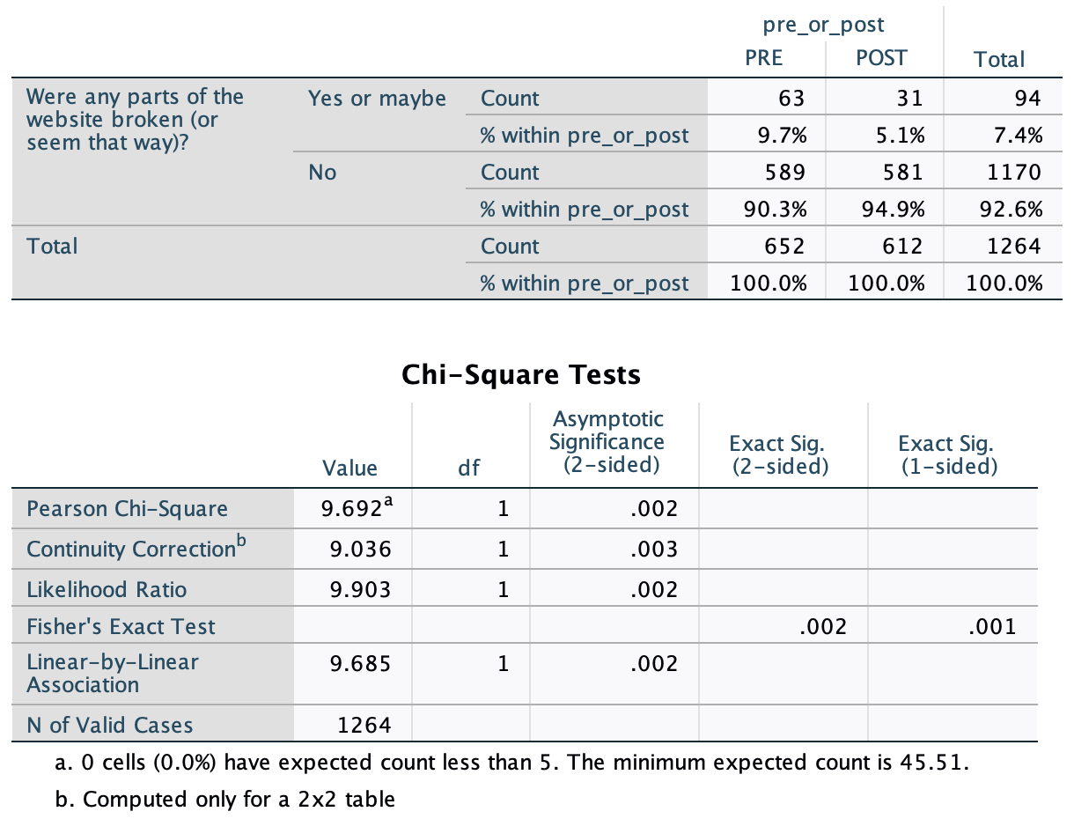

Users found the US site more visually appealing in our post-upgrade satisfaction survey compared to our baseline satisfaction survey. This difference is statistically significant:
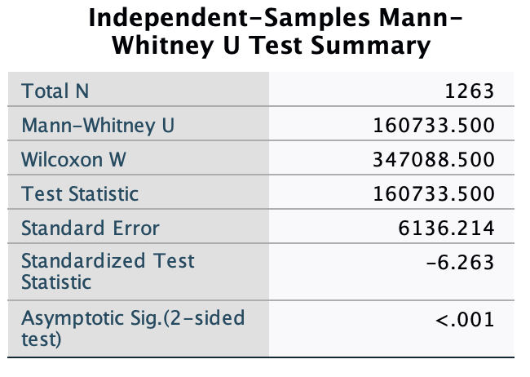
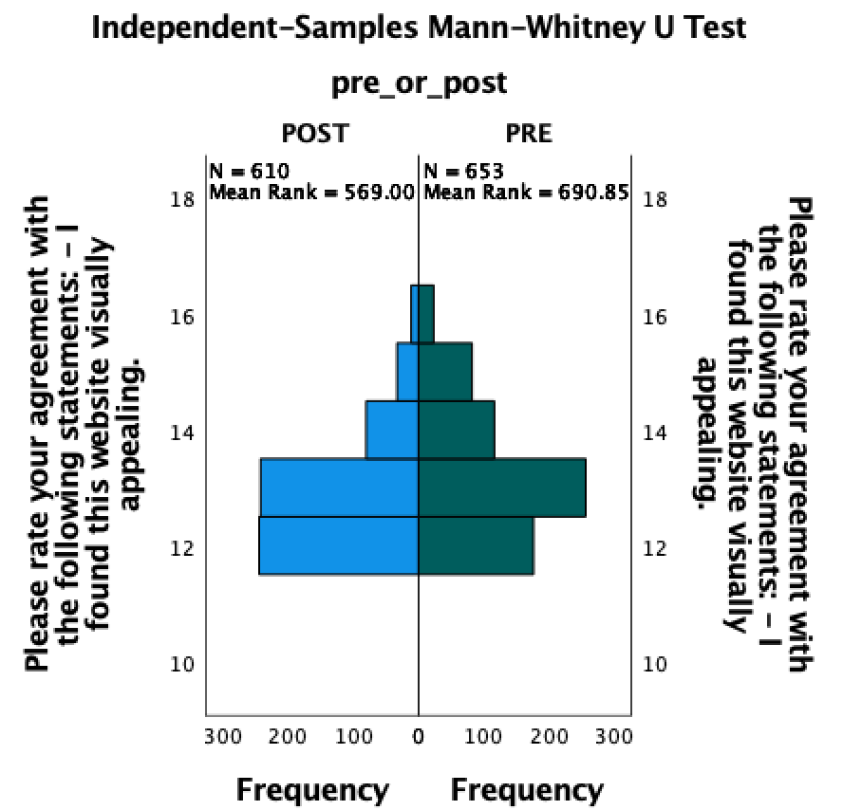

Users found it easier to find what they needed on the US site in our post-upgrade satisfaction survey compared to our baseline satisfaction survey. This difference is statistically significant:
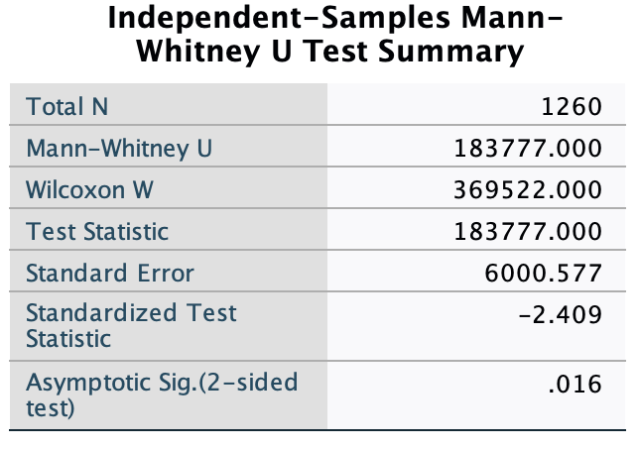
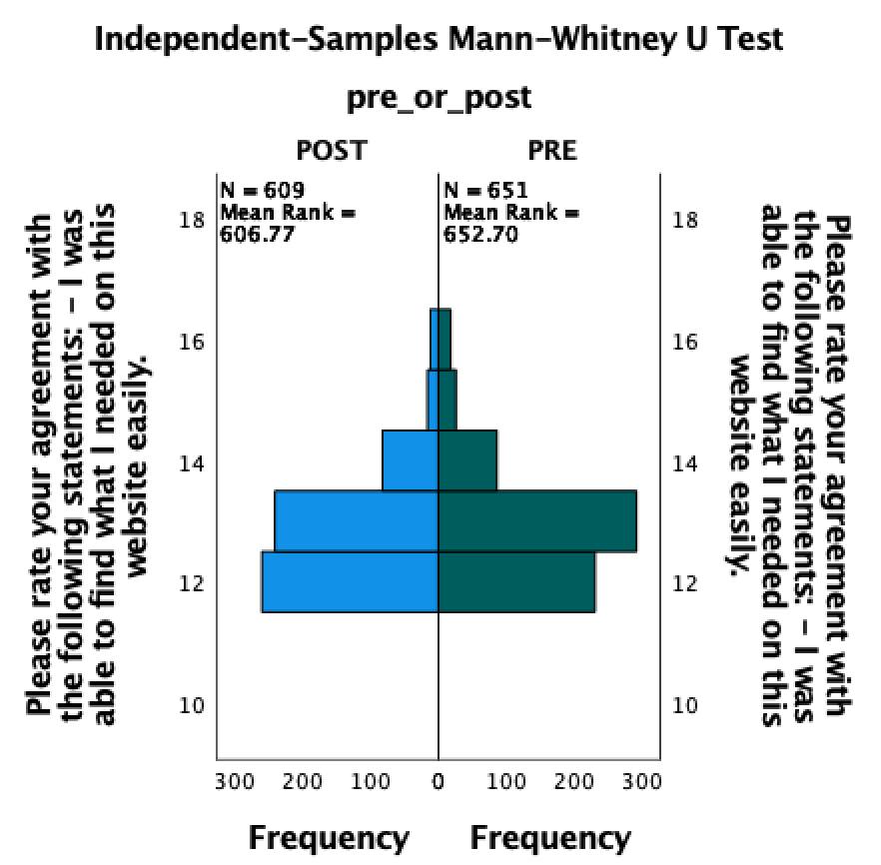

Users found the US site displayed better on their devices in our post-upgrade satisfaction survey compared to our baseline satisfaction survey. This difference is statistically significant:
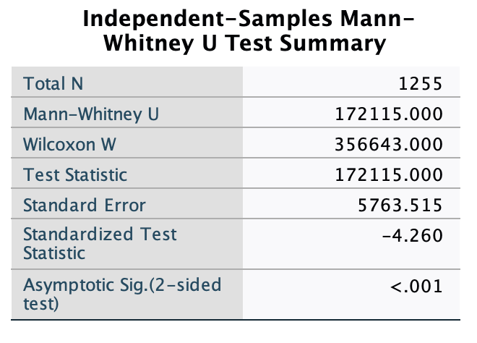
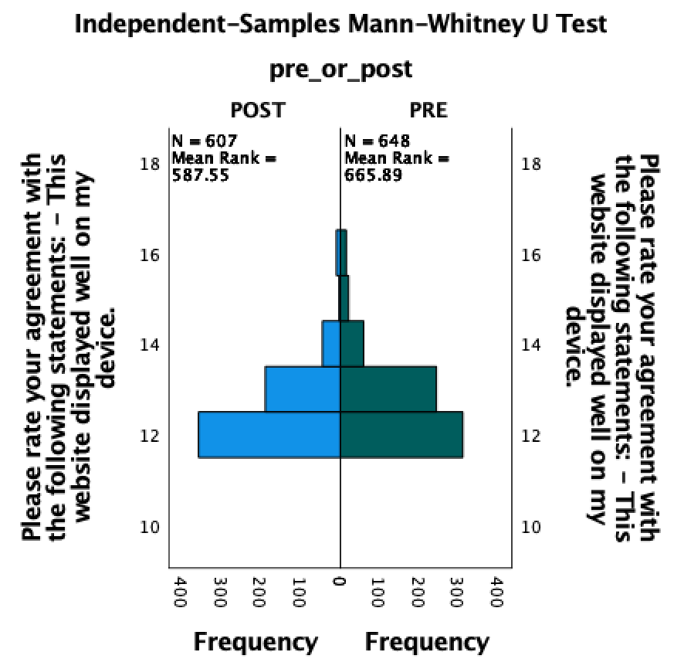

Our online satisfaction survey of Understanding Evolution users found that:
- 71% either agreed or strongly agreed that the site informed them about recent developments in the field of evolution
- 81% either agreed or strongly agreed that the site was visually appealing
- 82% either agreed or strongly agreed that they could find what they needed easily on the site
- 87% either agreed or strongly agreed that the site displayed well on their device

Takers of our post-upgrade satisfaction survey of UE were more likely to report that the site informed them about recent developments in the field of evolution compared to takers of our baseline satisfaction survey. This difference is statistically significant:
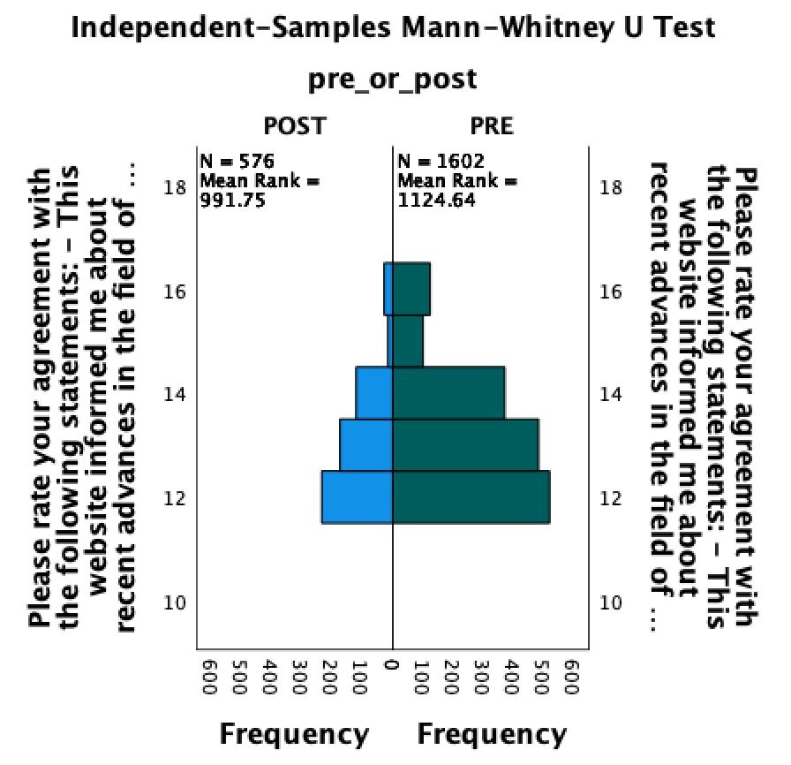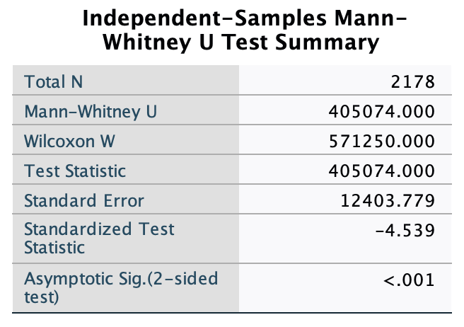

Before our upgrade, in our baseline satisfaction survey (PRE results below) nearly 15% of UE users perceived parts of the UE site as broken. After our upgrade, in our online satisfaction survey only 9% did (POST results below). This difference is statistically significant:
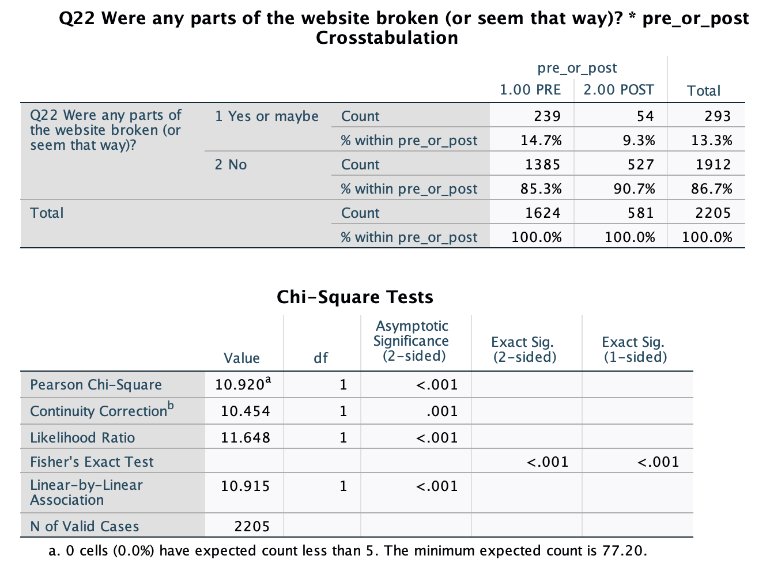

Users found the UE site more visually appealing in our post-upgrade satisfaction survey compared to our baseline satisfaction survey. This difference is statistically significant:
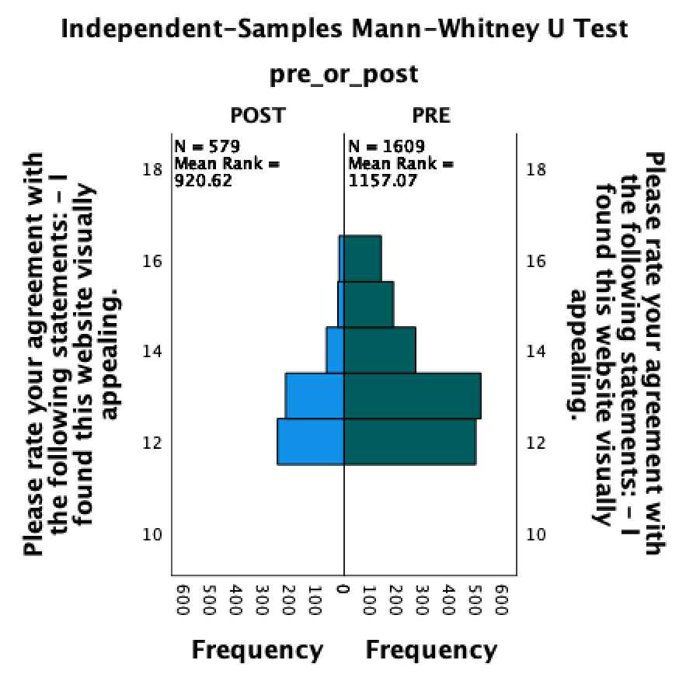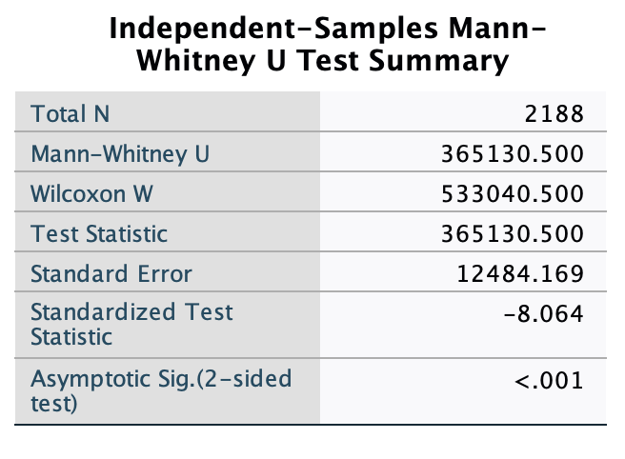

Users found it easier to find what they needed on the UE site in our post-upgrade satisfaction survey compared to our baseline satisfaction survey. This difference is statistically significant:
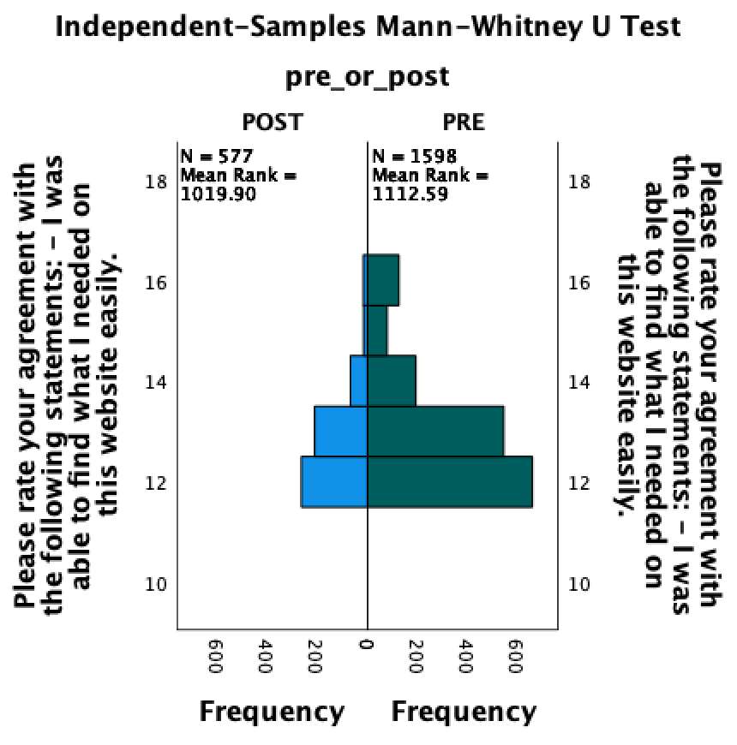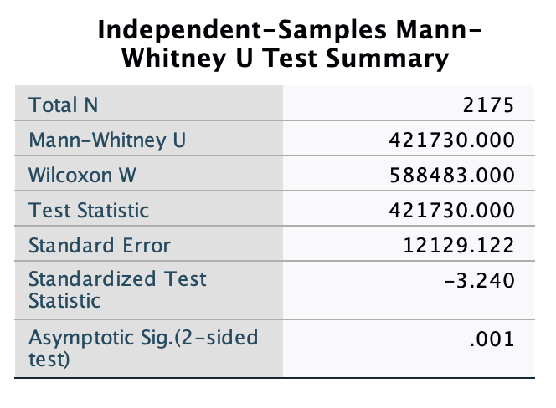
Users found the UE site displayed better on their devices in our post-upgrade satisfaction survey compared to our baseline satisfaction survey. This difference is statistically significant:
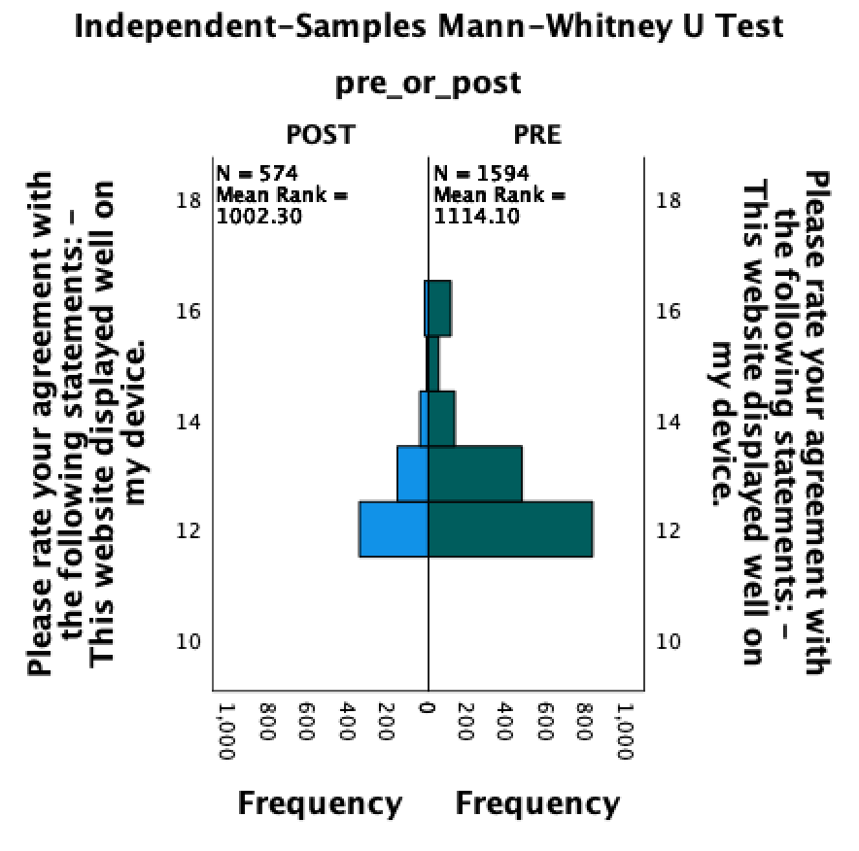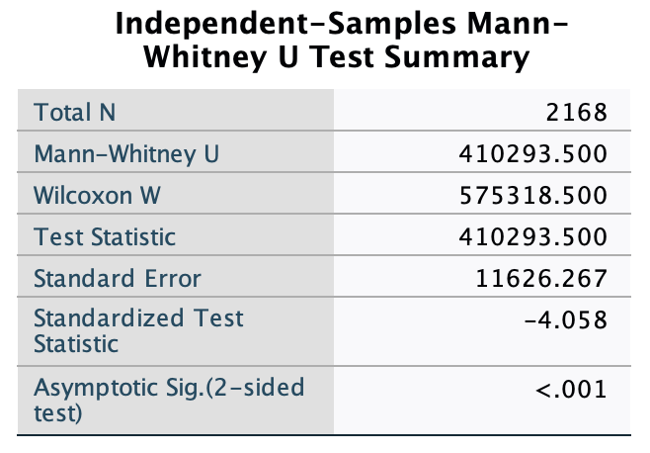

Key finding: Users are attracted to the sites and find useful information/tools; upgrades increased overall user satisfaction
Our online satisfaction survey of Understanding Science users found that:
- Users reported that were very likely (with a mean rating of 8.12 out of 10) to recommend the website to a friend or colleague
- Users reported that were very likely (with a mean rating of 8.40 out of 10) to revisit the site to access information

Furthermore, both these ratings increased from the baseline satisfaction survey to the post-upgrade satisfaction survey. These differences were statistically significant:
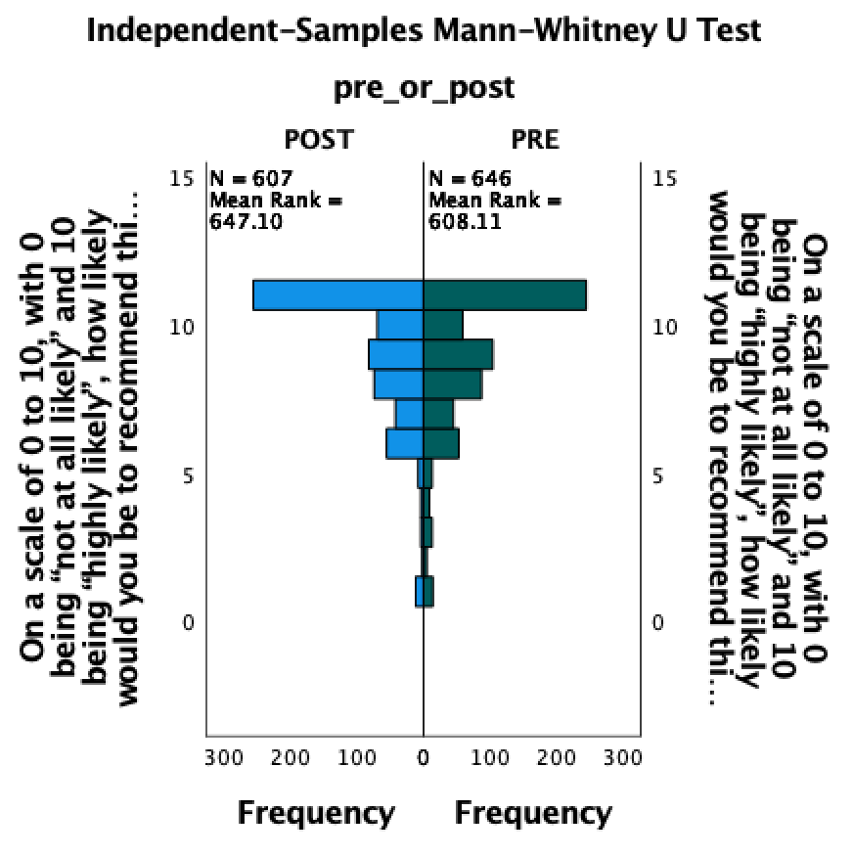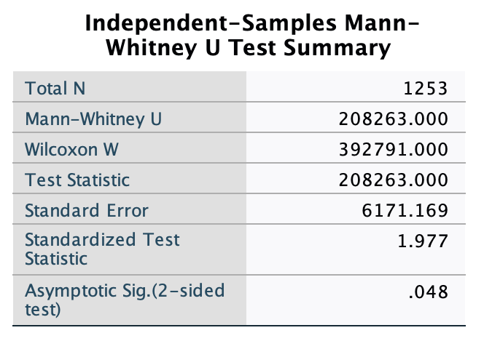
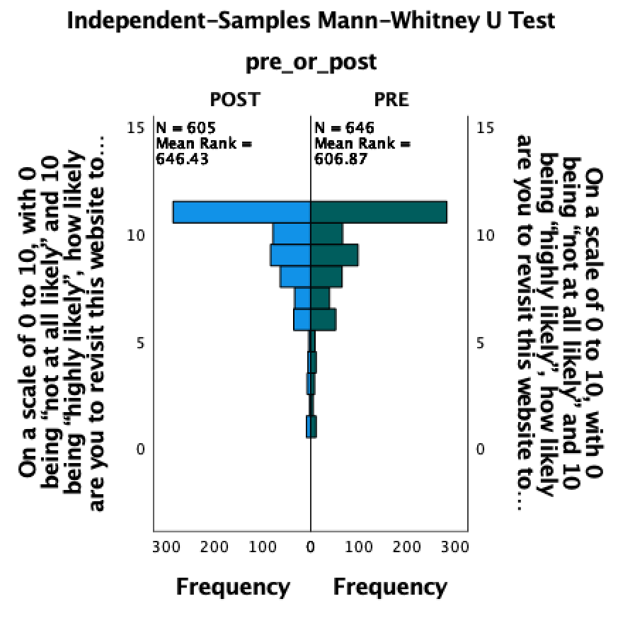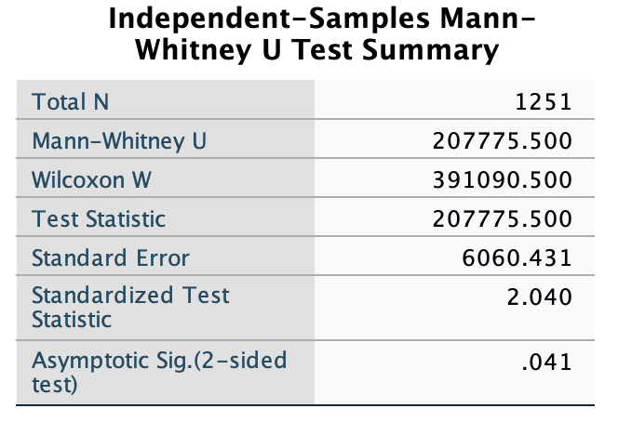

Our online satisfaction survey of Understanding Evolution users found that:
- Users reported that were very likely (with a mean rating of 8.11 out of 10) to recommend the website to a friend or colleague
- Users reported that were very likely (with a mean rating of 8.24 out of 10) to revisit the site to access information

Furthermore, both these ratings increased from the baseline satisfaction survey to the post-upgrade satisfaction survey. These differences were statistically significant:
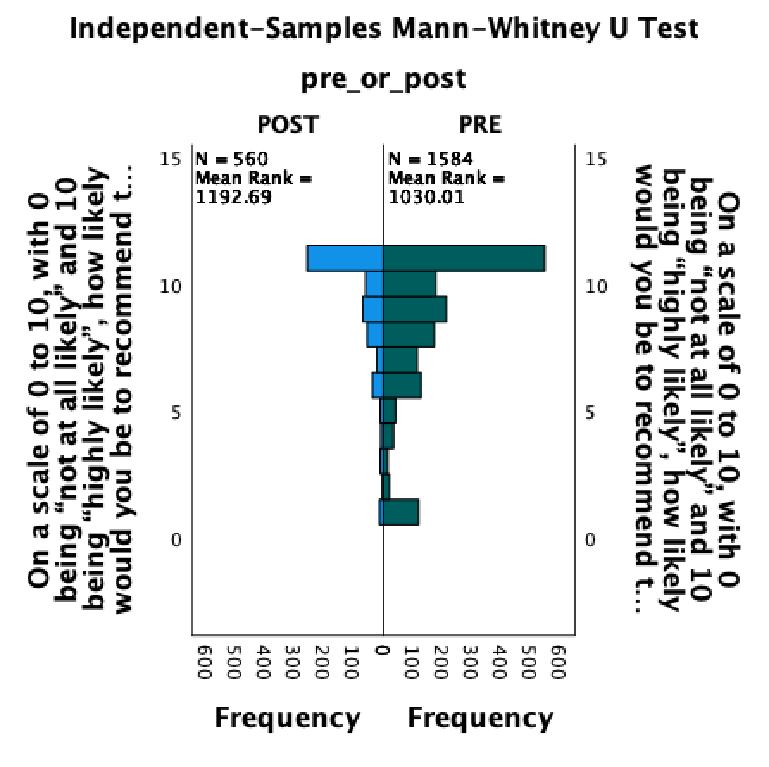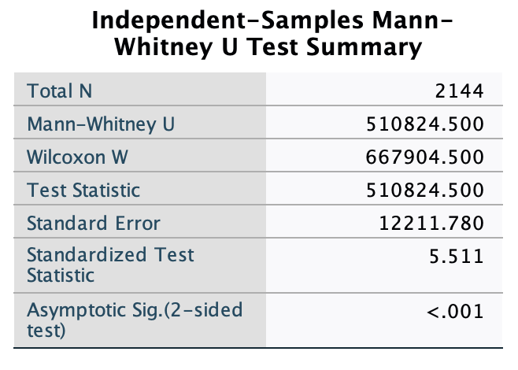
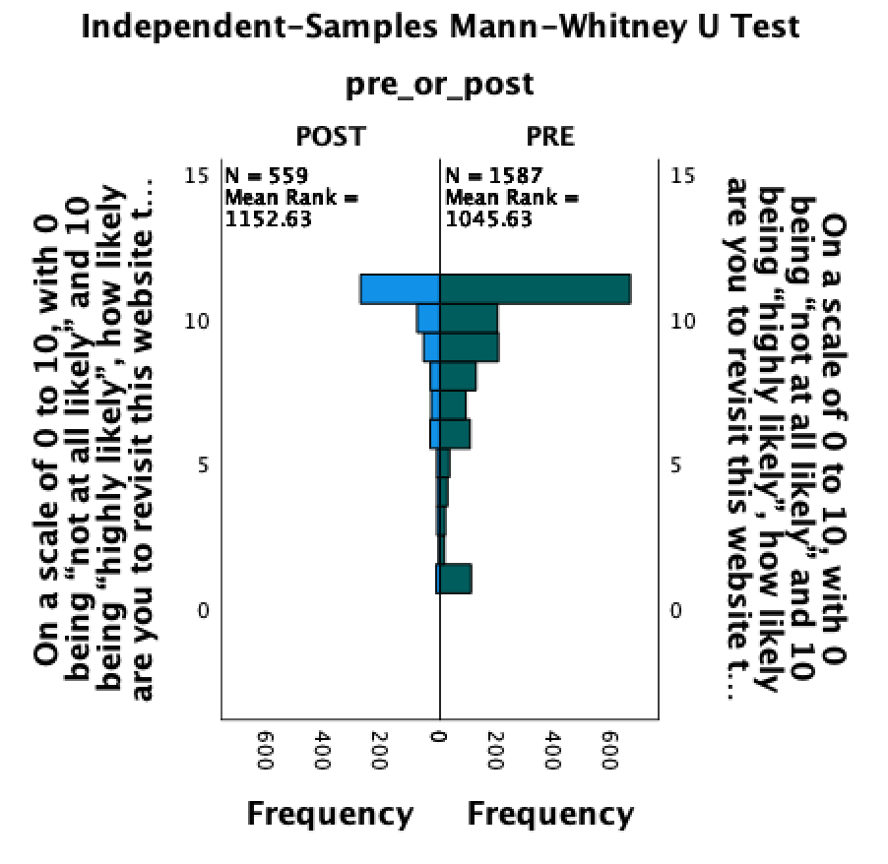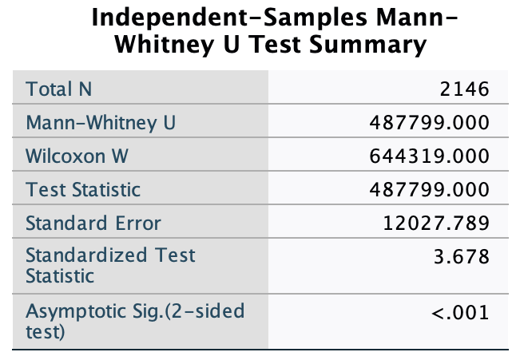

Key finding: New features developed for the sites are perceived as useful and support learning/interest
For the Understanding Science website, the modernization project developed a new page on bias in science, and a survey, linked to from that page, was used to assess its effectiveness. 56 users (nearly all self-reporting as African American students) took the survey:
- 59% either agreed or strongly agreed that the page increased their understanding
- 59% either agreed or strongly agreed that the page increased their interest
- 100% of teachers (n=6) either agreed or strongly agreed that the page will help them engage students with the nature and process of science
- 100% of teachers either agreed or strongly agreed that they are confident they can apply what they learned in their teaching
- 59% were likely or highly likely to recommend the content to a friend
This page has been viewed more than 2000 times since it debuted.

For the Understanding Science website, the modernization project developed a new page indexing stories of science, and a survey was used to assess its effectiveness. 145 users (from a range of ethnicities, ages, and educational backgrounds) took the survey:
- 81% either agreed or strongly agreed that the page increased their understanding
- 72% either agreed or strongly agreed that the page increased their interest
- 80% of teachers (n=10) either agreed or strongly agreed that the page will help them engage students with the nature and process of science
- 90% of teachers either agreed or strongly agreed that they are confident they can apply what they learned in their teaching
- 77% were likely or highly likely to recommend the content to a friend who wanted to learn about the nature and process of science
- 60% of teachers (n=10) were likely or highly likely to recommend the content to a friend who wanted to teach about the nature and process of science
The homepage for Science Stories has been viewed more than 11,000 times since it debuted.

As part of the modernization project, we also developed new pdf downloads for the Understanding Science site to make it easier to print and access the content offline. Since the upgraded site debuted, such pdfs have been downloaded from the site around 14,000 times.

For the Understanding Evolution website, the modernization project developed 4 new Digging Data features, and a survey was used to assess their effectiveness. 193 users (from a range of ethnicities, ages, and educational backgrounds) took the survey on the mutation Digging Data:
- 86% either agreed or strongly agreed that the page increased their understanding
- 76% either agreed or strongly agreed that the page increased their interest
- 85% either agreed or strongly agreed that the page showed them how evolutionary ideas are supported by data
- 85% either agreed or strongly agreed that the page showed them how evolutionary biologists work or interpret data
- 79% either agreed or strongly agreed that the page showed them that diverse scientists are engaged with evolution research
- 89% of teachers (n=19) either agreed or strongly agreed that the page will help them engage students with using and interpreting data
- 84% of teachers either agreed or strongly agreed that this feature encouraged them to use authentic data in their teaching
- 79% of teachers either agreed or strongly agreed that this feature would help them highlight the work of diverse scientists
- 79% of teachers either agreed or strongly agreed that they are confident they can apply what they learned in their teaching
- 63% of teachers reported that they are likely to or might use the feature in their teaching
Because of a changeover in Google Analytics that spans our data collection period, we cannot report a consistent, cumulative statistic for the mutation Digging Data feature. However, since May 2022 when Google Analytics 4 debuted, this feature has garnered more than 80,000 pageviews.

69 users (from a range of ethnicities, ages, and educational backgrounds) took the survey on the artificial selection Digging Data:
- 84% either agreed or strongly agreed that the page increased their understanding
- 68% either agreed or strongly agreed that the page increased their interest
- 88% either agreed or strongly agreed that the page showed them how evolutionary ideas are supported by data
- 86% either agreed or strongly agreed that the page showed them how evolutionary biologists work or interpret data
- 79% either agreed or strongly agreed that the page showed them that diverse scientists are engaged with evolution research
- 85% of teachers (n=13) either agreed or strongly agreed that the page will help them engage students with using and interpreting data
- 69% of teachers either agreed or strongly agreed that this feature encouraged them to use authentic data in their teaching
- 69% of teachers either agreed or strongly agreed that this feature would help them highlight the work of diverse scientists
- 84% of teachers either agreed or strongly agreed that they are confident they can apply what they learned in their teaching
- 71% of teachers reported that they are likely to or might use the feature in their teaching
Since May 2022 when Google Analytics 4 debuted, this feature has garnered more than 45,000 pageviews.

46 users (from a range of ethnicities, ages, and educational backgrounds) took the survey on the macroevolution Digging Data:
- 95% either agreed or strongly agreed that the page increased their understanding
- 82% either agreed or strongly agreed that the page increased their interest
- 92% either agreed or strongly agreed that the page showed them how evolutionary ideas are supported by data
- 89% either agreed or strongly agreed that the page showed them how evolutionary biologists work or interpret data
- 84% either agreed or strongly agreed that the page showed them that diverse scientists are engaged with evolution research
- 83% of teachers (n=12) either agreed or strongly agreed that the page will help them engage students with using and interpreting data
- 92% of teachers either agreed or strongly agreed that this feature encouraged them to use authentic data in their teaching
- 75% of teachers either agreed or strongly agreed that this feature would help them highlight the work of diverse scientists
- 83% of teachers either agreed or strongly agreed that they are confident they can apply what they learned in their teaching
- 91% of teachers reported that they are likely to or might use the feature in their teaching
Since May 2022 when Google Analytics 4 debuted, this feature has garnered more than 15,000 pageviews.

107 users (from a range of ethnicities, ages, and educational backgrounds) took the survey on the sexual selection Digging Data:
- 89% either agreed or strongly agreed that the page increased their understanding
- 71% either agreed or strongly agreed that the page increased their interest
- 94% either agreed or strongly agreed that the page showed them how evolutionary ideas are supported by data
- 94% either agreed or strongly agreed that the page showed them how evolutionary biologists work or interpret data
- 79% either agreed or strongly agreed that the page showed them that diverse scientists are engaged with evolution research
- 76% of teachers (n=21) either agreed or strongly agreed that the page will help them engage students with using and interpreting data
- 81% of teachers either agreed or strongly agreed that this feature encouraged them to use authentic data in their teaching
- 81% of teachers either agreed or strongly agreed that this feature would help them highlight the work of diverse scientists
- 80% of teachers either agreed or strongly agreed that they are confident they can apply what they learned in their teaching
- 76% of teachers reported that they are likely to or might use the feature in their teaching
Since May 2022 when Google Analytics 4 debuted, this feature has garnered more than 54,000 pageviews.

In addition, 27 teachers thus far have requested answer keys to the above four activities, indicating clear plans to use them in class.

As part of the modernization project, we also developed new pdf downloads for the Understanding Evolution site to make it easier to print and access the content offline. Since May 2022 when Google Analytics 4 debuted, such pdfs have been downloaded from the site around 9000 times.

Key finding: Audiences for the sites are diverse and growing
The audience for the upgraded Understanding Science website is large, broad, and reflects modern patterns of internet access that increasingly relies on mobile devices. The upgraded site has received more than 1.9 million pageviews since launch with an average engagement time of 2 minutes 28s. While the site’s primary audience is from the United States, it also engages a significant number of users in the Philippines, India, Canada, and Australia. Around a third of the site’s users access it from a mobile device.

Because a changeover in Google Analytics occurred concurrently with the launch of the US website, it is difficult to compare the size of the audience for the site pre- and post-upgrade. However, we can examine site traffic patterns over time since launch. There appears to be no significant increase in the number of pageviews in the 2.5 months post-launch compared to the same set of days the following year. However, we do see a significant increase in user activity (that is, first-time visitors, return visitors who engage with the site for significant length time, or interact with it in other ways) comparing these time periods. So, engagement with the site appears to be growing.
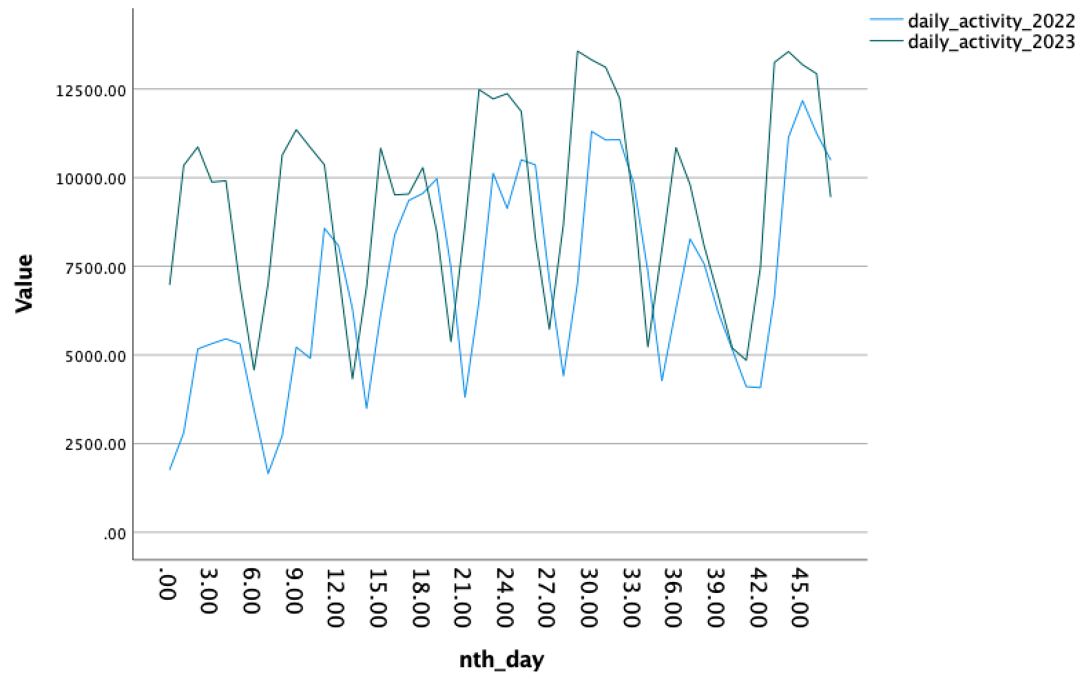
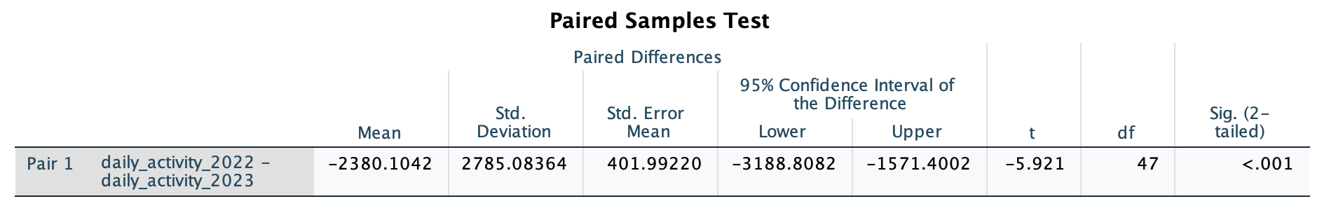

Because of a changeover in Google Analytics that spans our data collection period, we cannot report consistent, cumulative statistics for the Understanding Evolution audience since the launch of the upgraded site. However, data collected since May 2022, when Google Analytics 4 debuted, suggests that the audience for the upgraded Understanding Evolution website is large, broad, and reflects modern patterns of internet access that increasingly relies on mobile devices. The upgraded site has received 14 million pageviews since May 2022 with an average engagement time of 3min 40s. While the site’s primary audience is from the United States, it also engages a significant number of users in Mexico, India, the Philippines, and Canada. More than a third of the site’s users access it from a mobile device.

The audience (by users or number of pageviews) does not appear to have grown for UE when comparing pre- to post-upgrade. However, it does appear that the audience for the site and their engagement with it are growing since the upgrades were implemented. We can examine the longest comparable timeframes available post-launch in Universal Analytics: Nov 11, 2021 - June 30, 2022 to Nov 11, 2022 - June 30, 2023. Comparing these time periods, we see a significant increase the number of daily pageviews:
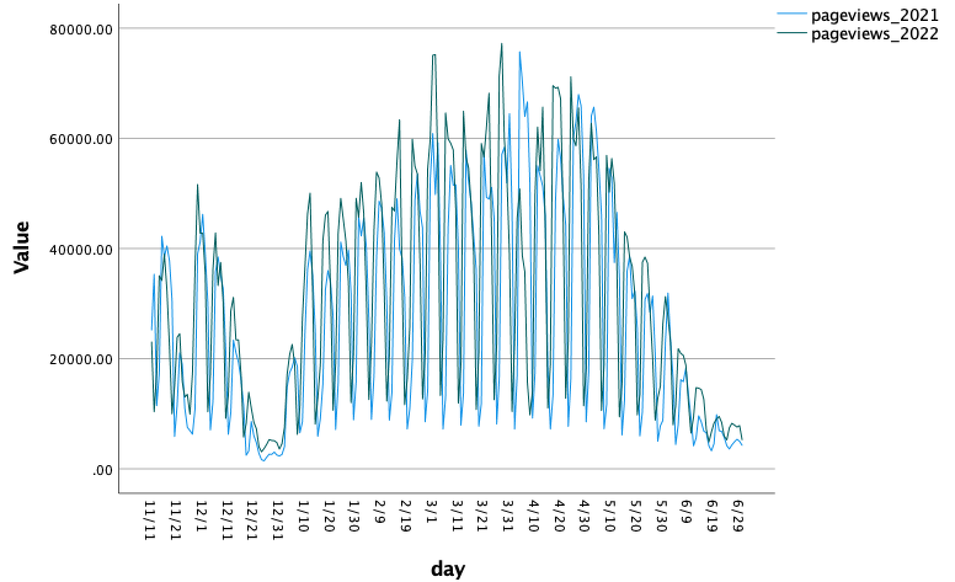
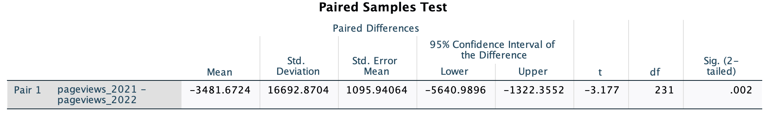

Comparing these time periods, we also see a significant increase the number of daily users:

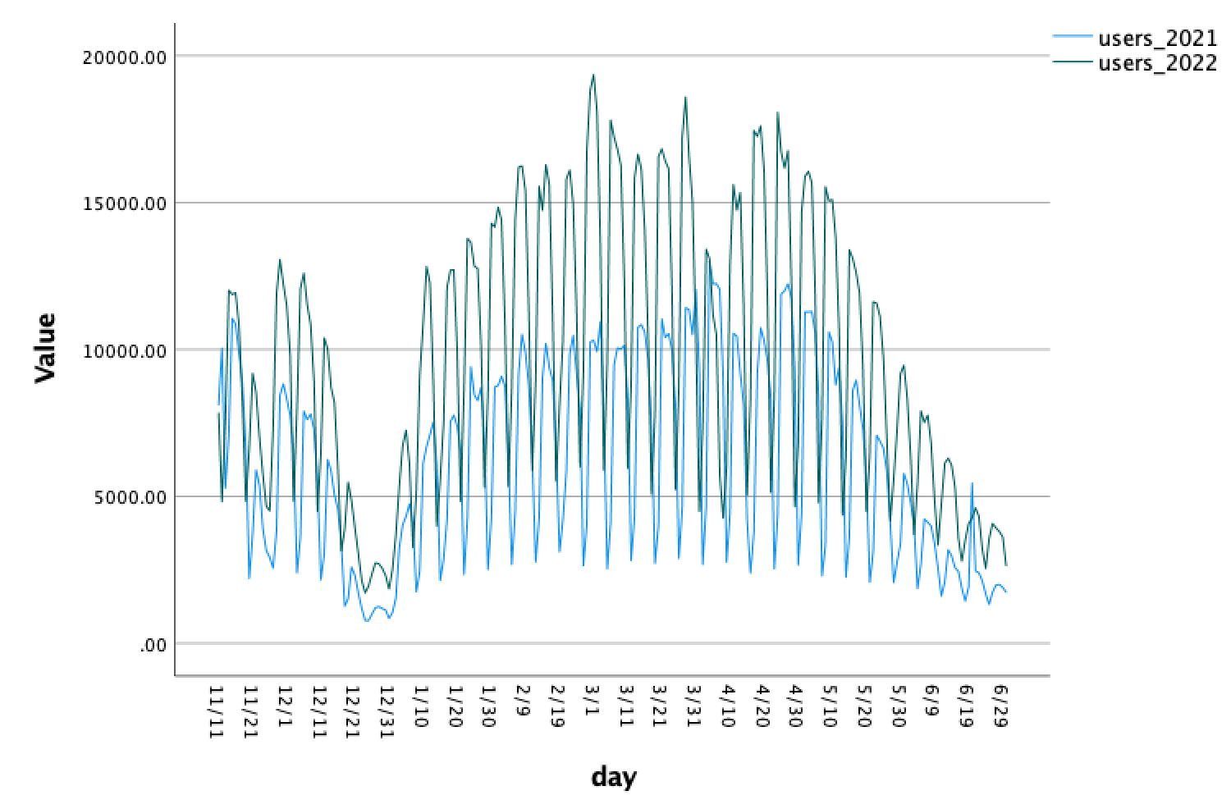
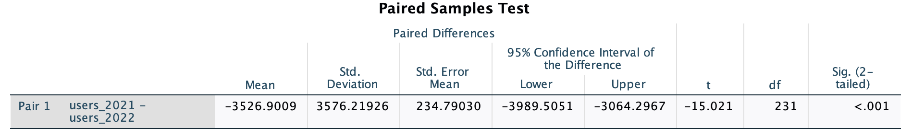

Looking at more recent data, we can also examine the longest comparable timeframes available post-launch in GA4: July 1 - Dec 1, 2022 and July 1 - Dec 1, 2023. Comparing these time periods, we see a significant increase in user activity (that is, first-time visitors, return visitors who engage with the site for significant length time, or interact with it in other ways). So, engagement with the site appears to be growing.
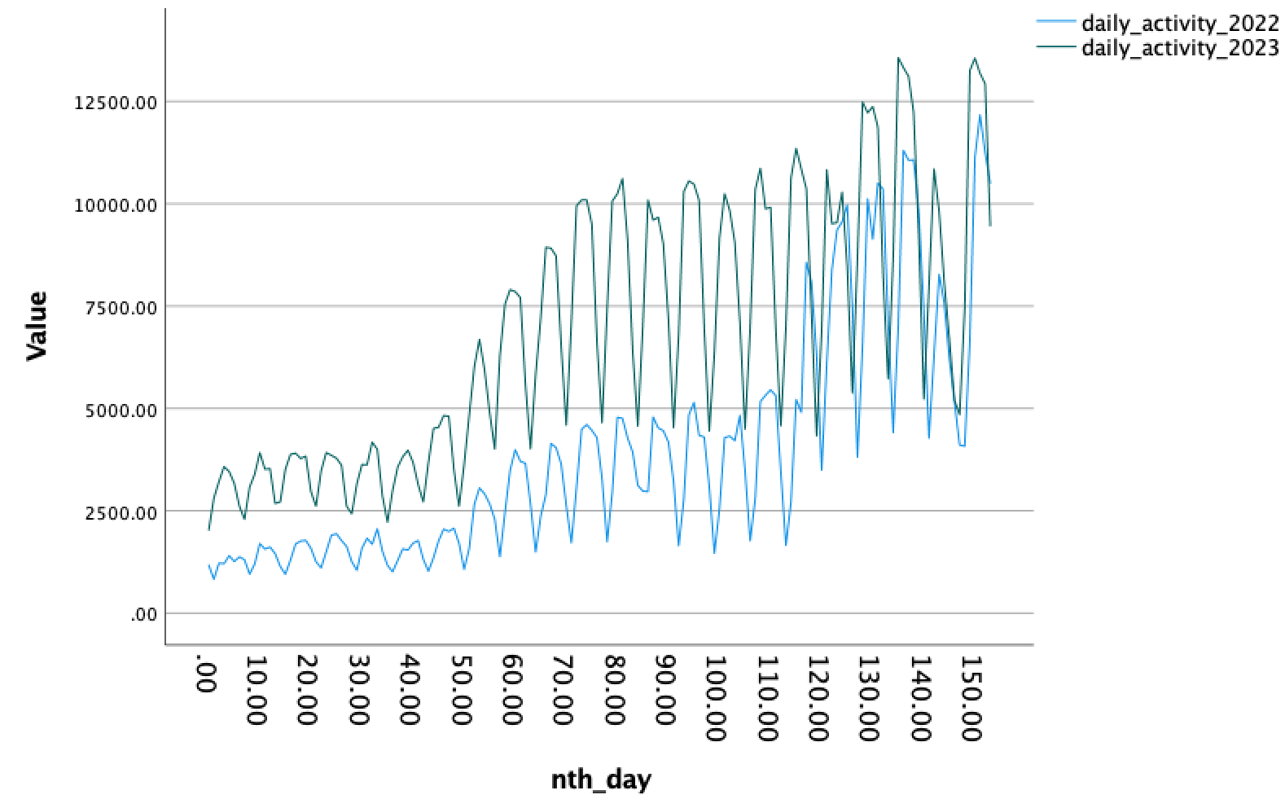
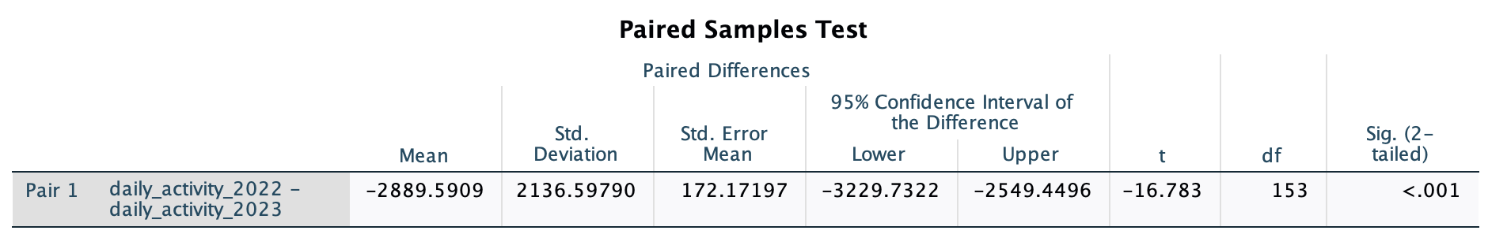

APPENDICES

APPENDIX I: Understanding Science Summative Only Satisfaction Report
APPENDIX II: Understanding Evolution Summative Only Satisfaction Report
APPENDIX III: Science Stories Satisfaction Report
APPENDIX IV: Bias in Science Satisfaction Report
APPENDIX V: Mutation Digging Data Satisfaction Report
APPENDIX VI: Artificial Selection Digging Data Satisfaction Report
APPENDIX VII: Macroevolution Digging Data Satisfaction Report
APPENDIX VIII: Sexual Selection Digging Data Satisfaction Report

APPENDIX I: Understanding Science Summative Only Satisfaction Report
Understanding Science: Summative assessment on website
WHO TOOK THIS SURVEY?
Q28 - How old are you?
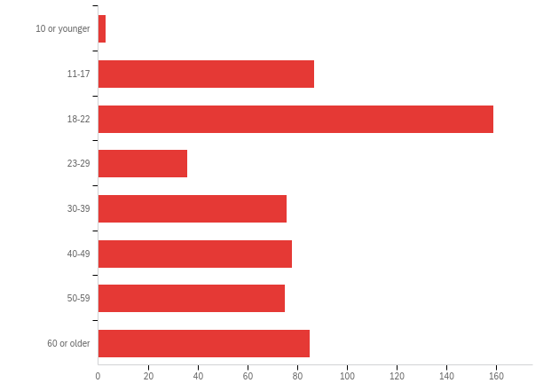

# | Answer | % | Count
1 | 10 or younger | 0.50% | 3
2 | 11-17 | 14.52% | 87
3 | 18-22 | 26.54% | 159
4 | 23-29 | 6.01% | 36
5 | 30-39 | 12.69% | 76
6 | 40-49 | 13.02% | 78
7 | 50-59 | 12.52% | 75
8 | 60 or older | 14.19% | 85
 | Total | 100% | 599

Q30 - What is your race or ethnicity? (Check all that apply.)
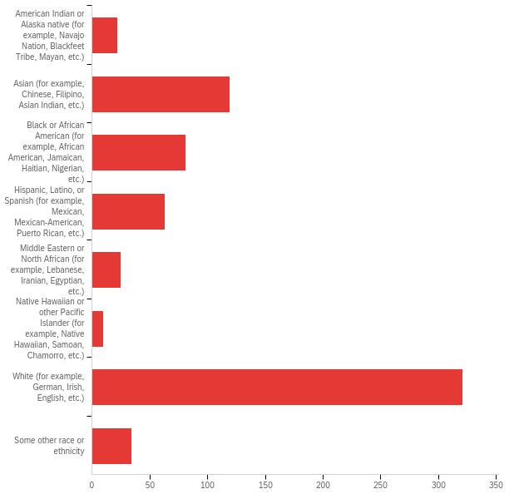

# | Answer | % | Count
1 | American Indian or Alaska native (for example, Navajo Nation, Blackfeet Tribe, Mayan, etc.) | 3.26% | 22
2 | Asian (for example, Chinese, Filipino, Asian Indian, etc.) | 17.63% | 119
3 | Black or African American (for example, African American, Jamaican, Haitian, Nigerian, etc.) | 12.00% | 81
4 | Hispanic, Latino, or Spanish (for example, Mexican, Mexican-American, Puerto Rican, etc.) | 9.33% | 63
5 | Middle Eastern or North African (for example, Lebanese, Iranian, Egyptian, etc.) | 3.70% | 25
6 | Native Hawaiian or other Pacific Islander (for example, Native Hawaiian, Samoan, Chamorro, etc.) | 1.48% | 10
7 | White (for example, German, Irish, English, etc.) | 47.56% | 321
8 | Some other race or ethnicity | 5.04% | 34
 | Total | 100% | 675

Q2 - I am a:
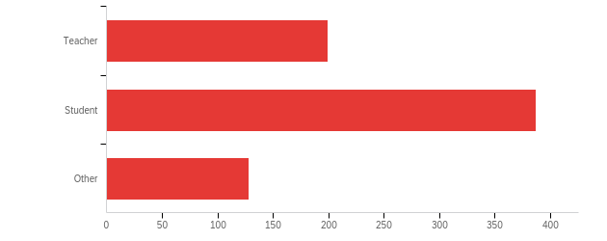

# | Answer | % | Count
1 | Teacher | 27.87% | 199
2 | Student | 54.20% | 387
3 | Other | 17.93% | 128
 | Total | 100% | 714

Q4 - I teach (check all that apply):
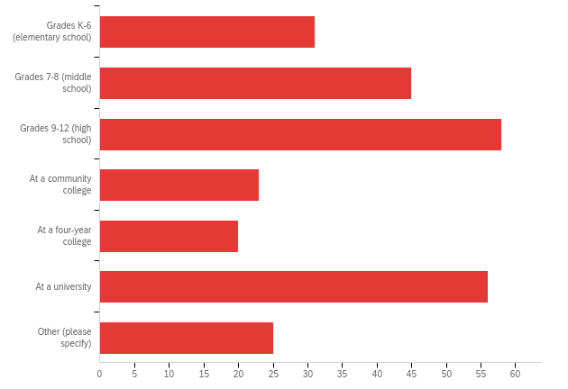

# | Answer | % | Count
1 | Grades K-6 (elementary school) | 12.02% | 31
2 | Grades 7-8 (middle school) | 17.44% | 45
3 | Grades 9-12 (high school) | 22.48% | 58
4 | At a community college | 8.91% | 23
5 | At a four-year college | 7.75% | 20
6 | At a university | 21.71% | 56
7 | Other (please specify) | 9.69% | 25
 | Total | 100% | 258

Q5 - The classes I teach include (check all that apply):
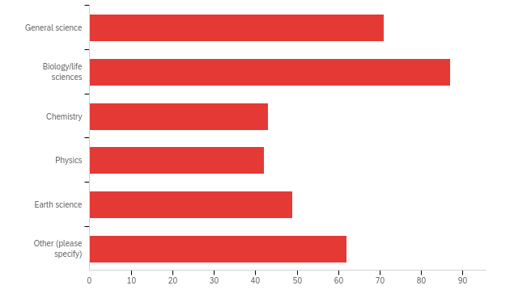

# | Answer | % | Count
1 | General science | 20.06% | 71
2 | Biology/life sciences | 24.58% | 87
3 | Chemistry | 12.15% | 43
4 | Physics | 11.86% | 42
5 | Earth science | 13.84% | 49
6 | Other (please specify) | 17.51% | 62
 | Total | 100% | 354

Q6 - What percent of students at your school qualify for free or reduced-price lunch?
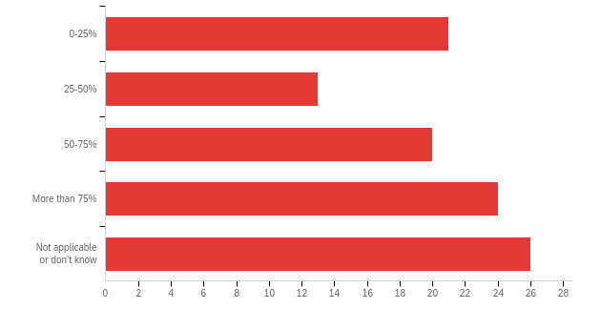

# | Answer | % | Count
1 | 0-25% | 20.19% | 21
2 | 25-50% | 12.50% | 13
3 | 50-75% | 19.23% | 20
4 | More than 75% | 23.08% | 24
5 | Not applicable or don’t know | 25.00% | 26
 | Total | 100% | 104

Q9 - I am a student in:
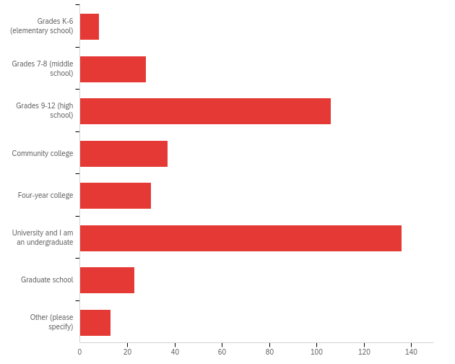

# | Answer | % | Count
1 | Grades K-6 (elementary school) | 2.10% | 8
2 | Grades 7-8 (middle school) | 7.35% | 28
3 | Grades 9-12 (high school) | 27.82% | 106
4 | Community college | 9.71% | 37
5 | Four-year college | 7.87% | 30
6 | University and I am an undergraduate | 35.70% | 136
7 | Graduate school | 6.04% | 23
8 | Other (please specify) | 3.41% | 13
 | Total | 100% | 381

Q11 - I recently visited the Understanding Science website in order to (check all that apply):
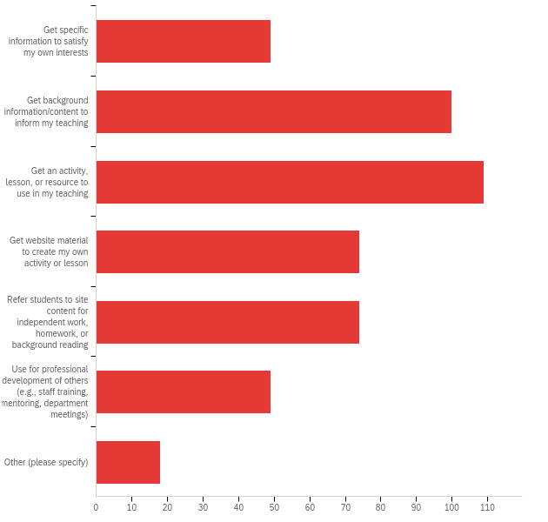

# | Answer | % | Count
1 | Get specific information to satisfy my own interests | 10.36% | 49
2 | Get background information/content to inform my teaching | 21.14% | 100
3 | Get an activity, lesson, or resource to use in my teaching | 23.04% | 109
4 | Get website material to create my own activity or lesson | 15.64% | 74
5 | Refer students to site content for independent work, homework, or background reading | 15.64% | 74
6 | Use for professional development of others (e.g., staff training, mentoring, department meetings) | 10.36% | 49
7 | Other (please specify) | 3.81% | 18
 | Total | 100% | 473

Q12 - I recently visited the Understanding Science website in order to (check all that apply):
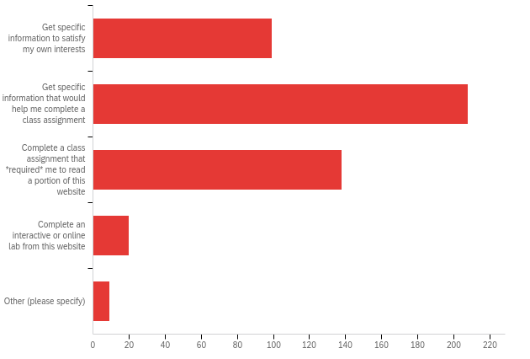

# | Answer | % | Count
1 | Get specific information to satisfy my own interests | 20.89% | 99
2 | Get specific information that would help me complete a class assignment | 43.88% | 208
3 | Complete a class assignment that *required* me to read a portion of this website | 29.11% | 138
4 | Complete an interactive or online lab from this website | 4.22% | 20
5 | Other (please specify) | 1.90% | 9
 | Total | 100% | 474

Q14 - How often do you visit this website?
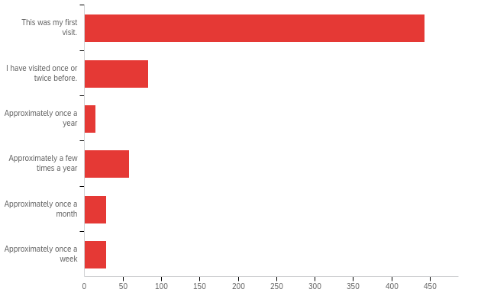

# | Answer | % | Count
1 | This was my first visit. | 67.74% | 443
2 | I have visited once or twice before. | 12.69% | 83
3 | Approximately once a year | 2.14% | 14
4 | Approximately a few times a year | 8.87% | 58
5 | Approximately once a month | 4.28% | 28
6 | Approximately once a week | 4.28% | 28
 | Total | 100% | 654

Q33 - I accessed the website on:
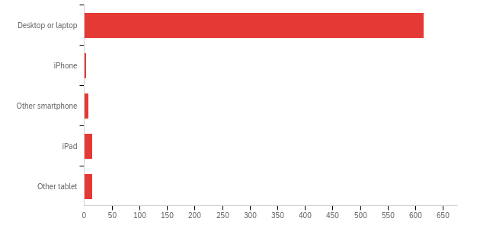

# | Answer | % | Count
1 | Desktop or laptop | 94.04% | 615
2 | iPhone | 0.46% | 3
3 | Other smartphone | 1.07% | 7
4 | iPad | 2.14% | 14
5 | Other tablet | 2.29% | 15
 | Total | 100% | 654

HOW DID YOU FEEL ABOUT THE CONTENT?
Q15 - Please rate your agreement with the following statements:
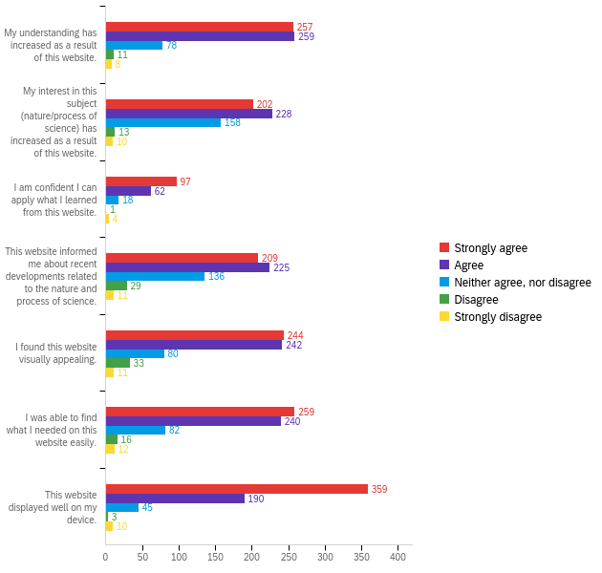

# | Question | Strongly agree |  | Agree |  | Neither agree, nor disagree |  | Disagree |  | Strongly disagree |  | Total
1 | My understanding has increased as a result of this website. | 41.92% | 257 | 42.25% | 259 | 12.72% | 78 | 1.79% | 11 | 1.31% | 8 | 613
2 | My interest in this subject (nature/process of science) has increased as a result of this website. | 33.06% | 202 | 37.32% | 228 | 25.86% | 158 | 2.13% | 13 | 1.64% | 10 | 611
3 | I am confident I can apply what I learned from this website. | 53.30% | 97 | 34.07% | 62 | 9.89% | 18 | 0.55% | 1 | 2.20% | 4 | 182
4 | This website informed me about recent developments related to the nature and process of science. | 34.26% | 209 | 36.89% | 225 | 22.30% | 136 | 4.75% | 29 | 1.80% | 11 | 610
5 | I found this website visually appealing. | 40.00% | 244 | 39.67% | 242 | 13.11% | 80 | 5.41% | 33 | 1.80% | 11 | 610
6 | I was able to find what I needed on this website easily. | 42.53% | 259 | 39.41% | 240 | 13.46% | 82 | 2.63% | 16 | 1.97% | 12 | 609
7 | This website displayed well on my device. | 59.14% | 359 | 31.30% | 190 | 7.41% | 45 | 0.49% | 3 | 1.65% | 10 | 607

Q22 - Were any parts of the website broken (or seem that way)?
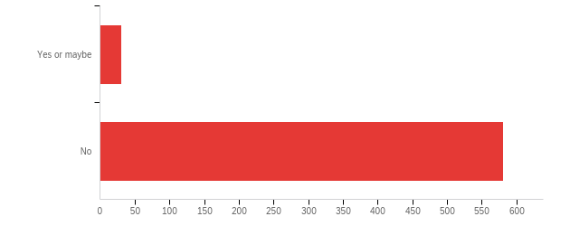

# | Answer | % | Count
1 | Yes or maybe | 5.07% | 31
2 | No | 94.93% | 581
 | Total | 100% | 612

Q24 - On a scale of 0 to 10, with 0 being “not at all likely” and 10 being “highly likely”, how likely would you be to recommend this website to a friend or colleague?
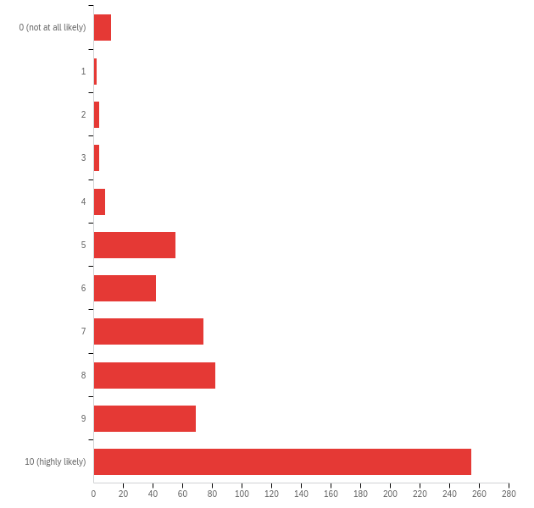

# | Field | Minimum | Maximum | Mean | Std Deviation | Variance | Count
1 | On a scale of 0 to 10, with 0 being “not at all likely” and 10 being “highly likely”, how likely would you be to recommend this website to a friend or colleague? | 1.00 | 11.00 | 9.12 | 2.24 | 5.03 | 607

# | Answer | % | Count
1 | 0 (not at all likely) | 1.98% | 12
2 | 1 | 0.33% | 2
3 | 2 | 0.66% | 4
4 | 3 | 0.66% | 4
5 | 4 | 1.32% | 8
6 | 5 | 9.06% | 55
7 | 6 | 6.92% | 42
8 | 7 | 12.19% | 74
9 | 8 | 13.51% | 82
10 | 9 | 11.37% | 69
11 | 10 (highly likely) | 42.01% | 255
 | Total | 100% | 607

Q25 - On a scale of 0 to 10, with 0 being “not at all likely” and 10 being “highly likely”, how likely are you to revisit this website to access information and resources?
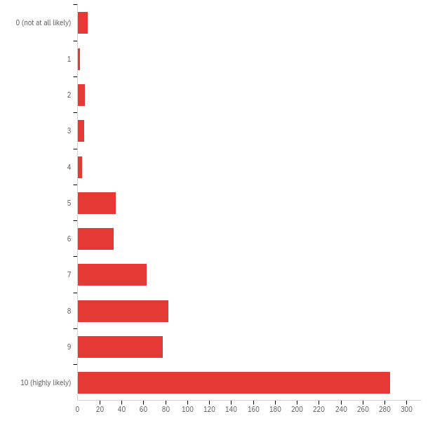

# | Field | Minimum | Maximum | Mean | Std Deviation | Variance | Count
1 | On a scale of 0 to 10, with 0 being “not at all likely” and 10 being “highly likely”, how likely are you to revisit this website to access information and resources? | 1.00 | 11.00 | 9.40 | 2.14 | 4.58 | 605

# | Answer | % | Count
1 | 0 (not at all likely) | 1.49% | 9
2 | 1 | 0.33% | 2
3 | 2 | 1.16% | 7
4 | 3 | 0.99% | 6
5 | 4 | 0.66% | 4
6 | 5 | 5.79% | 35
7 | 6 | 5.45% | 33
8 | 7 | 10.41% | 63
9 | 8 | 13.72% | 83
10 | 9 | 12.89% | 78
11 | 10 (highly likely) | 47.11% | 285
 | Total | 100% | 605

APPENDIX II: Understanding Evolution Summative Only Satisfaction Report
Understanding Evolution: Summative assessment on website
WHO TOOK THIS SURVEY?
Q28 - How old are you?
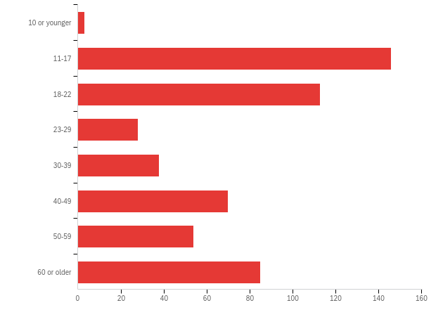

# | Answer | % | Count
1 | 10 or younger | 0.56% | 3
2 | 11-17 | 27.19% | 146
3 | 18-22 | 21.04% | 113
4 | 23-29 | 5.21% | 28
5 | 30-39 | 7.08% | 38
6 | 40-49 | 13.04% | 70
7 | 50-59 | 10.06% | 54
8 | 60 or older | 15.83% | 85
 | Total | 100% | 537

Q30 - What is your race or ethnicity? (Check all that apply.)
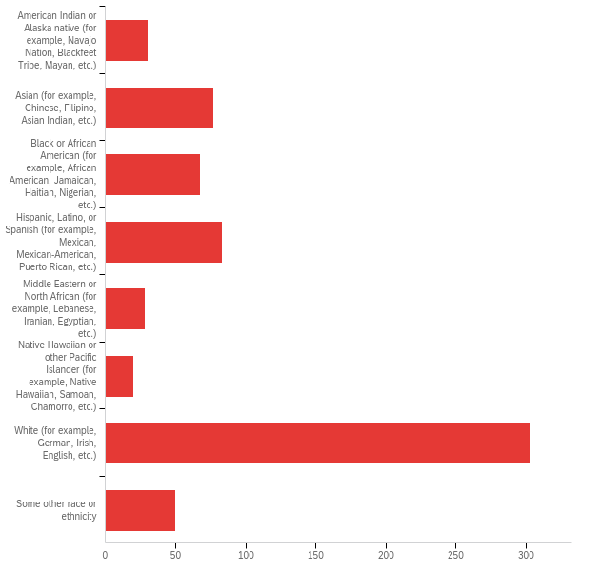

# | Answer | % | Count
1 | American Indian or Alaska native (for example, Navajo Nation, Blackfeet Tribe, Mayan, etc.) | 4.55% | 30
2 | Asian (for example, Chinese, Filipino, Asian Indian, etc.) | 11.68% | 77
3 | Black or African American (for example, African American, Jamaican, Haitian, Nigerian, etc.) | 10.32% | 68
4 | Hispanic, Latino, or Spanish (for example, Mexican, Mexican-American, Puerto Rican, etc.) | 12.59% | 83
5 | Middle Eastern or North African (for example, Lebanese, Iranian, Egyptian, etc.) | 4.25% | 28
6 | Native Hawaiian or other Pacific Islander (for example, Native Hawaiian, Samoan, Chamorro, etc.) | 3.03% | 20
7 | White (for example, German, Irish, English, etc.) | 45.98% | 303
8 | Some other race or ethnicity | 7.59% | 50
 | Total | 100% | 659

Q2 - I am a:
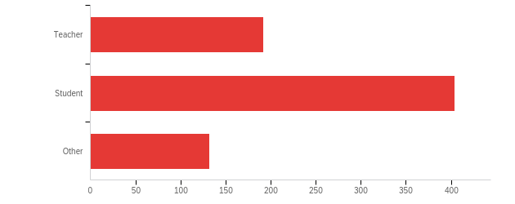

# | Answer | % | Count
1 | Teacher | 26.37% | 192
2 | Student | 55.49% | 404
3 | Other | 18.13% | 132
 | Total | 100% | 728

Q4 - I teach (check all that apply):
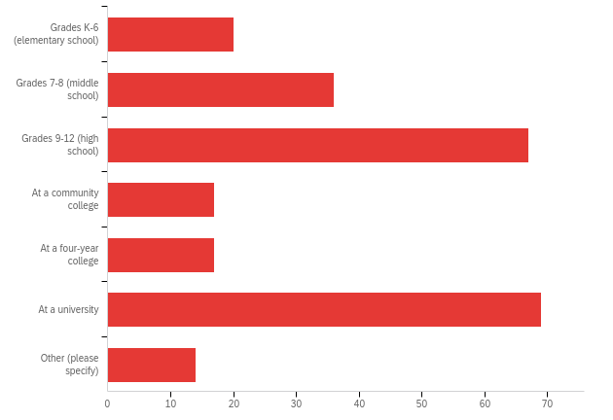

# | Answer | % | Count
1 | Grades K-6 (elementary school) | 8.33% | 20
2 | Grades 7-8 (middle school) | 15.00% | 36
3 | Grades 9-12 (high school) | 27.92% | 67
4 | At a community college | 7.08% | 17
5 | At a four-year college | 7.08% | 17
6 | At a university | 28.75% | 69
7 | Other (please specify) | 5.83% | 14
 | Total | 100% | 240

Q5 - The classes I teach include (check all that apply):
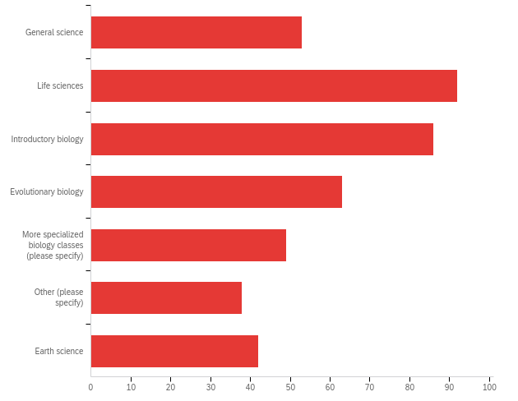

# | Answer | % | Count
1 | General science | 12.53% | 53
2 | Life sciences | 21.75% | 92
3 | Introductory biology | 20.33% | 86
4 | Evolutionary biology | 14.89% | 63
5 | More specialized biology classes (please specify) | 11.58% | 49
6 | Other (please specify) | 8.98% | 38
7 | Earth science | 9.93% | 42
 | Total | 100% | 423

Q6 - What percent of students at your school qualify for free or reduced-price lunch?
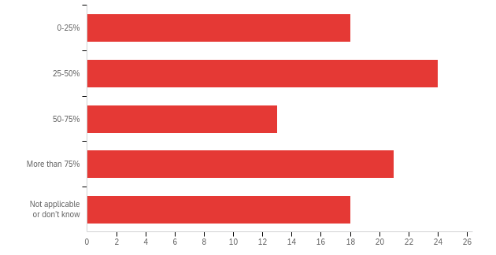

# | Answer | % | Count
1 | 0-25% | 19.15% | 18
2 | 25-50% | 25.53% | 24
3 | 50-75% | 13.83% | 13
4 | More than 75% | 22.34% | 21
5 | Not applicable or don’t know | 19.15% | 18
 | Total | 100% | 94

Q9 - I am a student in:
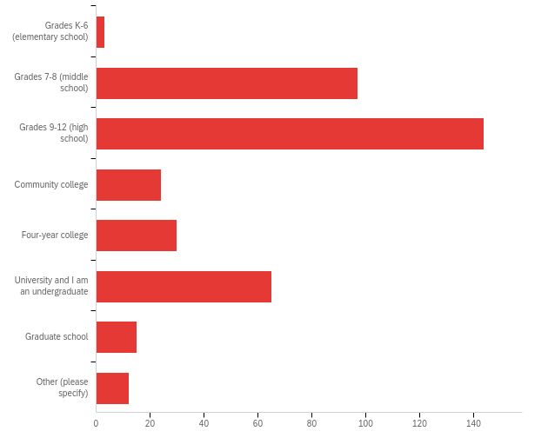

# | Answer | % | Count
1 | Grades K-6 (elementary school) | 0.77% | 3
2 | Grades 7-8 (middle school) | 24.87% | 97
3 | Grades 9-12 (high school) | 36.92% | 144
4 | Community college | 6.15% | 24
5 | Four-year college | 7.69% | 30
6 | University and I am an undergraduate | 16.67% | 65
7 | Graduate school | 3.85% | 15
8 | Other (please specify) | 3.08% | 12
 | Total | 100% | 390

Q11 - I recently visited the Understanding Evolution website in order to (check all that apply):
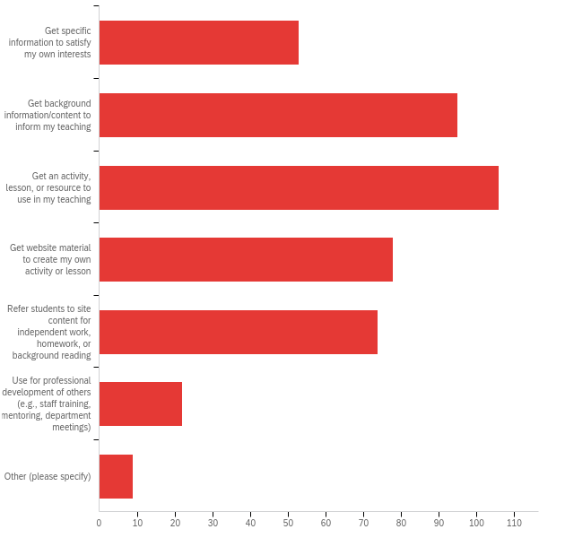

# | Answer | % | Count
1 | Get specific information to satisfy my own interests | 12.13% | 53
2 | Get background information/content to inform my teaching | 21.74% | 95
3 | Get an activity, lesson, or resource to use in my teaching | 24.26% | 106
4 | Get website material to create my own activity or lesson | 17.85% | 78
5 | Refer students to site content for independent work, homework, or background reading | 16.93% | 74
6 | Use for professional development of others (e.g., staff training, mentoring, department meetings) | 5.03% | 22
7 | Other (please specify) | 2.06% | 9
 | Total | 100% | 437

Q12 - I recently visited the Understanding Evolution website in order to (check all that apply):
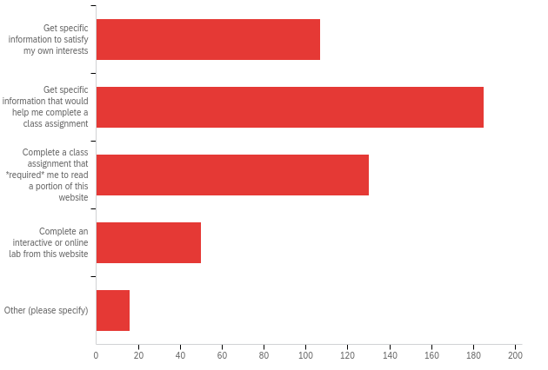

# | Answer | % | Count
1 | Get specific information to satisfy my own interests | 21.93% | 107
2 | Get specific information that would help me complete a class assignment | 37.91% | 185
3 | Complete a class assignment that *required* me to read a portion of this website | 26.64% | 130
4 | Complete an interactive or online lab from this website | 10.25% | 50
5 | Other (please specify) | 3.28% | 16
 | Total | 100% | 488

Q14 - How often do you visit this website?
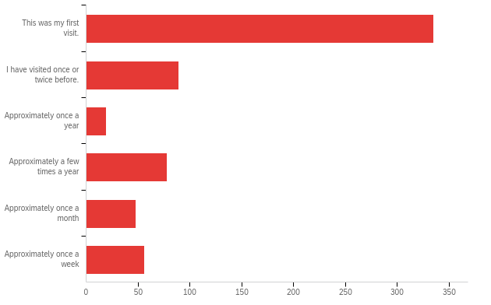

# | Answer | % | Count
1 | This was my first visit. | 53.60% | 335
2 | I have visited once or twice before. | 14.24% | 89
3 | Approximately once a year | 3.04% | 19
4 | Approximately a few times a year | 12.48% | 78
5 | Approximately once a month | 7.68% | 48
6 | Approximately once a week | 8.96% | 56
 | Total | 100% | 625

Q33 - I accessed the website on:
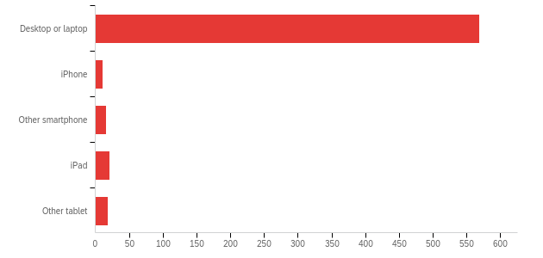

# | Answer | % | Count
1 | Desktop or laptop | 89.61% | 569
2 | iPhone | 1.73% | 11
3 | Other smartphone | 2.52% | 16
4 | iPad | 3.31% | 21
5 | Other tablet | 2.83% | 18
 | Total | 100% | 635

HOW DID YOU FEEL ABOUT THE CONTENT?
Q15 - Please rate your agreement with the following statements:
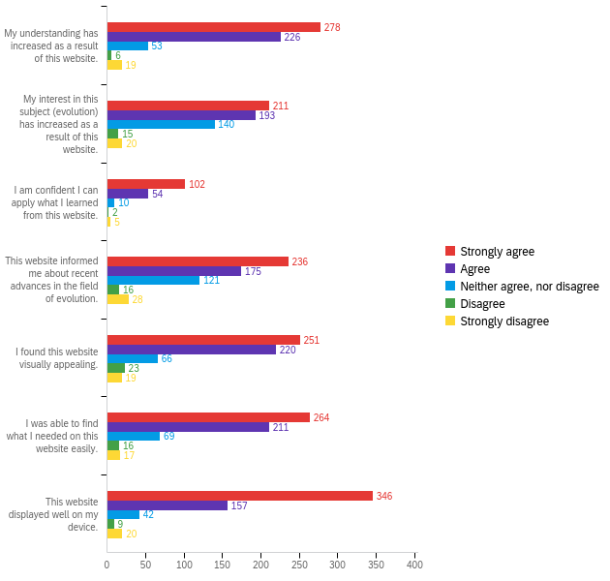

# | Question | Strongly agree |  | Agree |  | Neither agree, nor disagree |  | Disagree |  | Strongly disagree |  | Total
1 | My understanding has increased as a result of this website. | 47.77% | 278 | 38.83% | 226 | 9.11% | 53 | 1.03% | 6 | 3.26% | 19 | 582
2 | My interest in this subject (evolution) has increased as a result of this website. | 36.44% | 211 | 33.33% | 193 | 24.18% | 140 | 2.59% | 15 | 3.45% | 20 | 579
3 | I am confident I can apply what I learned from this website. | 58.96% | 102 | 31.21% | 54 | 5.78% | 10 | 1.16% | 2 | 2.89% | 5 | 173
4 | This website informed me about recent advances in the field of evolution. | 40.97% | 236 | 30.38% | 175 | 21.01% | 121 | 2.78% | 16 | 4.86% | 28 | 576
5 | I found this website visually appealing. | 43.35% | 251 | 38.00% | 220 | 11.40% | 66 | 3.97% | 23 | 3.28% | 19 | 579
6 | I was able to find what I needed on this website easily. | 45.75% | 264 | 36.57% | 211 | 11.96% | 69 | 2.77% | 16 | 2.95% | 17 | 577
7 | This website displayed well on my device. | 60.28% | 346 | 27.35% | 157 | 7.32% | 42 | 1.57% | 9 | 3.48% | 20 | 574

Q22 - Were any parts of the website broken (or seem that way)?
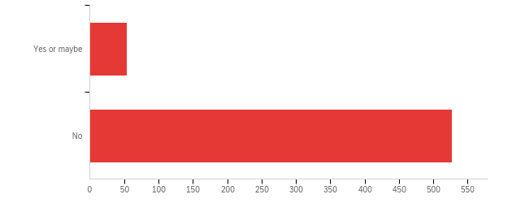

# | Answer | % | Count
1 | Yes or maybe | 9.29% | 54
2 | No | 90.71% | 527
 | Total | 100% | 581

Q24 - On a scale of 0 to 10, with 0 being “not at all likely” and 10 being “highly likely”, how likely would you be to recommend this website to a friend or colleague?
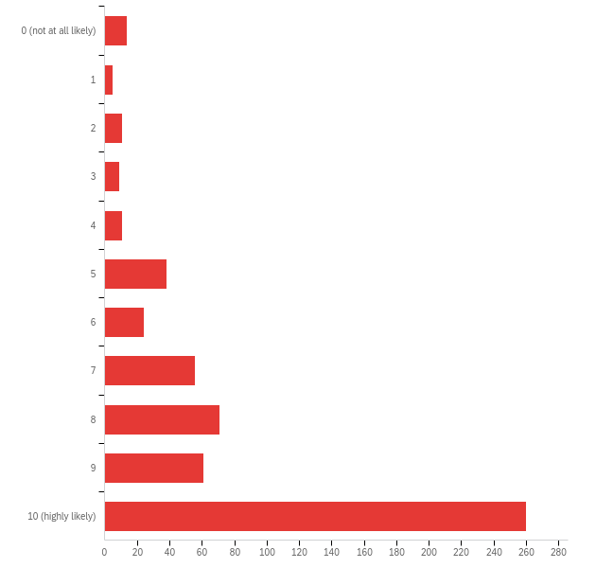

# | Field | Minimum | Maximum | Mean | Std Deviation | Variance | Count
1 | On a scale of 0 to 10, with 0 being “not at all likely” and 10 being “highly likely”, how likely would you be to recommend this website to a friend or colleague? | 1.00 | 11.00 | 9.11 | 2.51 | 6.30 | 560

# | Answer | % | Count
1 | 0 (not at all likely) | 2.50% | 14
2 | 1 | 0.89% | 5
3 | 2 | 1.96% | 11
4 | 3 | 1.61% | 9
5 | 4 | 1.96% | 11
6 | 5 | 6.79% | 38
7 | 6 | 4.29% | 24
8 | 7 | 10.00% | 56
9 | 8 | 12.68% | 71
10 | 9 | 10.89% | 61
11 | 10 (highly likely) | 46.43% | 260
 | Total | 100% | 560

Q25 - On a scale of 0 to 10, with 0 being “not at all likely” and 10 being “highly likely”, how likely are you to revisit this website to access information and resources?
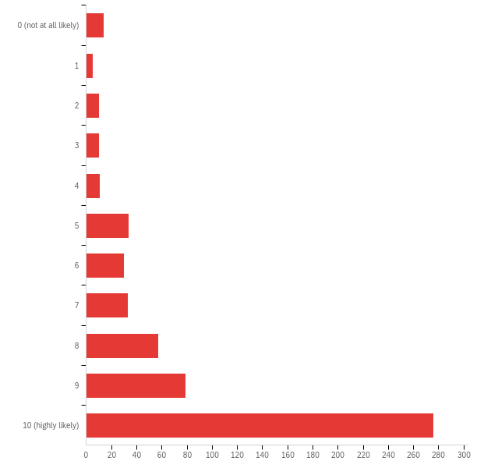

# | Field | Minimum | Maximum | Mean | Std Deviation | Variance | Count
1 | On a scale of 0 to 10, with 0 being “not at all likely” and 10 being “highly likely”, how likely are you to revisit this website to access information and resources? | 1.00 | 11.00 | 9.24 | 2.52 | 6.33 | 559

# | Answer | % | Count
1 | 0 (not at all likely) | 2.50% | 14
2 | 1 | 0.89% | 5
3 | 2 | 1.79% | 10
4 | 3 | 1.79% | 10
5 | 4 | 1.97% | 11
6 | 5 | 6.08% | 34
7 | 6 | 5.37% | 30
8 | 7 | 5.90% | 33
9 | 8 | 10.20% | 57
10 | 9 | 14.13% | 79
11 | 10 (highly likely) | 49.37% | 276
 | Total | 100% | 559

APPENDIX III: Science Stories Satisfaction Report
Understanding Science: Summative assessment on new Science Stories section
WHO TOOK THIS SURVEY?
Q28 - How old are you?
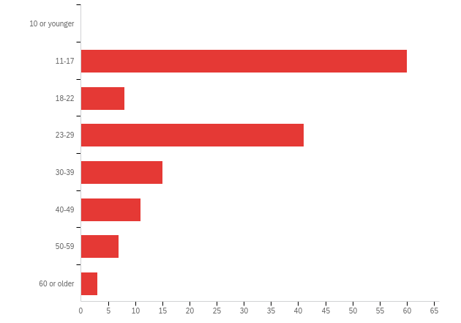

# | Answer | % | Count
1 | 10 or younger | 0.00% | 0
2 | 11-17 | 41.38% | 60
3 | 18-22 | 5.52% | 8
4 | 23-29 | 28.28% | 41
5 | 30-39 | 10.34% | 15
6 | 40-49 | 7.59% | 11
7 | 50-59 | 4.83% | 7
8 | 60 or older | 2.07% | 3
 | Total | 100% | 145

Q29 - What is the highest level of school you have completed or the highest degree you have received?
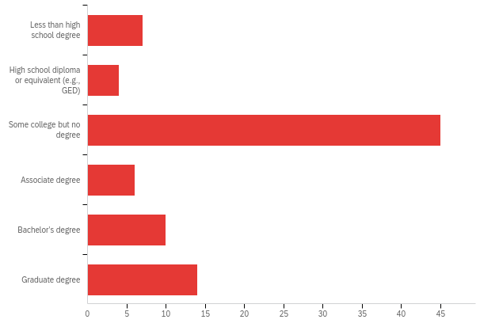

# | Answer | % | Count
1 | Less than high school degree | 8.14% | 7
2 | High school diploma or equivalent (e.g., GED) | 4.65% | 4
3 | Some college but no degree | 52.33% | 45
4 | Associate degree | 6.98% | 6
5 | Bachelor’s degree | 11.63% | 10
6 | Graduate degree | 16.28% | 14
 | Total | 100% | 86

Q30 - What is your race or ethnicity? (Check all that apply.)
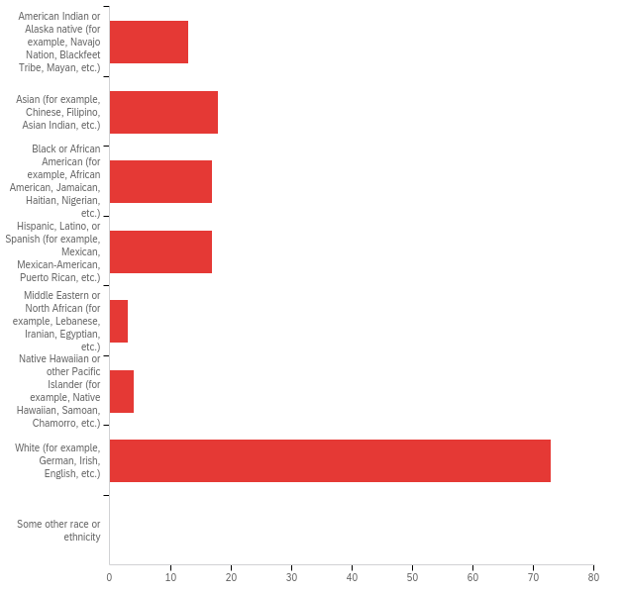

# | Answer | % | Count
1 | American Indian or Alaska native (for example, Navajo Nation, Blackfeet Tribe, Mayan, etc.) | 8.97% | 13
2 | Asian (for example, Chinese, Filipino, Asian Indian, etc.) | 12.41% | 18
3 | Black or African American (for example, African American, Jamaican, Haitian, Nigerian, etc.) | 11.72% | 17
4 | Hispanic, Latino, or Spanish (for example, Mexican, Mexican-American, Puerto Rican, etc.) | 11.72% | 17
5 | Middle Eastern or North African (for example, Lebanese, Iranian, Egyptian, etc.) | 2.07% | 3
6 | Native Hawaiian or other Pacific Islander (for example, Native Hawaiian, Samoan, Chamorro, etc.) | 2.76% | 4
7 | White (for example, German, Irish, English, etc.) | 50.34% | 73
8 | Some other race or ethnicity | 0.00% | 0
 | Total | 100% | 145

Q2 - I am a:
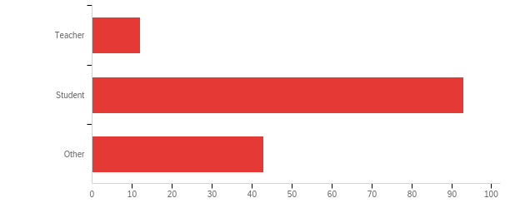

# | Answer | % | Count
1 | Teacher | 8.11% | 12
2 | Student | 62.84% | 93
3 | Other | 29.05% | 43
 | Total | 100% | 148

Q4 - I teach (check all that apply):
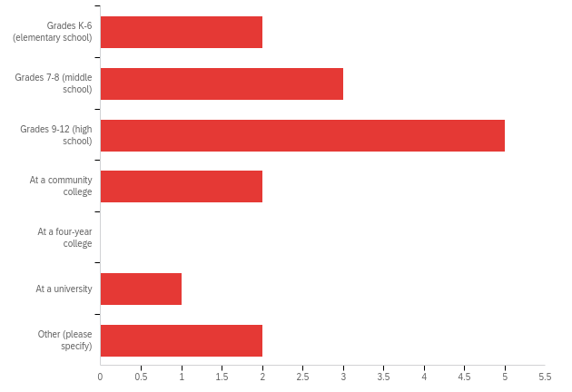

# | Answer | % | Count
1 | Grades K-6 (elementary school) | 13.33% | 2
2 | Grades 7-8 (middle school) | 20.00% | 3
3 | Grades 9-12 (high school) | 33.33% | 5
4 | At a community college | 13.33% | 2
5 | At a four-year college | 0.00% | 0
6 | At a university | 6.67% | 1
7 | Other (please specify) | 13.33% | 2
 | Total | 100% | 15

Q5 - The classes I teach include (check all that apply):
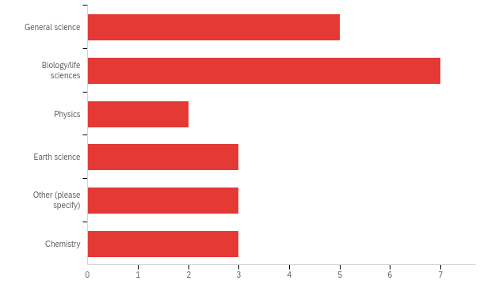

# | Answer | % | Count
3 | Physics | 8.70% | 2
5 | Other (please specify) | 13.04% | 3
1 | General science | 21.74% | 5
4 | Earth science | 13.04% | 3
7 | Chemistry | 13.04% | 3
2 | Biology/life sciences | 30.43% | 7
 | Total | 100% | 23

Q6 - What percent of students at your school qualify for free or reduced-price lunch?
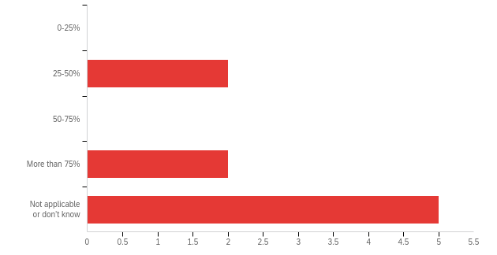

# | Answer | % | Count
1 | 0-25% | 0.00% | 0
2 | 25-50% | 22.22% | 2
3 | 50-75% | 0.00% | 0
4 | More than 75% | 22.22% | 2
5 | Not applicable or don’t know | 55.56% | 5
 | Total | 100% | 9

Q9 - I am a(n):
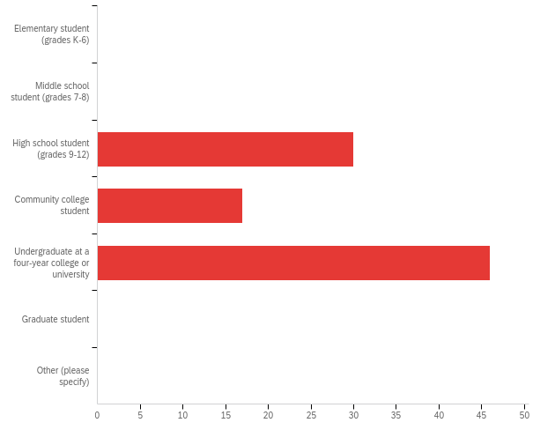

# | Answer | % | Count
1 | Elementary student (grades K-6) | 0.00% | 0
2 | Middle school student (grades 7-8) | 0.00% | 0
3 | High school student (grades 9-12) | 32.26% | 30
4 | Community college student | 18.28% | 17
5 | Undergraduate at a four-year college or university | 49.46% | 46
7 | Graduate student | 0.00% | 0
8 | Other (please specify) | 0.00% | 0
 | Total | 100% | 93

HOW DID YOU FEEL ABOUT THE CONTENT?
Q15 - Please rate your agreement with the following statements regarding the Science Stories webpage:
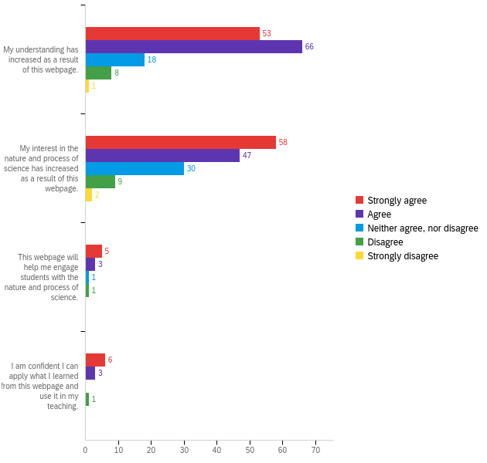

Q24 - On a scale of 0 to 5, with 0 being “not at all likely” and 5 being “highly likely”, how likely would you be to recommend the Science Stories webpage to a friend or colleague who wants to learn about the nature and process of science?
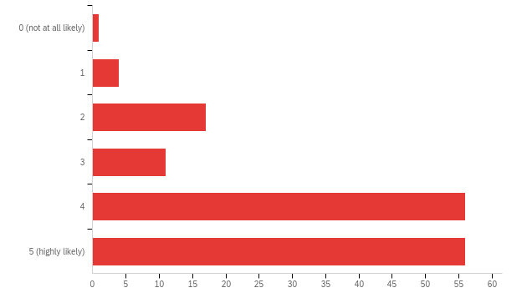

# | Answer | % | Count
1 | 0 (not at all likely) | 0.69% | 1
2 | 1 | 2.76% | 4
3 | 2 | 11.72% | 17
4 | 3 | 7.59% | 11
5 | 4 | 38.62% | 56
6 | 5 (highly likely) | 38.62% | 56
 | Total | 100% | 145

APPENDIX IV: Bias in Science Satisfaction Report
Understanding Science: Summative assessment on new content about bias in science
WHO TOOK THIS SURVEY?
Q28 - How old are you?
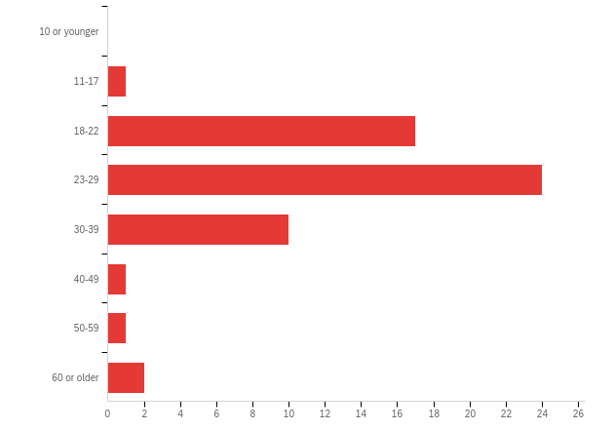

# | Answer | % | Count
1 | 10 or younger | 0.00% | 0
2 | 11-17 | 1.79% | 1
3 | 18-22 | 30.36% | 17
4 | 23-29 | 42.86% | 24
5 | 30-39 | 17.86% | 10
6 | 40-49 | 1.79% | 1
7 | 50-59 | 1.79% | 1
8 | 60 or older | 3.57% | 2
 | Total | 100% | 56

Q29 - What is the highest level of school you have completed or the highest degree you have received?
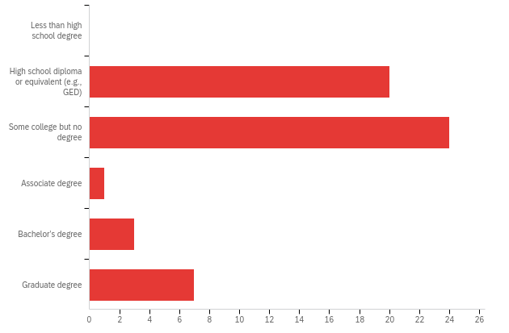

# | Answer | % | Count
1 | Less than high school degree | 0.00% | 0
2 | High school diploma or equivalent (e.g., GED) | 36.36% | 20
3 | Some college but no degree | 43.64% | 24
4 | Associate degree | 1.82% | 1
5 | Bachelor’s degree | 5.45% | 3
6 | Graduate degree | 12.73% | 7
 | Total | 100% | 55

Q30 - What is your race or ethnicity? (Check all that apply.)
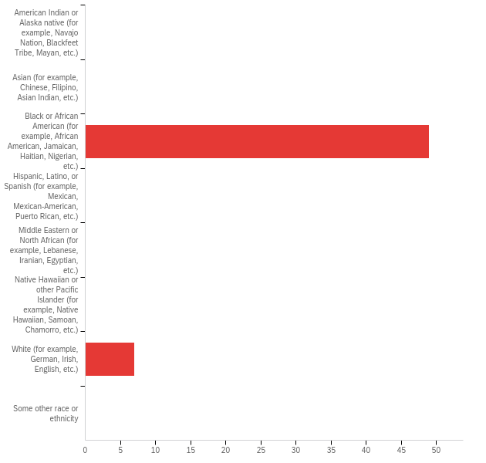

# | Answer | % | Count
1 | American Indian or Alaska native (for example, Navajo Nation, Blackfeet Tribe, Mayan, etc.) | 0.00% | 0
2 | Asian (for example, Chinese, Filipino, Asian Indian, etc.) | 0.00% | 0
3 | Black or African American (for example, African American, Jamaican, Haitian, Nigerian, etc.) | 87.50% | 49
4 | Hispanic, Latino, or Spanish (for example, Mexican, Mexican-American, Puerto Rican, etc.) | 0.00% | 0
5 | Middle Eastern or North African (for example, Lebanese, Iranian, Egyptian, etc.) | 0.00% | 0
6 | Native Hawaiian or other Pacific Islander (for example, Native Hawaiian, Samoan, Chamorro, etc.) | 0.00% | 0
7 | White (for example, German, Irish, English, etc.) | 12.50% | 7
8 | Some other race or ethnicity | 0.00% | 0
 | Total | 100% | 56

Q2 - I am a:
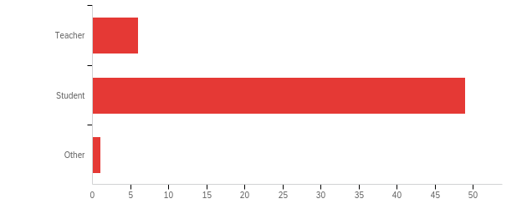

# | Answer | % | Count
1 | Teacher | 10.71% | 6
2 | Student | 87.50% | 49
3 | Other | 1.79% | 1
 | Total | 100% | 56

Q4 - I teach (check all that apply):
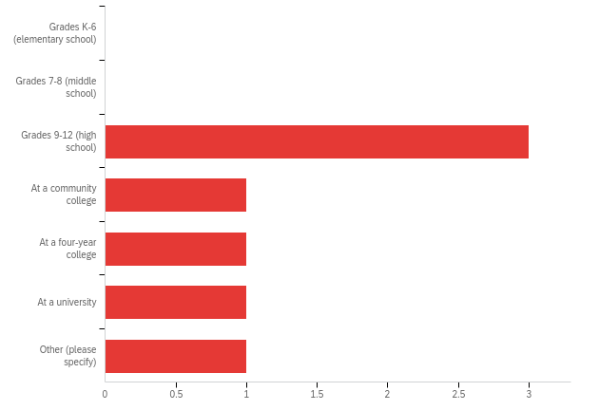

Q5 - The classes I teach include (check all that apply):
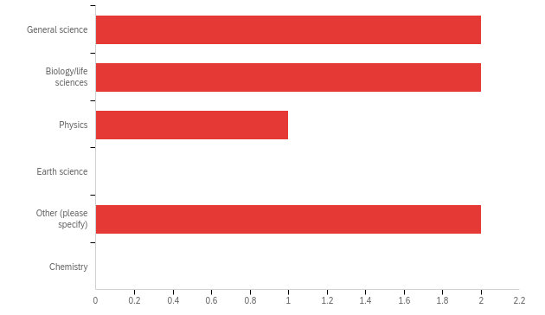

# | Answer | % | Count
3 | Physics | 14.29% | 1
5 | Other (please specify) | 28.57% | 2
1 | General science | 28.57% | 2
4 | Earth science | 0.00% | 0
7 | Chemistry | 0.00% | 0
2 | Biology/life sciences | 28.57% | 2
 | Total | 100% | 7

Q6 - What percent of students at your school qualify for free or reduced-price lunch?
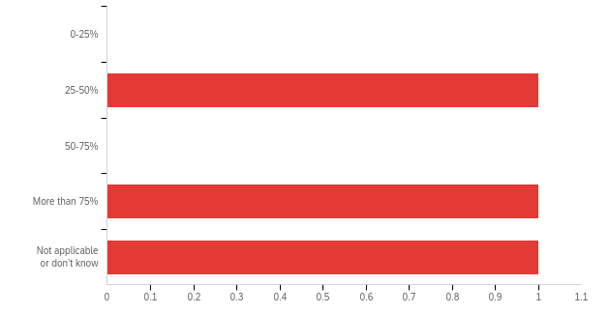

# | Answer | % | Count
1 | 0-25% | 0.00% | 0
2 | 25-50% | 33.33% | 1
3 | 50-75% | 0.00% | 0
4 | More than 75% | 33.33% | 1
5 | Not applicable or don’t know | 33.33% | 1
 | Total | 100% | 3

Q9 - I am a(n):
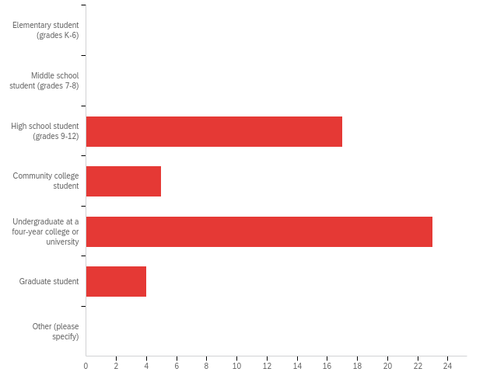

# | Answer | % | Count
1 | Elementary student (grades K-6) | 0.00% | 0
2 | Middle school student (grades 7-8) | 0.00% | 0
3 | High school student (grades 9-12) | 34.69% | 17
4 | Community college student | 10.20% | 5
5 | Undergraduate at a four-year college or university | 46.94% | 23
7 | Graduate student | 8.16% | 4
8 | Other (please specify) | 0.00% | 0
 | Total | 100% | 49

HOW DID YOU FEEL ABOUT THE CONTENT?

Q15 - Please rate your agreement with the following statements regarding that webpage:
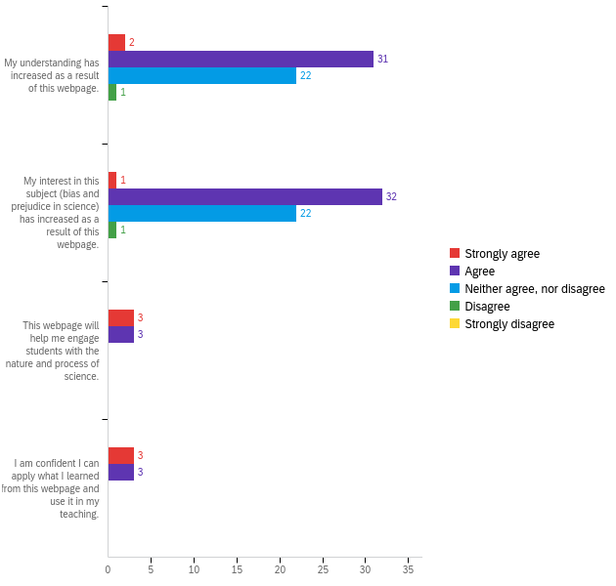

Q24 - On a scale of 0 to 5, with 0 being “not at all likely” and 5 being “highly likely”, how likely would you be to recommend this webpage on bias and prejudice in science to a friend or colleague who wants to learn about this topic?
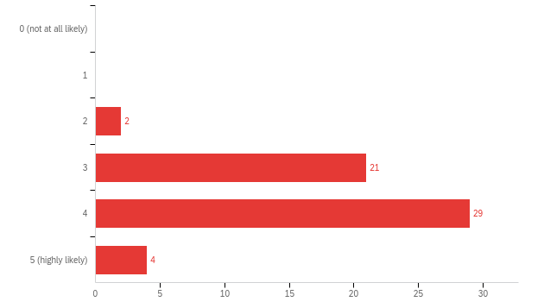

# | Field | Minimum | Maximum | Mean | Std Deviation | Variance | Count
1 | On a scale of 0 to 5, with 0 being “not at all likely” and 5 being “highly likely”, how likely would you be to recommend this webpage on bias and prejudice in science to a friend or colleague who wants to learn about this topic? | 3.00 | 6.00 | 4.63 | 0.67 | 0.45 | 56

APPENDIX V: Mutation Digging Data Satisfaction Report
Understanding Evolution: Summative assessment on mutation Digging Data feature
WHO TOOK THIS SURVEY?
Q28 - How old are you?
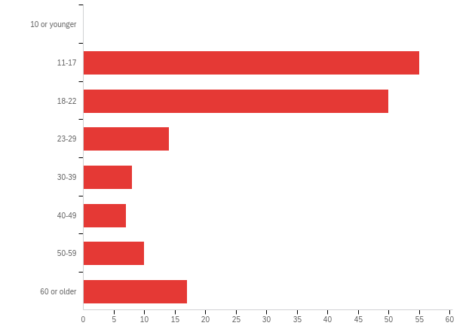

# | Answer | % | Count
1 | 10 or younger | 0.00% | 0
2 | 11-17 | 34.16% | 55
3 | 18-22 | 31.06% | 50
4 | 23-29 | 8.70% | 14
5 | 30-39 | 4.97% | 8
6 | 40-49 | 4.35% | 7
7 | 50-59 | 6.21% | 10
8 | 60 or older | 10.56% | 17
 | Total | 100% | 161

Q29 - What is the highest level of school you have completed or the highest degree you have received?
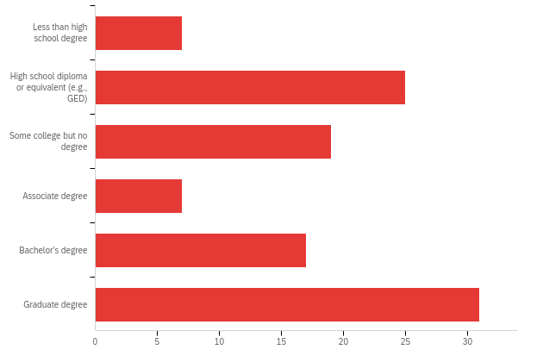

# | Answer | % | Count
1 | Less than high school degree | 6.60% | 7
2 | High school diploma or equivalent (e.g., GED) | 23.58% | 25
3 | Some college but no degree | 17.92% | 19
4 | Associate degree | 6.60% | 7
5 | Bachelor’s degree | 16.04% | 17
6 | Graduate degree | 29.25% | 31
 | Total | 100% | 106

Q30 - What is your race or ethnicity? (Check all that apply.)
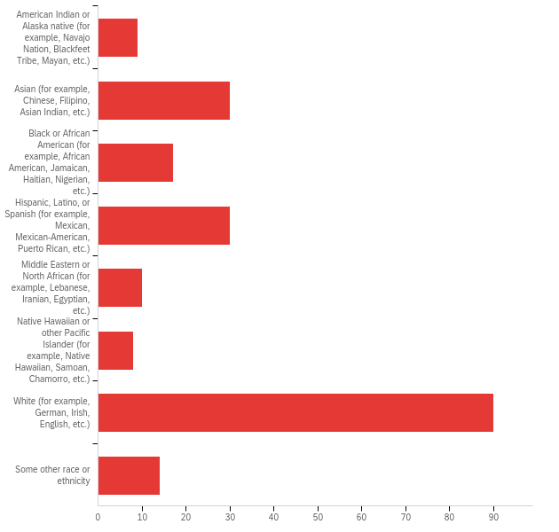

# | Answer | % | Count
1 | American Indian or Alaska native (for example, Navajo Nation, Blackfeet Tribe, Mayan, etc.) | 4.33% | 9
2 | Asian (for example, Chinese, Filipino, Asian Indian, etc.) | 14.42% | 30
3 | Black or African American (for example, African American, Jamaican, Haitian, Nigerian, etc.) | 8.17% | 17
4 | Hispanic, Latino, or Spanish (for example, Mexican, Mexican-American, Puerto Rican, etc.) | 14.42% | 30
5 | Middle Eastern or North African (for example, Lebanese, Iranian, Egyptian, etc.) | 4.81% | 10
6 | Native Hawaiian or other Pacific Islander (for example, Native Hawaiian, Samoan, Chamorro, etc.) | 3.85% | 8
7 | White (for example, German, Irish, English, etc.) | 43.27% | 90
8 | Some other race or ethnicity | 6.73% | 14
 | Total | 100% | 208

Q2 - I am a:
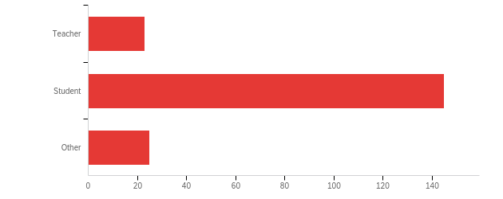

# | Answer | % | Count
1 | Teacher | 11.92% | 23
2 | Student | 75.13% | 145
3 | Other | 12.95% | 25
 | Total | 100% | 193

Q4 - I teach (check all that apply):
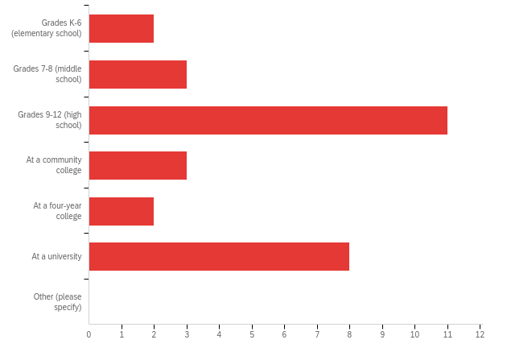

# | Answer | % | Count
1 | Grades K-6 (elementary school) | 6.90% | 2
2 | Grades 7-8 (middle school) | 10.34% | 3
3 | Grades 9-12 (high school) | 37.93% | 11
4 | At a community college | 10.34% | 3
5 | At a four-year college | 6.90% | 2
6 | At a university | 27.59% | 8
7 | Other (please specify) | 0.00% | 0
 | Total | 100% | 29

Q5 - The classes I teach include (check all that apply):
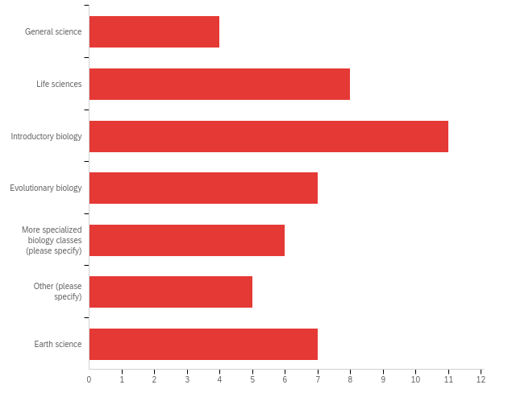

# | Answer | % | Count
1 | General science | 8.33% | 4
2 | Life sciences | 16.67% | 8
3 | Introductory biology | 22.92% | 11
4 | Evolutionary biology | 14.58% | 7
5 | More specialized biology classes (please specify) | 12.50% | 6
6 | Other (please specify) | 10.42% | 5
7 | Earth science | 14.58% | 7
 | Total | 100% | 48

Q6 - What percent of students at your school qualify for free or reduced-price lunch?
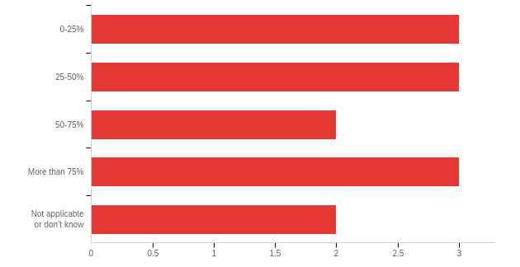

# | Answer | % | Count
1 | 0-25% | 23.08% | 3
2 | 25-50% | 23.08% | 3
3 | 50-75% | 15.38% | 2
4 | More than 75% | 23.08% | 3
5 | Not applicable or don’t know | 15.38% | 2
 | Total | 100% | 13

Q9 - I am a(n):
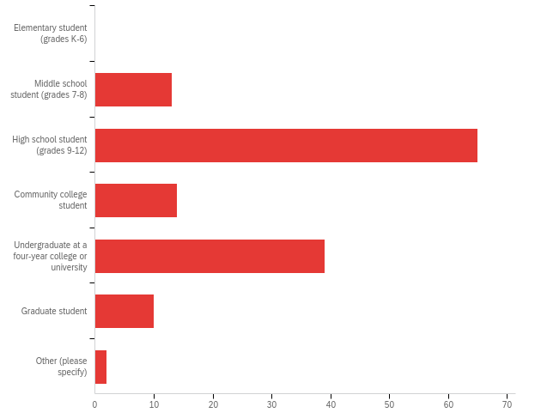

# | Answer | % | Count
1 | Elementary student (grades K-6) | 0.00% | 0
2 | Middle school student (grades 7-8) | 9.09% | 13
3 | High school student (grades 9-12) | 45.45% | 65
4 | Community college student | 9.79% | 14
5 | Undergraduate at a four-year college or university | 27.27% | 39
7 | Graduate student | 6.99% | 10
8 | Other (please specify) | 1.40% | 2
 | Total | 100% | 143

HOW DID YOU FEEL ABOUT THE CONTENT?
Q15 - Please rate your agreement with the following statements regarding the Digging Data feature (i.e., article and linked lessons and resources):
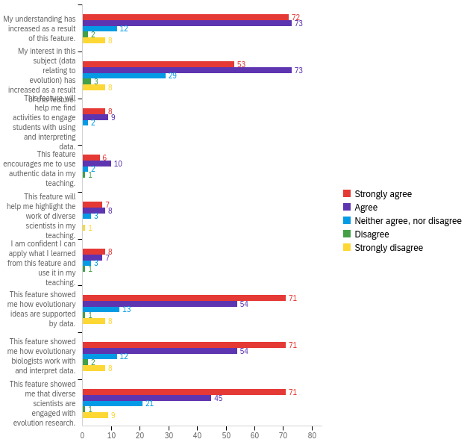

# | Question | Strongly agree |  | Agree |  | Neither agree, nor disagree |  | Disagree |  | Strongly disagree |  | Total
1 | My understanding has increased as a result of this feature. | 43.11% | 72 | 43.71% | 73 | 7.19% | 12 | 1.20% | 2 | 4.79% | 8 | 167
2 | My interest in this subject (data relating to evolution) has increased as a result of this feature. | 31.93% | 53 | 43.98% | 73 | 17.47% | 29 | 1.81% | 3 | 4.82% | 8 | 166
3 | This feature will help me find activities to engage students with using and interpreting data. | 42.11% | 8 | 47.37% | 9 | 10.53% | 2 | 0.00% | 0 | 0.00% | 0 | 19
4 | This feature encourages me to use authentic data in my teaching. | 31.58% | 6 | 52.63% | 10 | 10.53% | 2 | 5.26% | 1 | 0.00% | 0 | 19
5 | This feature will help me highlight the work of diverse scientists in my teaching. | 36.84% | 7 | 42.11% | 8 | 15.79% | 3 | 0.00% | 0 | 5.26% | 1 | 19
6 | I am confident I can apply what I learned from this feature and use it in my teaching. | 42.11% | 8 | 36.84% | 7 | 15.79% | 3 | 5.26% | 1 | 0.00% | 0 | 19
7 | This feature showed me how evolutionary ideas are supported by data. | 48.30% | 71 | 36.73% | 54 | 8.84% | 13 | 0.68% | 1 | 5.44% | 8 | 147
8 | This feature showed me how evolutionary biologists work with and interpret data. | 48.30% | 71 | 36.73% | 54 | 8.16% | 12 | 1.36% | 2 | 5.44% | 8 | 147
9 | This feature showed me that diverse scientists are engaged with evolution research. | 48.30% | 71 | 30.61% | 45 | 14.29% | 21 | 0.68% | 1 | 6.12% | 9 | 147

Q37 - Which of the following best describes your feelings about the Digging Data feature?
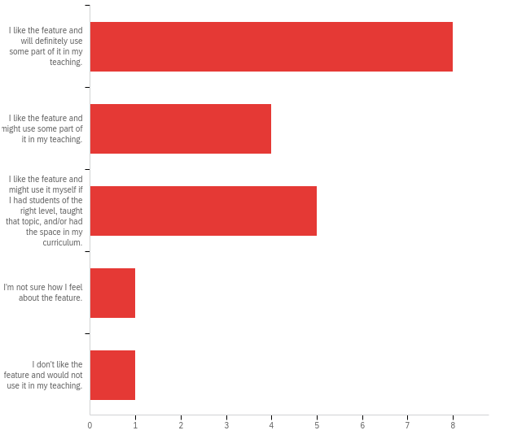

# | Answer | % | Count
1 | I like the feature and will definitely use some part of it in my teaching. | 42.11% | 8
2 | I like the feature and might use some part of it in my teaching. | 21.05% | 4
3 | I like the feature and might use it myself if I had students of the right level, taught that topic, and/or had the space in my curriculum. | 26.32% | 5
4 | I'm not sure how I feel about the feature. | 5.26% | 1
5 | I don't like the feature and would not use it in my teaching. | 5.26% | 1
 | Total | 100% | 19

Q39 - On a scale of 0 to 10, with 0 being “not at all likely” and 10 being “highly likely”, how likely would you be to recommend the Digging Data feature and resources to a friend or colleague who wants to teach about this topic?
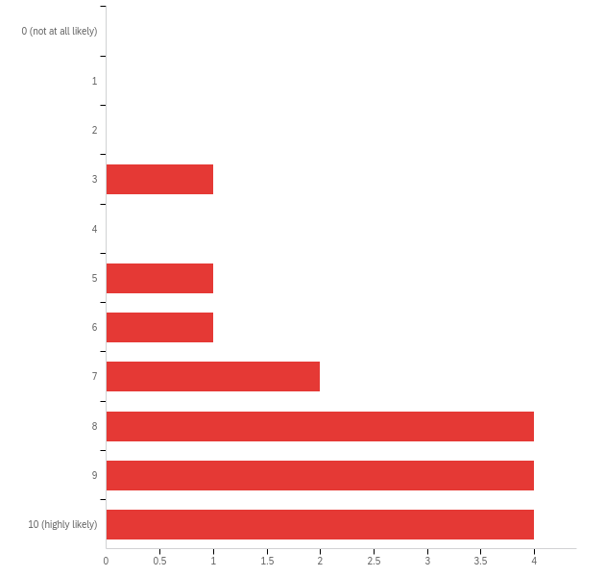

# | Answer | % | Count
1 | 0 (not at all likely) | 0.00% | 0
2 | 1 | 0.00% | 0
3 | 2 | 0.00% | 0
4 | 3 | 5.88% | 1
5 | 4 | 0.00% | 0
6 | 5 | 5.88% | 1
7 | 6 | 5.88% | 1
8 | 7 | 11.76% | 2
9 | 8 | 23.53% | 4
10 | 9 | 23.53% | 4
11 | 10 (highly likely) | 23.53% | 4
 | Total | 100% | 17

Q24 - On a scale of 0 to 10, with 0 being “not at all likely” and 10 being “highly likely”, how likely would you be to recommend the Digging Data feature and resources to a friend or colleague who wants to learn about this topic?
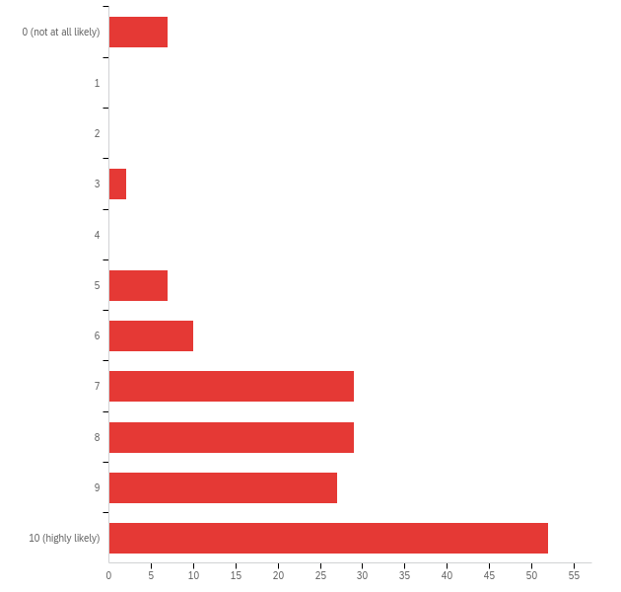

# | Answer | % | Count
1 | 0 (not at all likely) | 4.29% | 7
2 | 1 | 0.00% | 0
3 | 2 | 0.00% | 0
4 | 3 | 1.23% | 2
5 | 4 | 0.00% | 0
6 | 5 | 4.29% | 7
7 | 6 | 6.13% | 10
8 | 7 | 17.79% | 29
9 | 8 | 17.79% | 29
10 | 9 | 16.56% | 27
11 | 10 (highly likely) | 31.90% | 52
 | Total | 100% | 163

APPENDIX VI: Artificial Selection Digging Data Satisfaction Report
Understanding Evolution: Summative assessment on artificial selection Digging Data feature
WHO TOOK THIS SURVEY?
Q28 - How old are you?
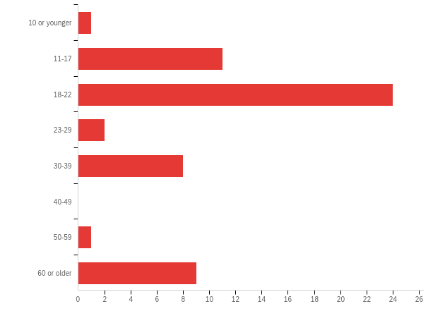

# | Answer | % | Count
1 | 10 or younger | 1.79% | 1
2 | 11-17 | 19.64% | 11
3 | 18-22 | 42.86% | 24
4 | 23-29 | 3.57% | 2
5 | 30-39 | 14.29% | 8
6 | 40-49 | 0.00% | 0
7 | 50-59 | 1.79% | 1
8 | 60 or older | 16.07% | 9
 | Total | 100% | 56

Q29 - What is the highest level of school you have completed or the highest degree you have received?
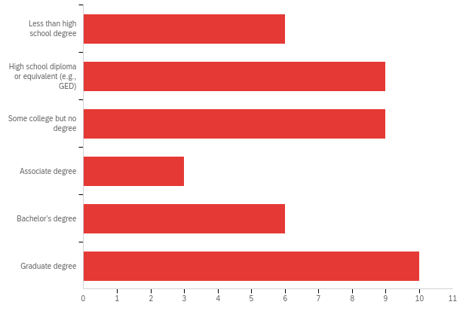

# | Answer | % | Count
1 | Less than high school degree | 13.95% | 6
2 | High school diploma or equivalent (e.g., GED) | 20.93% | 9
3 | Some college but no degree | 20.93% | 9
4 | Associate degree | 6.98% | 3
5 | Bachelor’s degree | 13.95% | 6
6 | Graduate degree | 23.26% | 10
 | Total | 100% | 43

Q30 - What is your race or ethnicity? (Check all that apply.)
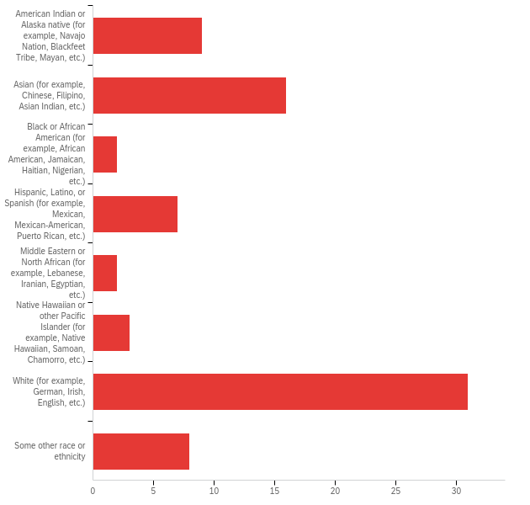

# | Answer | % | Count
1 | American Indian or Alaska native (for example, Navajo Nation, Blackfeet Tribe, Mayan, etc.) | 11.54% | 9
2 | Asian (for example, Chinese, Filipino, Asian Indian, etc.) | 20.51% | 16
3 | Black or African American (for example, African American, Jamaican, Haitian, Nigerian, etc.) | 2.56% | 2
4 | Hispanic, Latino, or Spanish (for example, Mexican, Mexican-American, Puerto Rican, etc.) | 8.97% | 7
5 | Middle Eastern or North African (for example, Lebanese, Iranian, Egyptian, etc.) | 2.56% | 2
6 | Native Hawaiian or other Pacific Islander (for example, Native Hawaiian, Samoan, Chamorro, etc.) | 3.85% | 3
7 | White (for example, German, Irish, English, etc.) | 39.74% | 31
8 | Some other race or ethnicity | 10.26% | 8
 | Total | 100% | 78

Q2 - I am a:
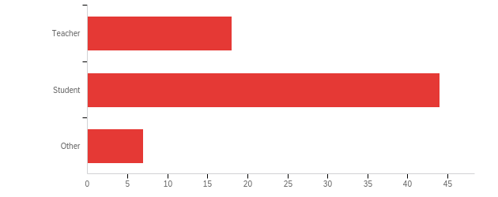

# | Answer | % | Count
1 | Teacher | 26.09% | 18
2 | Student | 63.77% | 44
3 | Other | 10.14% | 7
 | Total | 100% | 69

Q4 - I teach (check all that apply):
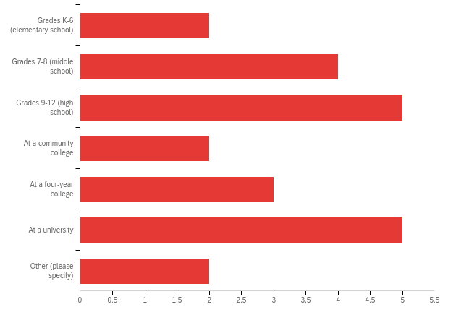

# | Answer | % | Count
1 | Grades K-6 (elementary school) | 8.70% | 2
2 | Grades 7-8 (middle school) | 17.39% | 4
3 | Grades 9-12 (high school) | 21.74% | 5
4 | At a community college | 8.70% | 2
5 | At a four-year college | 13.04% | 3
6 | At a university | 21.74% | 5
7 | Other (please specify) | 8.70% | 2
 | Total | 100% | 23

Q5 - The classes I teach include (check all that apply):
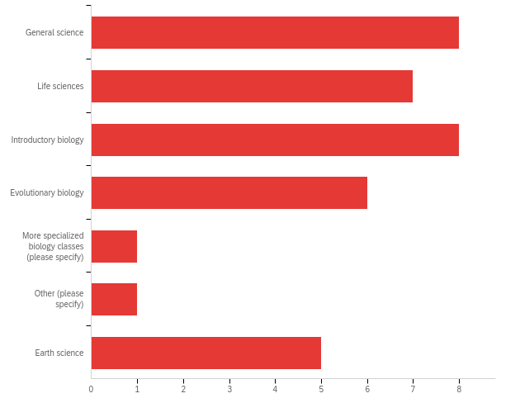

# | Answer | % | Count
1 | General science | 22.22% | 8
2 | Life sciences | 19.44% | 7
3 | Introductory biology | 22.22% | 8
4 | Evolutionary biology | 16.67% | 6
5 | More specialized biology classes (please specify) | 2.78% | 1
6 | Other (please specify) | 2.78% | 1
7 | Earth science | 13.89% | 5
 | Total | 100% | 36

Q6 - What percent of students at your school qualify for free or reduced-price lunch?
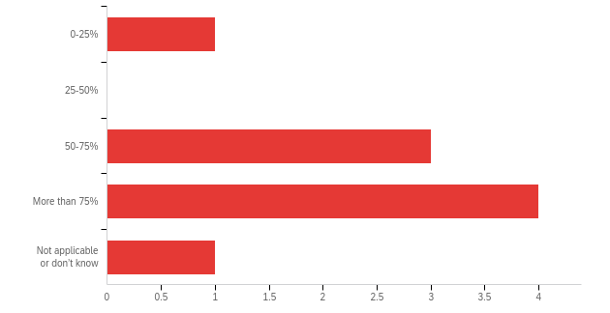

# | Answer | % | Count
1 | 0-25% | 11.11% | 1
2 | 25-50% | 0.00% | 0
3 | 50-75% | 33.33% | 3
4 | More than 75% | 44.44% | 4
5 | Not applicable or don’t know | 11.11% | 1
 | Total | 100% | 9

Q9 - I am a(n):
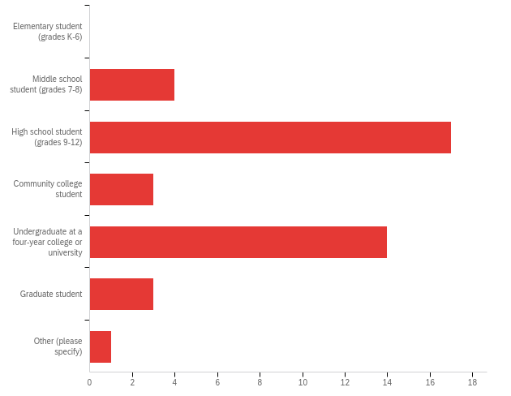

# | Answer | % | Count
1 | Elementary student (grades K-6) | 0.00% | 0
2 | Middle school student (grades 7-8) | 9.52% | 4
3 | High school student (grades 9-12) | 40.48% | 17
4 | Community college student | 7.14% | 3
5 | Undergraduate at a four-year college or university | 33.33% | 14
7 | Graduate student | 7.14% | 3
8 | Other (please specify) | 2.38% | 1
 | Total | 100% | 42

HOW DID YOU FEEL ABOUT THE CONTENT?
Q15 - Please rate your agreement with the following statements regarding the Digging Data feature (i.e., article and linked lessons and resources):
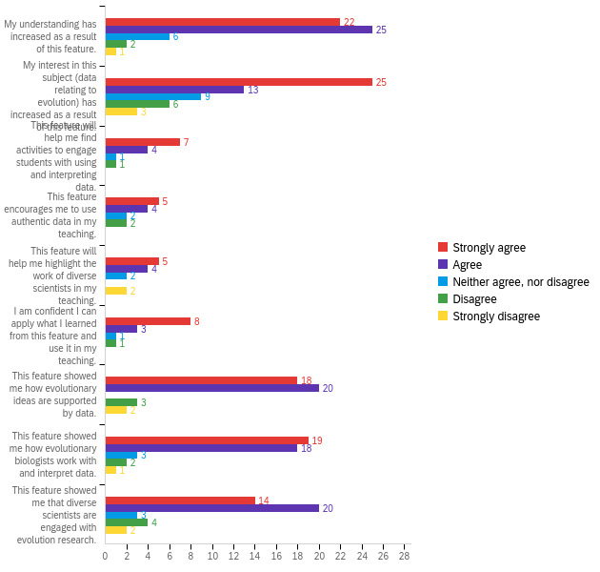

# | Question | Strongly agree |  | Agree |  | Neither agree, nor disagree |  | Disagree |  | Strongly disagree |  | Total
1 | My understanding has increased as a result of this feature. | 39.29% | 22 | 44.64% | 25 | 10.71% | 6 | 3.57% | 2 | 1.79% | 1 | 56
2 | My interest in this subject (data relating to evolution) has increased as a result of this feature. | 44.64% | 25 | 23.21% | 13 | 16.07% | 9 | 10.71% | 6 | 5.36% | 3 | 56
3 | This feature will help me find activities to engage students with using and interpreting data. | 53.85% | 7 | 30.77% | 4 | 7.69% | 1 | 7.69% | 1 | 0.00% | 0 | 13
4 | This feature encourages me to use authentic data in my teaching. | 38.46% | 5 | 30.77% | 4 | 15.38% | 2 | 15.38% | 2 | 0.00% | 0 | 13
5 | This feature will help me highlight the work of diverse scientists in my teaching. | 38.46% | 5 | 30.77% | 4 | 15.38% | 2 | 0.00% | 0 | 15.38% | 2 | 13
6 | I am confident I can apply what I learned from this feature and use it in my teaching. | 61.54% | 8 | 23.08% | 3 | 7.69% | 1 | 7.69% | 1 | 0.00% | 0 | 13
7 | This feature showed me how evolutionary ideas are supported by data. | 41.86% | 18 | 46.51% | 20 | 0.00% | 0 | 6.98% | 3 | 4.65% | 2 | 43
8 | This feature showed me how evolutionary biologists work with and interpret data. | 44.19% | 19 | 41.86% | 18 | 6.98% | 3 | 4.65% | 2 | 2.33% | 1 | 43
9 | This feature showed me that diverse scientists are engaged with evolution research. | 32.56% | 14 | 46.51% | 20 | 6.98% | 3 | 9.30% | 4 | 4.65% | 2 | 43

Q37 - Which of the following best describes your feelings about the Digging Data feature?
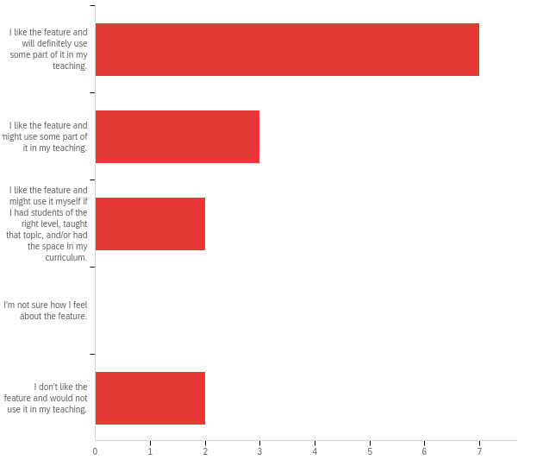

# | Answer | % | Count
1 | I like the feature and will definitely use some part of it in my teaching. | 50.00% | 7
2 | I like the feature and might use some part of it in my teaching. | 21.43% | 3
3 | I like the feature and might use it myself if I had students of the right level, taught that topic, and/or had the space in my curriculum. | 14.29% | 2
4 | I'm not sure how I feel about the feature. | 0.00% | 0
5 | I don't like the feature and would not use it in my teaching. | 14.29% | 2
 | Total | 100% | 14

Q39 - On a scale of 0 to 10, with 0 being “not at all likely” and 10 being “highly likely”, how likely would you be to recommend the Digging Data feature and resources to a friend or colleague who wants to teach about this topic?
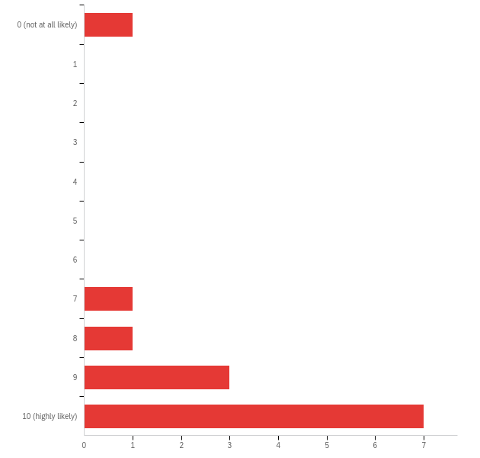

# | Answer | % | Count
1 | 0 (not at all likely) | 7.69% | 1
2 | 1 | 0.00% | 0
3 | 2 | 0.00% | 0
4 | 3 | 0.00% | 0
5 | 4 | 0.00% | 0
6 | 5 | 0.00% | 0
7 | 6 | 0.00% | 0
8 | 7 | 7.69% | 1
9 | 8 | 7.69% | 1
10 | 9 | 23.08% | 3
11 | 10 (highly likely) | 53.85% | 7
 | Total | 100% | 13

Q24 - On a scale of 0 to 10, with 0 being “not at all likely” and 10 being “highly likely”, how likely would you be to recommend the Digging Data feature and resources to a friend or colleague who wants to learn about this topic?
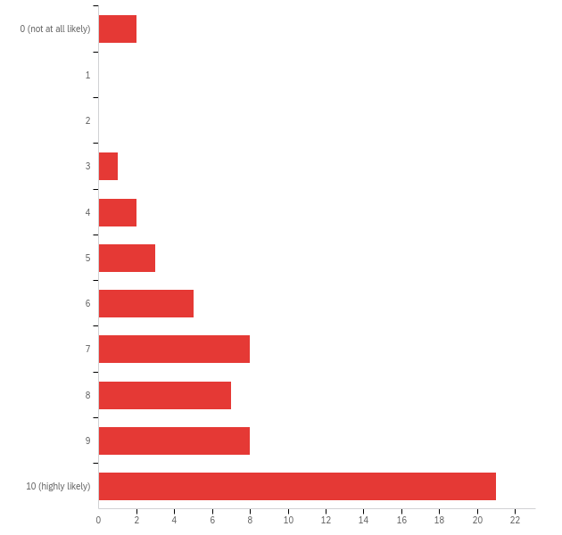

# | Answer | % | Count
1 | 0 (not at all likely) | 3.51% | 2
2 | 1 | 0.00% | 0
3 | 2 | 0.00% | 0
4 | 3 | 1.75% | 1
5 | 4 | 3.51% | 2
6 | 5 | 5.26% | 3
7 | 6 | 8.77% | 5
8 | 7 | 14.04% | 8
9 | 8 | 12.28% | 7
10 | 9 | 14.04% | 8
11 | 10 (highly likely) | 36.84% | 21
 | Total | 100% | 57

APPENDIX VII: Macroevolution Digging Data Satisfaction Report
Understanding Evolution: Summative assessment on macroevolution Digging Data feature
Q28 - How old are you?
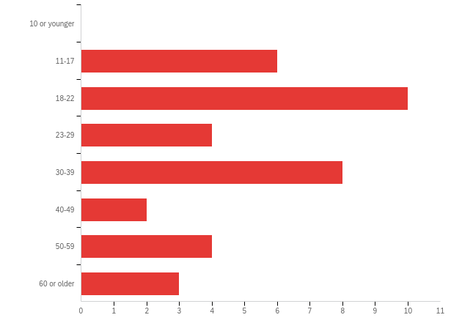

# | Answer | % | Count
1 | 10 or younger | 0.00% | 0
2 | 11-17 | 16.22% | 6
3 | 18-22 | 27.03% | 10
4 | 23-29 | 10.81% | 4
5 | 30-39 | 21.62% | 8
6 | 40-49 | 5.41% | 2
7 | 50-59 | 10.81% | 4
8 | 60 or older | 8.11% | 3
 | Total | 100% | 37

Q29 - What is the highest level of school you have completed or the highest degree you have received?
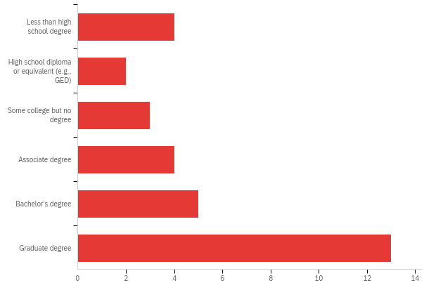

# | Answer | % | Count
1 | Less than high school degree | 12.90% | 4
2 | High school diploma or equivalent (e.g., GED) | 6.45% | 2
3 | Some college but no degree | 9.68% | 3
4 | Associate degree | 12.90% | 4
5 | Bachelor’s degree | 16.13% | 5
6 | Graduate degree | 41.94% | 13
 | Total | 100% | 31

Q30 - What is your race or ethnicity? (Check all that apply.)
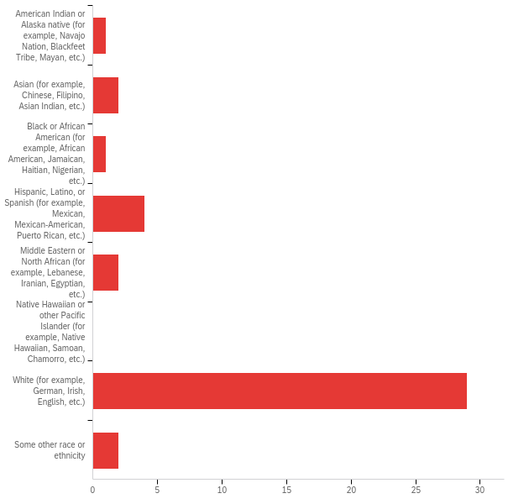

# | Answer | % | Count
1 | American Indian or Alaska native (for example, Navajo Nation, Blackfeet Tribe, Mayan, etc.) | 2.44% | 1
2 | Asian (for example, Chinese, Filipino, Asian Indian, etc.) | 4.88% | 2
3 | Black or African American (for example, African American, Jamaican, Haitian, Nigerian, etc.) | 2.44% | 1
4 | Hispanic, Latino, or Spanish (for example, Mexican, Mexican-American, Puerto Rican, etc.) | 9.76% | 4
5 | Middle Eastern or North African (for example, Lebanese, Iranian, Egyptian, etc.) | 4.88% | 2
6 | Native Hawaiian or other Pacific Islander (for example, Native Hawaiian, Samoan, Chamorro, etc.) | 0.00% | 0
7 | White (for example, German, Irish, English, etc.) | 70.73% | 29
8 | Some other race or ethnicity | 4.88% | 2
 | Total | 100% | 41

Q2 - I am a:
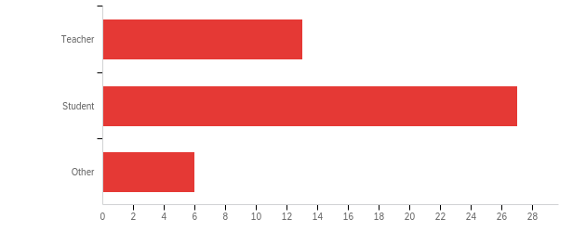

# | Answer | % | Count
1 | Teacher | 28.26% | 13
2 | Student | 58.70% | 27
3 | Other | 13.04% | 6
 | Total | 100% | 46

Q4 - I teach (check all that apply):
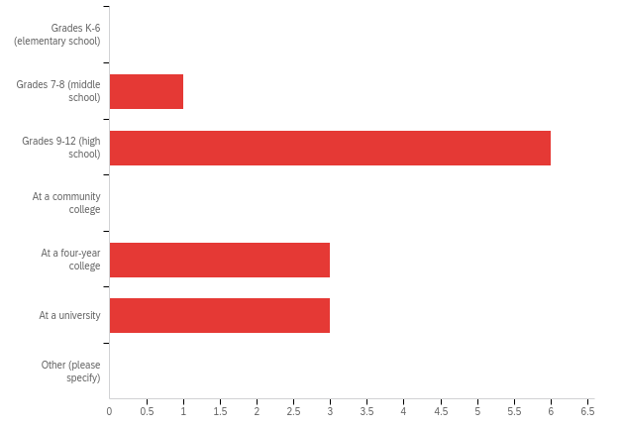

# | Answer | % | Count
1 | Grades K-6 (elementary school) | 0.00% | 0
2 | Grades 7-8 (middle school) | 7.69% | 1
3 | Grades 9-12 (high school) | 46.15% | 6
4 | At a community college | 0.00% | 0
5 | At a four-year college | 23.08% | 3
6 | At a university | 23.08% | 3
7 | Other (please specify) | 0.00% | 0
 | Total | 100% | 13

Q5 - The classes I teach include (check all that apply):
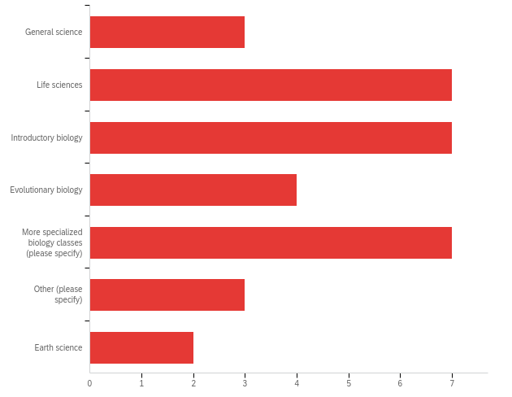

# | Answer | % | Count
1 | General science | 9.09% | 3
2 | Life sciences | 21.21% | 7
3 | Introductory biology | 21.21% | 7
4 | Evolutionary biology | 12.12% | 4
5 | More specialized biology classes (please specify) | 21.21% | 7
6 | Other (please specify) | 9.09% | 3
7 | Earth science | 6.06% | 2
 | Total | 100% | 33

Q6 - What percent of students at your school qualify for free or reduced-price lunch?
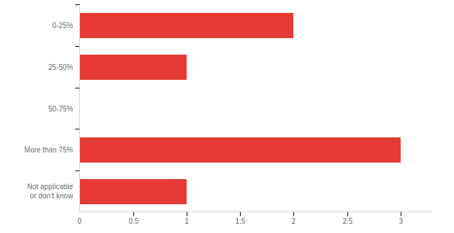

# | Answer | % | Count
1 | 0-25% | 28.57% | 2
2 | 25-50% | 14.29% | 1
3 | 50-75% | 0.00% | 0
4 | More than 75% | 42.86% | 3
5 | Not applicable or don’t know | 14.29% | 1
 | Total | 100% | 7

Q9 - I am a(n):
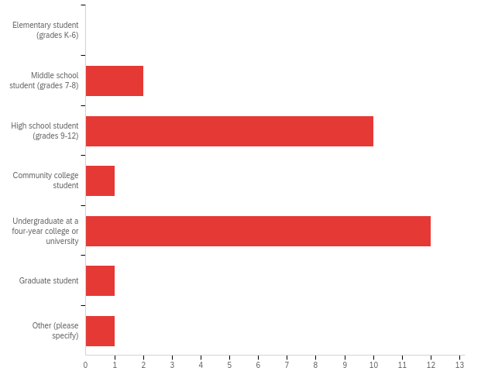

# | Answer | % | Count
1 | Elementary student (grades K-6) | 0.00% | 0
2 | Middle school student (grades 7-8) | 7.41% | 2
3 | High school student (grades 9-12) | 37.04% | 10
4 | Community college student | 3.70% | 1
5 | Undergraduate at a four-year college or university | 44.44% | 12
7 | Graduate student | 3.70% | 1
8 | Other (please specify) | 3.70% | 1
 | Total | 100% | 27

Q15 - Please rate your agreement with the following statements regarding the Digging Data feature (i.e., article and linked lessons and resources):
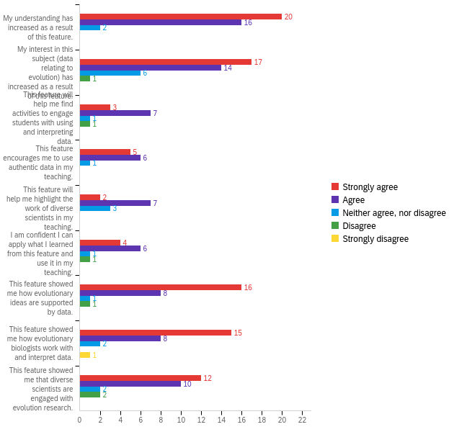

# | Question | Strongly agree |  | Agree |  | Neither agree, nor disagree |  | Disagree |  | Strongly disagree |  | Total
1 | My understanding has increased as a result of this feature. | 52.63% | 20 | 42.11% | 16 | 5.26% | 2 | 0.00% | 0 | 0.00% | 0 | 38
2 | My interest in this subject (data relating to evolution) has increased as a result of this feature. | 44.74% | 17 | 36.84% | 14 | 15.79% | 6 | 2.63% | 1 | 0.00% | 0 | 38
3 | This feature will help me find activities to engage students with using and interpreting data. | 25.00% | 3 | 58.33% | 7 | 8.33% | 1 | 8.33% | 1 | 0.00% | 0 | 12
4 | This feature encourages me to use authentic data in my teaching. | 41.67% | 5 | 50.00% | 6 | 8.33% | 1 | 0.00% | 0 | 0.00% | 0 | 12
5 | This feature will help me highlight the work of diverse scientists in my teaching. | 16.67% | 2 | 58.33% | 7 | 25.00% | 3 | 0.00% | 0 | 0.00% | 0 | 12
6 | I am confident I can apply what I learned from this feature and use it in my teaching. | 33.33% | 4 | 50.00% | 6 | 8.33% | 1 | 8.33% | 1 | 0.00% | 0 | 12
7 | This feature showed me how evolutionary ideas are supported by data. | 61.54% | 16 | 30.77% | 8 | 3.85% | 1 | 3.85% | 1 | 0.00% | 0 | 26
8 | This feature showed me how evolutionary biologists work with and interpret data. | 57.69% | 15 | 30.77% | 8 | 7.69% | 2 | 0.00% | 0 | 3.85% | 1 | 26
9 | This feature showed me that diverse scientists are engaged with evolution research. | 46.15% | 12 | 38.46% | 10 | 7.69% | 2 | 7.69% | 2 | 0.00% | 0 | 26

Q37 - Which of the following best describes your feelings about the Digging Data feature?
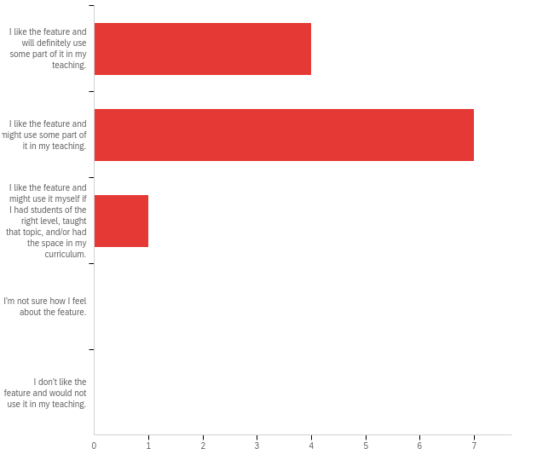

# | Answer | % | Count
1 | I like the feature and will definitely use some part of it in my teaching. | 33.33% | 4
2 | I like the feature and might use some part of it in my teaching. | 58.33% | 7
3 | I like the feature and might use it myself if I had students of the right level, taught that topic, and/or had the space in my curriculum. | 8.33% | 1
4 | I'm not sure how I feel about the feature. | 0.00% | 0
5 | I don't like the feature and would not use it in my teaching. | 0.00% | 0
 | Total | 100% | 12

Q39 - On a scale of 0 to 10, with 0 being “not at all likely” and 10 being “highly likely”, how likely would you be to recommend the Digging Data feature and resources to a friend or colleague who wants to teach about this topic?
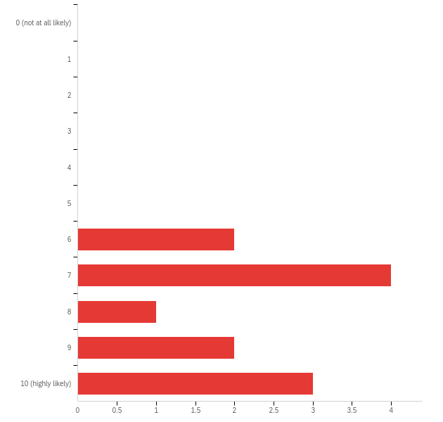

# | Answer | % | Count
1 | 0 (not at all likely) | 0.00% | 0
2 | 1 | 0.00% | 0
3 | 2 | 0.00% | 0
4 | 3 | 0.00% | 0
5 | 4 | 0.00% | 0
6 | 5 | 0.00% | 0
7 | 6 | 16.67% | 2
8 | 7 | 33.33% | 4
9 | 8 | 8.33% | 1
10 | 9 | 16.67% | 2
11 | 10 (highly likely) | 25.00% | 3
 | Total | 100% | 12

Q24 - On a scale of 0 to 10, with 0 being “not at all likely” and 10 being “highly likely”, how likely would you be to recommend the Digging Data feature and resources to a friend or colleague who wants to learn about this topic?
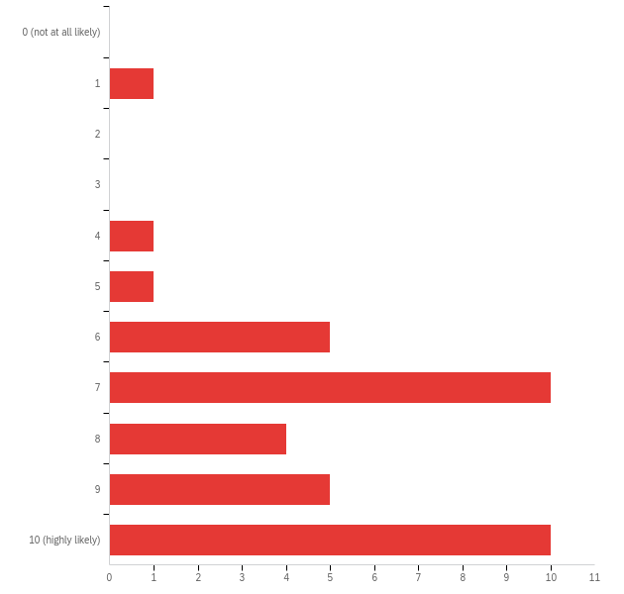

# | Answer | % | Count
1 | 0 (not at all likely) | 0.00% | 0
2 | 1 | 2.70% | 1
3 | 2 | 0.00% | 0
4 | 3 | 0.00% | 0
5 | 4 | 2.70% | 1
6 | 5 | 2.70% | 1
7 | 6 | 13.51% | 5
8 | 7 | 27.03% | 10
9 | 8 | 10.81% | 4
10 | 9 | 13.51% | 5
11 | 10 (highly likely) | 27.03% | 10
 | Total | 100% | 37

APPENDIX VIII: Sexual Selection Digging Data Satisfaction Report
Understanding Evolution: Summative assessment on sexual selection Digging Data feature
Q28 - How old are you?
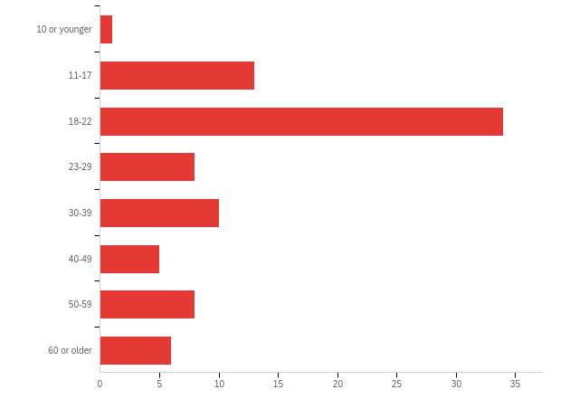

# | Answer | % | Count
1 | 10 or younger | 1.18% | 1
2 | 11-17 | 15.29% | 13
3 | 18-22 | 40.00% | 34
4 | 23-29 | 9.41% | 8
5 | 30-39 | 11.76% | 10
6 | 40-49 | 5.88% | 5
7 | 50-59 | 9.41% | 8
8 | 60 or older | 7.06% | 6
 | Total | 100% | 85

Q29 - What is the highest level of school you have completed or the highest degree you have received?
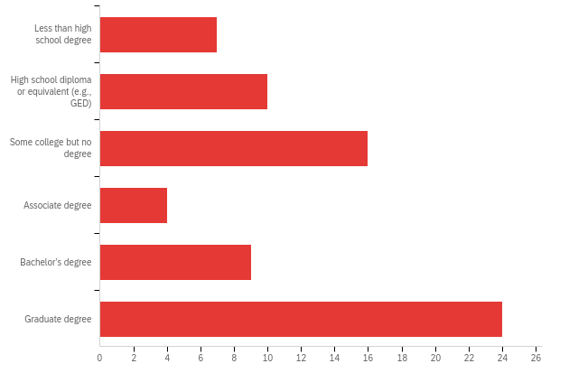

# | Answer | % | Count
1 | Less than high school degree | 10.00% | 7
2 | High school diploma or equivalent (e.g., GED) | 14.29% | 10
3 | Some college but no degree | 22.86% | 16
4 | Associate degree | 5.71% | 4
5 | Bachelor’s degree | 12.86% | 9
6 | Graduate degree | 34.29% | 24
 | Total | 100% | 70

Q30 - What is your race or ethnicity? (Check all that apply.)
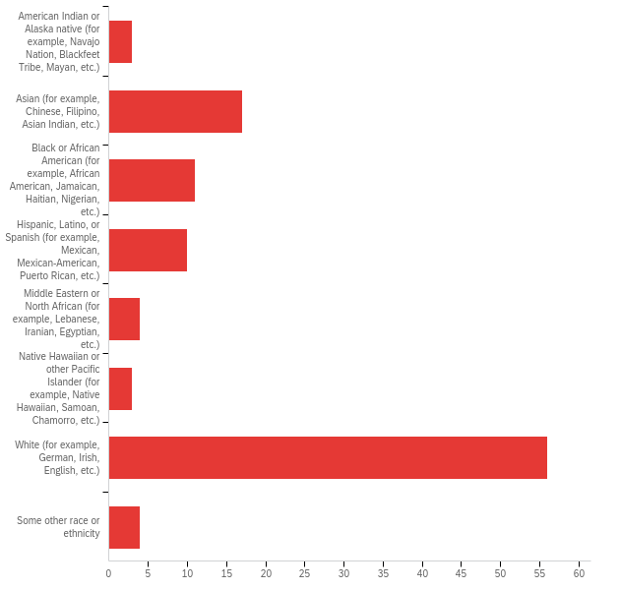

# | Answer | % | Count
1 | American Indian or Alaska native (for example, Navajo Nation, Blackfeet Tribe, Mayan, etc.) | 2.78% | 3
2 | Asian (for example, Chinese, Filipino, Asian Indian, etc.) | 15.74% | 17
3 | Black or African American (for example, African American, Jamaican, Haitian, Nigerian, etc.) | 10.19% | 11
4 | Hispanic, Latino, or Spanish (for example, Mexican, Mexican-American, Puerto Rican, etc.) | 9.26% | 10
5 | Middle Eastern or North African (for example, Lebanese, Iranian, Egyptian, etc.) | 3.70% | 4
6 | Native Hawaiian or other Pacific Islander (for example, Native Hawaiian, Samoan, Chamorro, etc.) | 2.78% | 3
7 | White (for example, German, Irish, English, etc.) | 51.85% | 56
8 | Some other race or ethnicity | 3.70% | 4
 | Total | 100% | 108

Q2 - I am a:
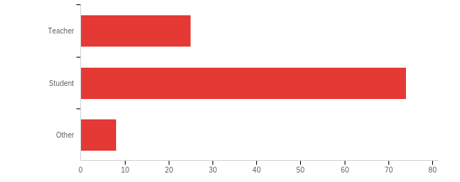

# | Answer | % | Count
1 | Teacher | 23.36% | 25
2 | Student | 69.16% | 74
3 | Other | 7.48% | 8
 | Total | 100% | 107

Q4 - I teach (check all that apply):
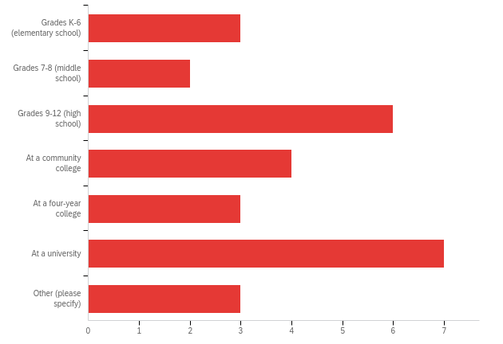

# | Answer | % | Count
1 | Grades K-6 (elementary school) | 10.71% | 3
2 | Grades 7-8 (middle school) | 7.14% | 2
3 | Grades 9-12 (high school) | 21.43% | 6
4 | At a community college | 14.29% | 4
5 | At a four-year college | 10.71% | 3
6 | At a university | 25.00% | 7
7 | Other (please specify) | 10.71% | 3
 | Total | 100% | 28

Q5 - The classes I teach include (check all that apply):
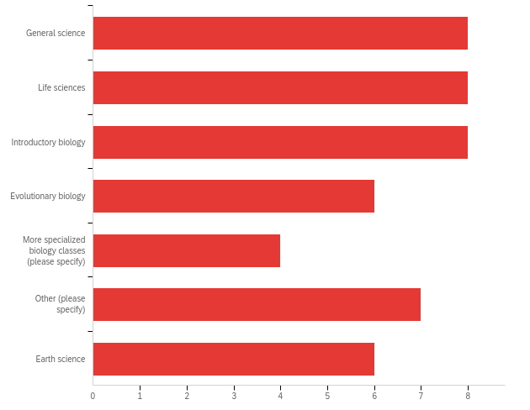

# | Answer | % | Count
1 | General science | 17.02% | 8
2 | Life sciences | 17.02% | 8
3 | Introductory biology | 17.02% | 8
4 | Evolutionary biology | 12.77% | 6
5 | More specialized biology classes (please specify) | 8.51% | 4
6 | Other (please specify) | 14.89% | 7
7 | Earth science | 12.77% | 6
 | Total | 100% | 47

Q6 - What percent of students at your school qualify for free or reduced-price lunch?
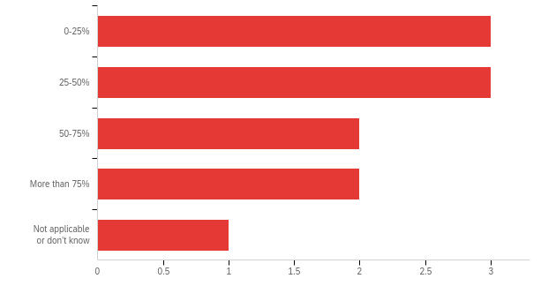

# | Answer | % | Count
1 | 0-25% | 27.27% | 3
2 | 25-50% | 27.27% | 3
3 | 50-75% | 18.18% | 2
4 | More than 75% | 18.18% | 2
5 | Not applicable or don’t know | 9.09% | 1
 | Total | 100% | 11

Q9 - I am a(n):
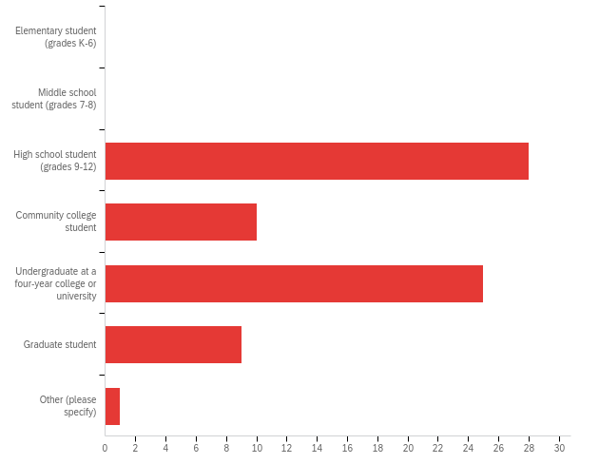

# | Answer | % | Count
1 | Elementary student (grades K-6) | 0.00% | 0
2 | Middle school student (grades 7-8) | 0.00% | 0
3 | High school student (grades 9-12) | 38.36% | 28
4 | Community college student | 13.70% | 10
5 | Undergraduate at a four-year college or university | 34.25% | 25
7 | Graduate student | 12.33% | 9
8 | Other (please specify) | 1.37% | 1
 | Total | 100% | 73

Q15 - Please rate your agreement with the following statements:
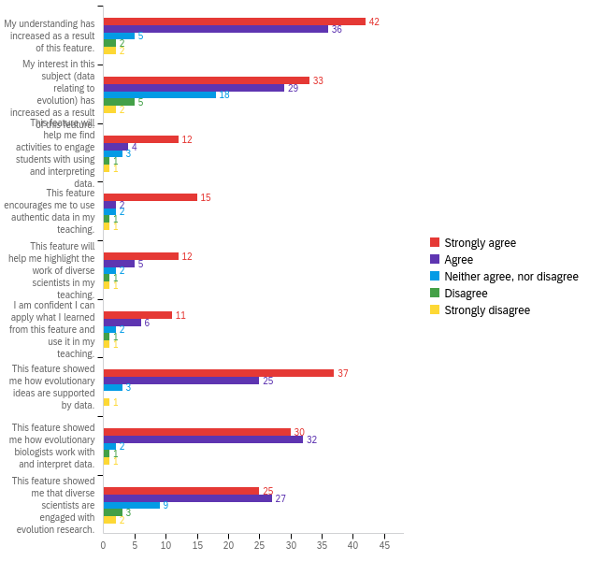

# | Question | Strongly agree |  | Agree |  | Neither agree, nor disagree |  | Disagree |  | Strongly disagree |  | Total
1 | My understanding has increased as a result of this feature. | 48.28% | 42 | 41.38% | 36 | 5.75% | 5 | 2.30% | 2 | 2.30% | 2 | 87
2 | My interest in this subject (data relating to evolution) has increased as a result of this feature. | 37.93% | 33 | 33.33% | 29 | 20.69% | 18 | 5.75% | 5 | 2.30% | 2 | 87
3 | This feature will help me find activities to engage students with using and interpreting data. | 57.14% | 12 | 19.05% | 4 | 14.29% | 3 | 4.76% | 1 | 4.76% | 1 | 21
4 | This feature encourages me to use authentic data in my teaching. | 71.43% | 15 | 9.52% | 2 | 9.52% | 2 | 4.76% | 1 | 4.76% | 1 | 21
5 | This feature will help me highlight the work of diverse scientists in my teaching. | 57.14% | 12 | 23.81% | 5 | 9.52% | 2 | 4.76% | 1 | 4.76% | 1 | 21
6 | I am confident I can apply what I learned from this feature and use it in my teaching. | 52.38% | 11 | 28.57% | 6 | 9.52% | 2 | 4.76% | 1 | 4.76% | 1 | 21
7 | This feature showed me how evolutionary ideas are supported by data. | 56.06% | 37 | 37.88% | 25 | 4.55% | 3 | 0.00% | 0 | 1.52% | 1 | 66
8 | This feature showed me how evolutionary biologists work with and interpret data. | 45.45% | 30 | 48.48% | 32 | 3.03% | 2 | 1.52% | 1 | 1.52% | 1 | 66
9 | This feature showed me that diverse scientists are engaged with evolution research. | 37.88% | 25 | 40.91% | 27 | 13.64% | 9 | 4.55% | 3 | 3.03% | 2 | 66

Q37 - Which of the following best describes your feelings about the Digging Data feature?
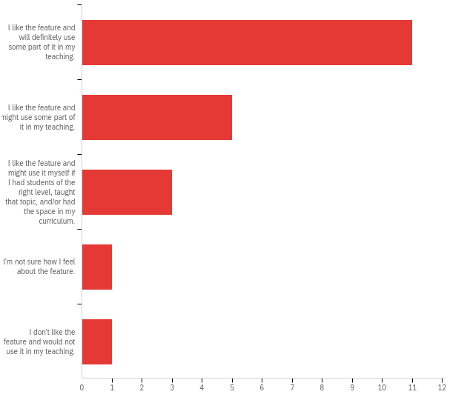

# | Answer | % | Count
1 | I like the feature and will definitely use some part of it in my teaching. | 52.38% | 11
2 | I like the feature and might use some part of it in my teaching. | 23.81% | 5
3 | I like the feature and might use it myself if I had students of the right level, taught that topic, and/or had the space in my curriculum. | 14.29% | 3
4 | I'm not sure how I feel about the feature. | 4.76% | 1
5 | I don't like the feature and would not use it in my teaching. | 4.76% | 1
 | Total | 100% | 21

Q39 - On a scale of 0 to 10, with 0 being “not at all likely” and 10 being “highly likely”, how likely would you be to recommend the Digging Data feature and resources to a friend or colleague who wants to teach about this topic?
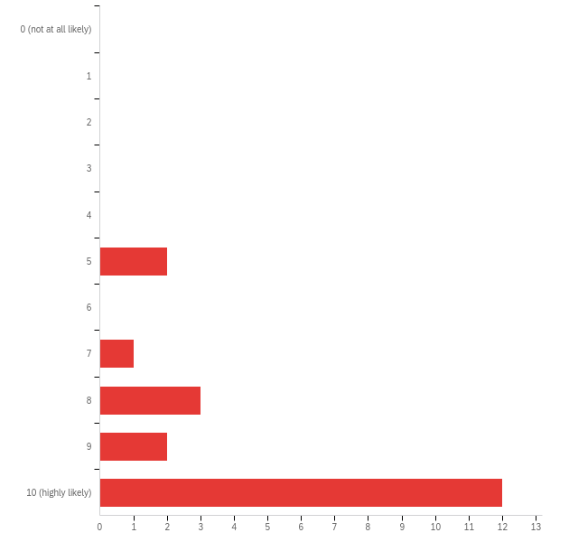

# | Answer | % | Count
1 | 0 (not at all likely) | 0.00% | 0
2 | 1 | 0.00% | 0
3 | 2 | 0.00% | 0
4 | 3 | 0.00% | 0
5 | 4 | 0.00% | 0
6 | 5 | 10.00% | 2
7 | 6 | 0.00% | 0
8 | 7 | 5.00% | 1
9 | 8 | 15.00% | 3
10 | 9 | 10.00% | 2
11 | 10 (highly likely) | 60.00% | 12
 | Total | 100% | 20

Q24 - On a scale of 0 to 10, with 0 being “not at all likely” and 10 being “highly likely”, how likely would you be to recommend the Digging Data feature and resources to a friend or colleague who wants to learn about this topic?
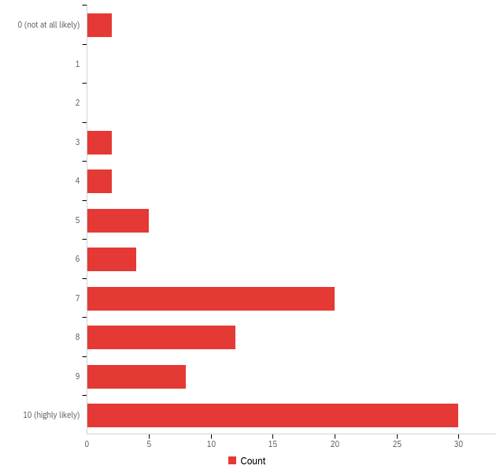

# | Answer | % | Count
1 | 0 (not at all likely) | 2.35% | 2
2 | 1 | 0.00% | 0
3 | 2 | 0.00% | 0
4 | 3 | 2.35% | 2
5 | 4 | 2.35% | 2
6 | 5 | 5.88% | 5
7 | 6 | 4.71% | 4
8 | 7 | 23.53% | 20
9 | 8 | 14.12% | 12
10 | 9 | 9.41% | 8
11 | 10 (highly likely) | 35.29% | 30
 | Total | 100% | 85

