Preparation and Day 1, Lady Beetle Lab:
PROCEDURES FOR SETTING UP BEETLE HABITATS AND PLACING BEETLES INTO CHILL COMA

Setting up habitats (to be done in advance of Lab Day 1:

- Beetle populations can be stored at room temperature in their original packaging, if it is fairly stable, or in a refrigerator at 4℃ for several months, but viability declines over time. Viability is improved if some of their straw packing material or crumpled, clean paper towel is kept with them (they will cluster together in the crevices). A vial with water plugged with cotton is also needed. The container must have some form of ventilation (add a few holes that are smaller than the beetles). Periodic light misting is helpful in maintaining a humidity level that the beetles prefer, but too much moisture will encourage mold growth. The pictures below show one possible example of beetle habitats.

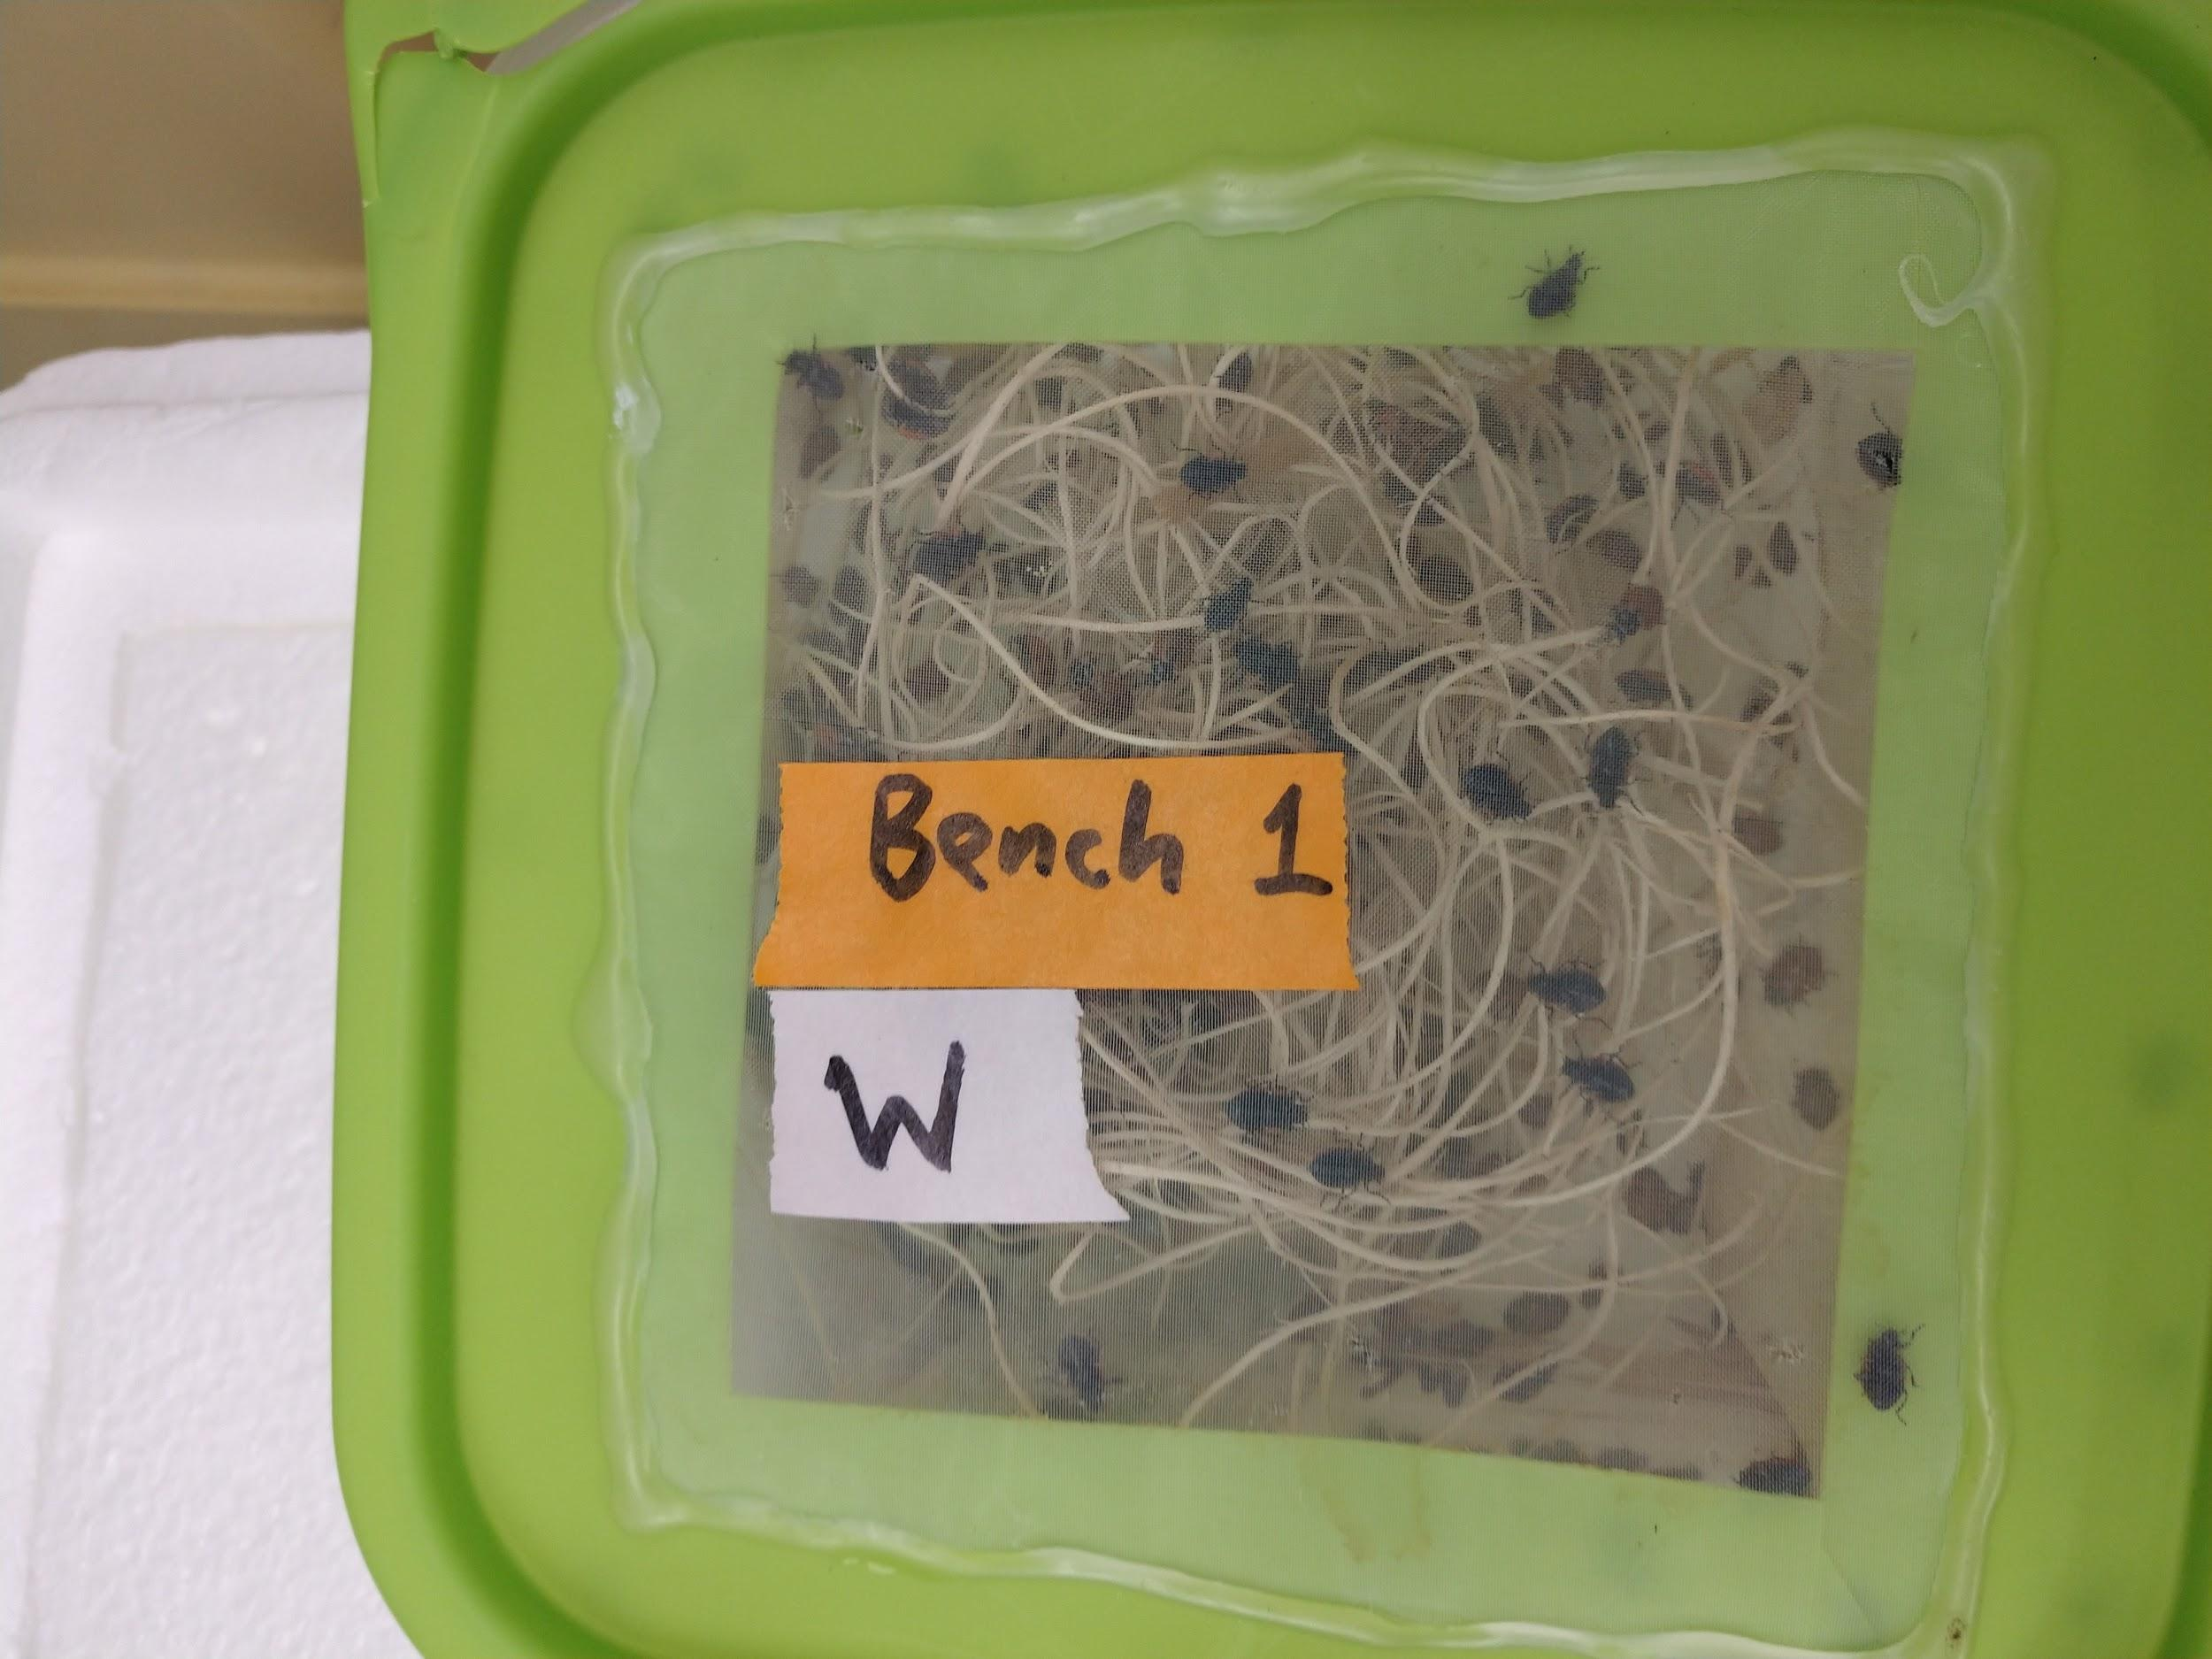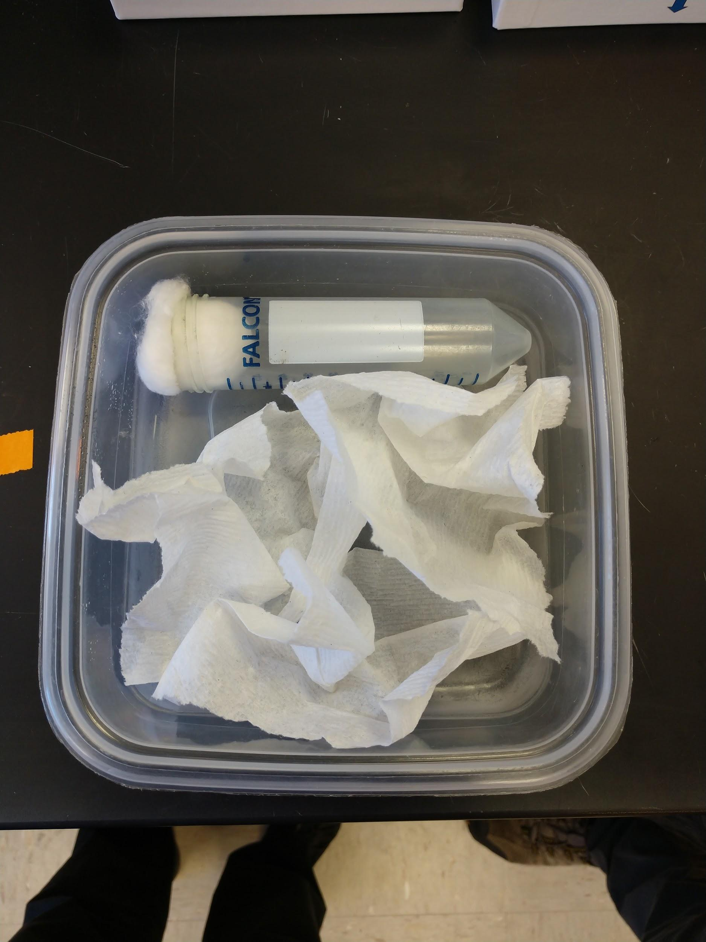

Lab, Day 1: Placing beetles into chill coma - Protocol tips:

- To chill beetles, a styrofoam box filled with crushed ice may be created, although other methods may be used. 15mL conical tubes were used, 8 beetles/tube. Cotton should be loosely packed into the tube to keep beetles in bottom portion of tube and thus immersed in ice. It is critical that the tubes be secured so that beetles be submerged in ice for the entire time period; if the tubes float or bob in such a way that the beetles can access a portion of the tube that is above the ice, they will not enter chill coma.

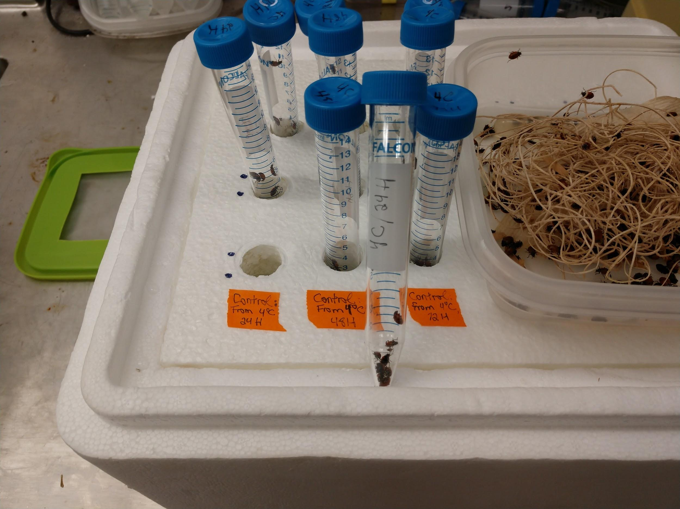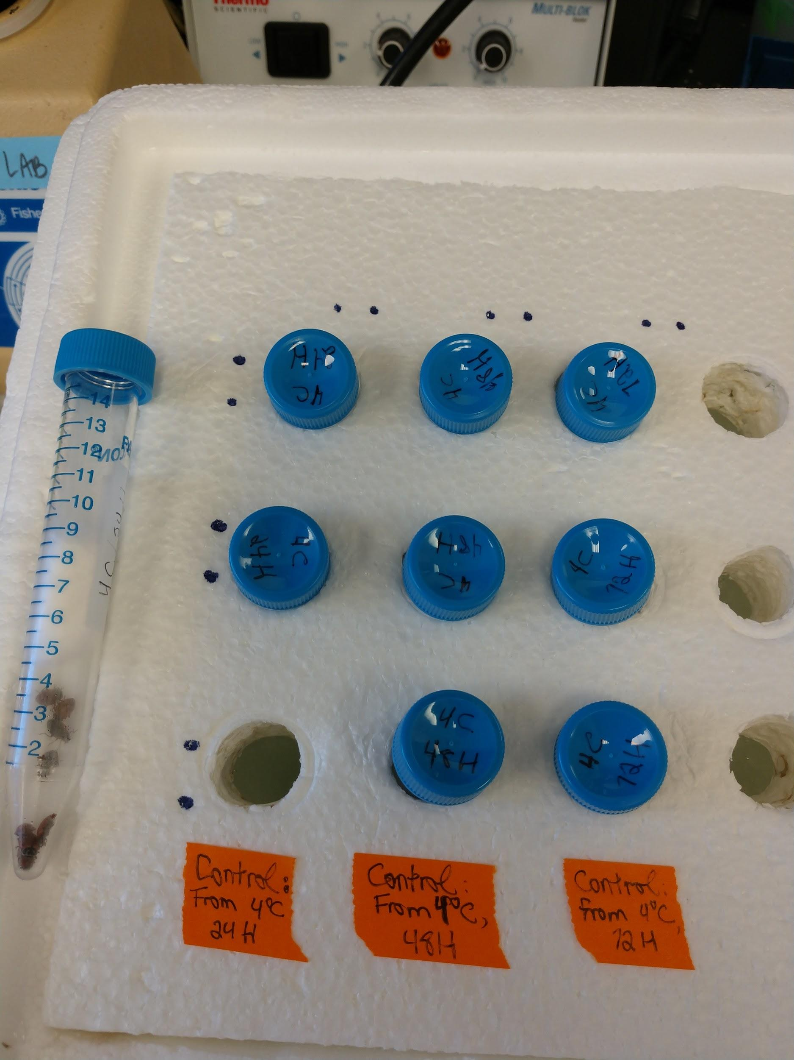

- Lady beetles may be transferred with fingers or by using featherweight soft forceps (Bioquip item #4748 or 4750). Grab beetles by the leg!

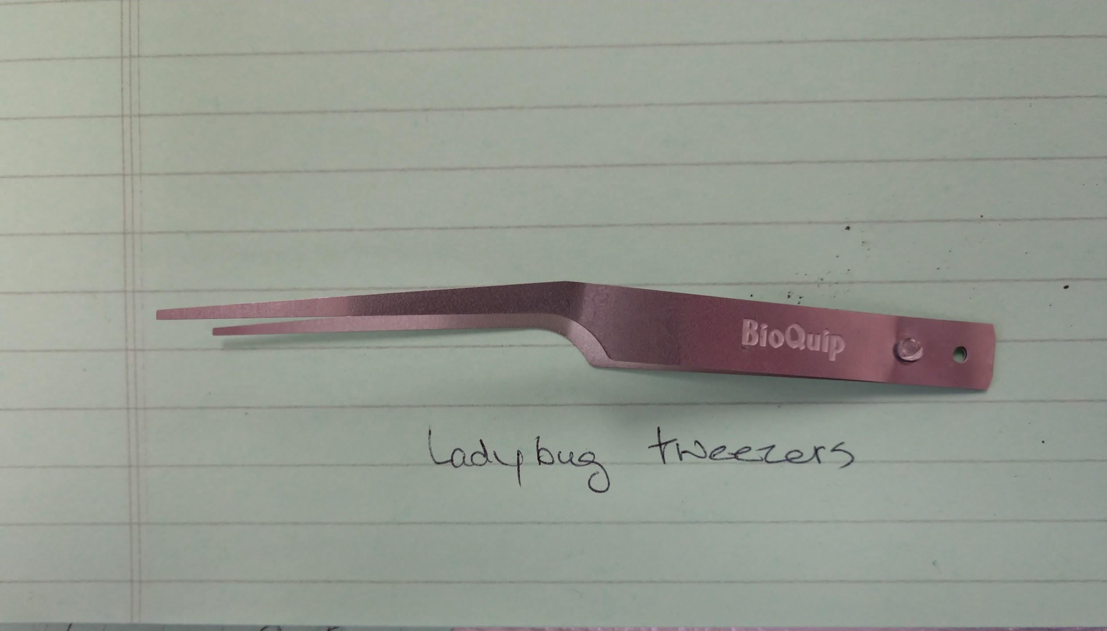

Lesson choreography:
- Ideally students should transfer beetles into vials, although the teacher could prep them as well (this would be time-consuming on the teacher’s part). Beetles become active very quickly when removed from the refrigerator. Work quickly but calmly. Beetles may be re-refrigerated to slow them down if necessary.
- 8-10 beetles is a reasonable number for a pair of students when evaluating Chill Coma Recovery Time (CCRT).

